# 1.Reports/ Rx Reports/ Auto Fill Utilization Report

Request:

Summary Only:

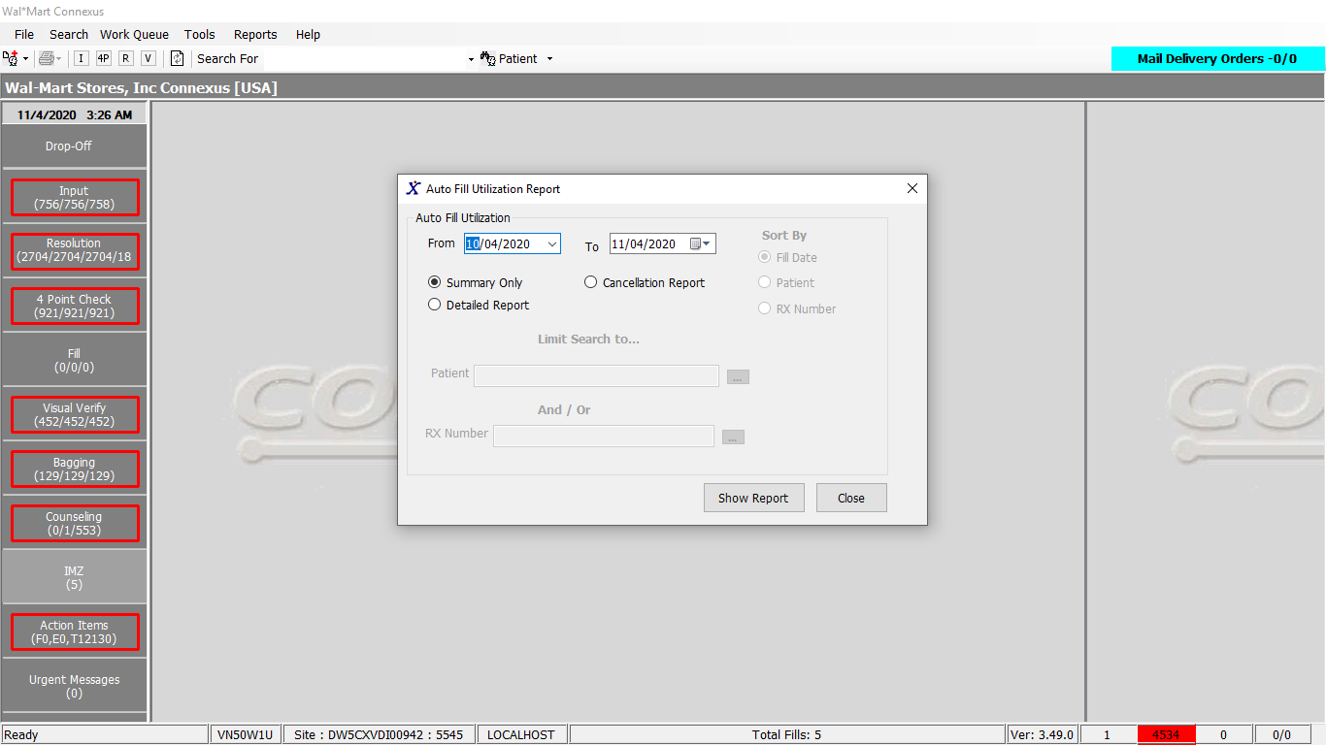

Cancellation / Detailed Report:

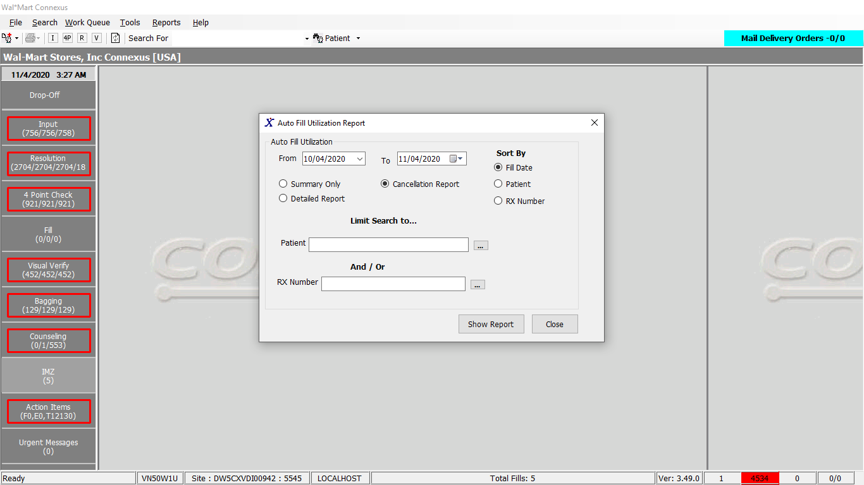

Child Popup :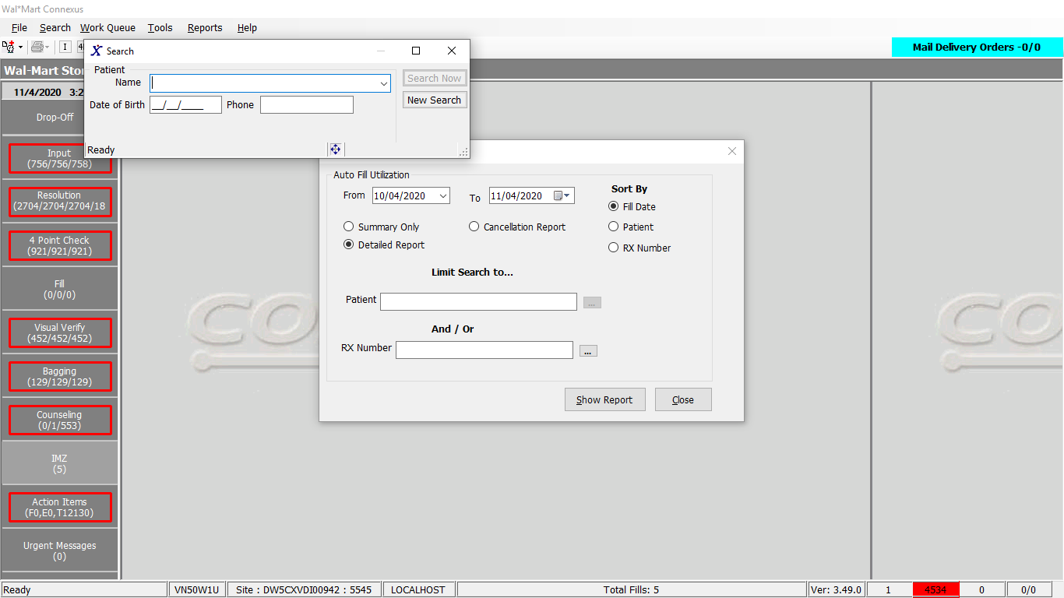

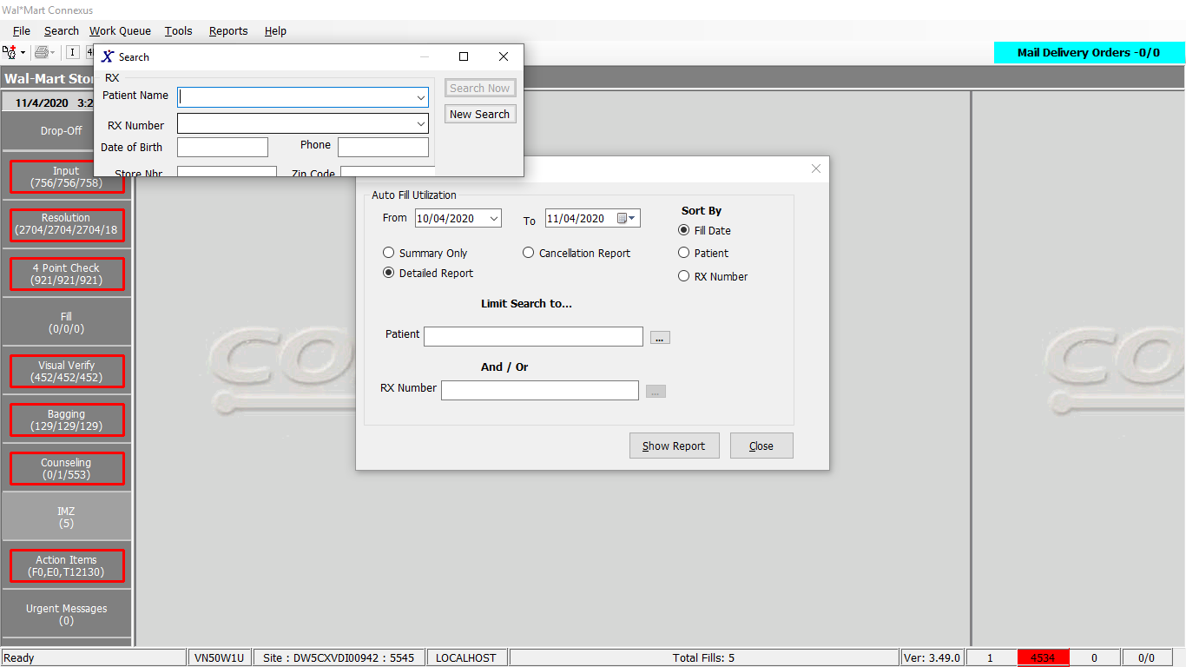

Response:

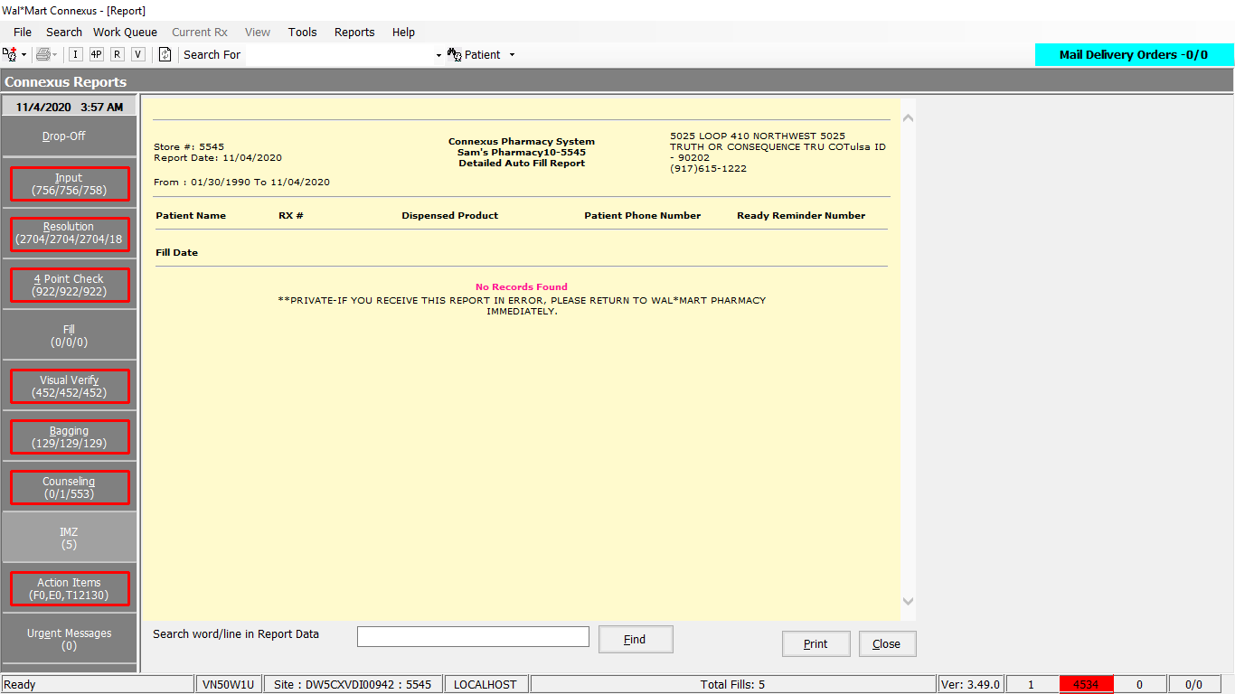

DAL:

AutoFillSummary Queries:

sqlString.Append(ReportQueries.AutoFillSummaryMain1)

Friend Const AutoFillSummaryMain1 As String = "SELECT rf.fill_date , COUNT(UNIQUE rf.rx_fill_id) NonAutoFillRefillCount " &

"FROM rx_order_detail rod, rx rx, rx_fill rf, rx_fill_activity rfa , rx_fill_item rfi " &

"WHERE rod.rx_id = rx.rx_id AND rf.rx_id=rx.rx_id AND rod.rx_fill_id = rf.rx_fill_id " &

"AND rf.rx_fill_id = rfi.rx_fill_id AND rfa.rx_fill_id = rf.rx_fill_id " &

"AND rod.request_type_code IN (1601,1606, 1607) AND rfa.activity_code=1119 " &

"AND rf.fill_date >= DATE(?) AND rf.fill_date <= DATE(?) " &

"GROUP BY rf.fill_date " &

"ORDER BY rf.fill_date "

'Updating AutoFillCount for showing unique Rx's details in AutoFillSummary Report

sqlString = New StringBuilder

sqlString.Append(ReportQueries.AutoFillSummaryMain2)

Friend Const AutoFillSummaryMain2 As String = "SELECT rf.fill_date , " &

"COUNT(UNIQUE rf.rx_fill_id) AutoFillRefillCount " &

"FROM rx_order_detail rod, rx_ord_dtl_activty ort, rx rx, rx_fill rf , rx_fill_activity rfa , rx_fill_item rfi " &

"WHERE rod.order_id = ort.order_id AND rod.rx_id = rx.rx_id AND rf.rx_id=rx.rx_id AND rod.rx_fill_id = rf.rx_fill_id " &

"AND rf.rx_fill_id = rfi.rx_fill_id AND rfa.rx_fill_id = rf.rx_fill_id AND rf.pos_ts is not null AND rfa.activity_code=1119 " &

"AND rod.request_type_code IN (1601,1606, 1607) " &

"AND rf.fill_date >= DATE(?) AND rf.fill_date <= DATE(?) " &

"AND ort.activity_userid = 'AUTOFILL' AND ort.activity_code = 1100 and ort.work_que_code = 1 " &

"GROUP BY rf.fill_date " &

"ORDER BY rf.fill_date "

'Updating AutoFillPatientCount for showing unique Patient's details in AutoFillSummary Report

sqlString = New StringBuilder

sqlString.Append(ReportQueries.AutoFillSummaryMain4)

Friend Const AutoFillSummaryMain4 As String = "SELECT rf.fill_date , " &

" COUNT(UNIQUE rx.Patient_id ) NoOfAutoFillPatients " &

"FROM rx_order_detail rod, rx_ord_dtl_activty ort, rx rx, rx_fill rf , rx_fill_activity rfa , rx_fill_item rfi " &

"WHERE rod.order_id = ort.order_id AND rod.rx_id = rx.rx_id AND rf.rx_id=rx.rx_id AND rod.rx_fill_id = rf.rx_fill_id " &

"AND rf.rx_fill_id = rfi.rx_fill_id AND rfa.rx_fill_id = rf.rx_fill_id AND rf.pos_ts is not null AND rfa.activity_code=1119 " &

"AND rod.request_type_code IN (1601,1606, 1607) " &

"AND rf.fill_date >= DATE(?) AND rf.fill_date <= DATE(?) " &

"AND ort.activity_userid = 'AUTOFILL' AND ort.activity_code = 1100 and ort.work_que_code = 1 " &

"GROUP BY rf.fill_date " &

"ORDER BY rf.fill_date "

'Updating the No of Auto Fills Cancelled

sqlString = New StringBuilder

sqlString.Append(ReportQueries.AutoFillSummaryMain3)

Friend Const AutoFillSummaryMain3 As String = "Select rf.fill_date , " &

"NVL(COUNT( UNIQUE rx.rx_id) ,0) NoOfAutoFillCancelled " &

"FROM rx_order_detail rod, rx_ord_dtl_activty ort, rx rx, rx_fill rf,rx_fill_activity rfa " &

"WHERE rod.order_id = ort.order_id AND rod.rx_id = rx.rx_id AND rf.rx_id=rx.rx_id AND rod.rx_fill_id = rf.rx_fill_id " &

"AND rf.status_code =20403 " &

"AND rfa.activity_code IN (1143,1161) AND rod.request_type_code IN (1601,1606, 1607) " &

"AND rfa.activity_seq_nbr = (SELECT MAX(activity_seq_nbr) " &

"FROM rx_fill_activity rfa1 WHERE rfa1.activity_code in (1141,1142,1143,1144,1145,1146,1161) " &

"AND rfa1.rx_fill_id = rf.rx_fill_id ) " &

"AND rf.fill_date >= DATE(?) AND rf.fill_date <= DATE(?) " &

"AND ort.activity_userid = 'AUTOFILL' AND ort.activity_code = 1100 and ort.work_que_code = 1 " &

"GROUP BY rf.fill_date " &

"ORDER BY rf.fill_date "

**AutofillDetail and Cancellation:**

sqlString.Append(ReportQueries.AutoFillDetailMain)

Friend Const AutoFillDetailMain As String = "Select distinct pa.patient_id, rf.fill_date, rx.rx_nbr, TRIM(NVL(pa.last_name,' ')) || ', ' || TRIM(NVL(pa.first_name,' ')) patient, " &

"CASE WHEN rx.compound_ind = 'N' THEN TRIM(pp.short_name) " &

"WHEN rx.compound_ind = 'Y' THEN TRIM(comp.compound_name) END dispensedproduct," &

"sc.communication_id PhoneNo,sc2.communication_id ready_reminder " &

"FROM rx_order_detail rod, rx_ord_dtl_activty ort, rx rx, patient pa, OUTER subject_comm sc, OUTER subject_comm sc2, rx_fill rf ," &

"OUTER (pharmacy_offering:pharmacy_product pp, pharmacy_offering:pharmacy_item pi) , " &

"OUTER (rx_compound rxc, compound comp), rx_fill_item rfi, rx_fill_activity rfa " &

"WHERE rx.patient_id = pa.patient_id " &

"AND pa.patient_id = sc.subject_id AND sc.comm_seq_nbr=(CASE WHEN pa.dflt_addr_type_cd = 3 then 1 else 10 end ) " &

"AND sc.subject_type_code = 300 AND sc.comm_method_code = 2 " &

"AND pa.patient_id = sc2.subject_id AND sc2.subject_type_code = 300 " &

"AND sc2.comm_method_code = 6 AND rfi.item_mds_fam_id = pi.mds_fam_id " &

"AND pi.product_mds_fam_id = pp.product_mds_fam_id AND rod.order_id = ort.order_id AND rx.rx_id = rod.rx_id " &

"AND rx.rx_id = rxc.rx_id AND rxc.compound_id = comp.compound_id " &

"AND rod.rx_fill_id = rf.rx_fill_id AND rf.rx_fill_id = rfi.rx_fill_id AND rfa.activity_code=1119 " &

"AND rfa.rx_fill_id = rf.rx_fill_id AND rod.request_type_code IN (1601,1606, 1607) " &

"AND ort.activity_userid = 'AUTOFILL' AND ort.activity_code = 1100 and ort.work_que_code = 1 " &

"AND rf.fill_date >= date(?) AND rf.fill_date <= date(?) "

ElseIf autoFillInputData.ReportType = AutoFillReportType.Cancellation Then

sqlString.Append(ReportQueries.AutoFillCancellation)

Friend Const AutoFillCancellation As String = "SELECT distinct pa.patient_id, rx.rx_nbr, rf.fill_date, " &

"TRIM(NVL(pa.last_name,' ')) || ', ' || TRIM(NVL(pa.first_name,' ')) patient, " &

" EXTEND(rf.fill_date, YEAR TO SECOND) activity_ts, " &

"CASE WHEN rx.compound_ind = 'N' THEN TRIM(pp.short_name) " &

"WHEN rx.compound_ind = 'Y' THEN TRIM(comp.compound_name) END dispensedproduct, " &

"sc.communication_id PhoneNo, sc2.communication_id ready_reminder " &

"FROM rx_order_detail rod, rx_ord_dtl_activty ort, rx rx, " &

"patient pa, OUTER subject_comm sc, " &

"OUTER subject_comm sc2, " &

"rx_fill rf , " &

"OUTER (pharmacy_offering:pharmacy_product pp, pharmacy_offering:pharmacy_item pi) , " &

"OUTER (rx_compound rxc, compound comp), " &

"rx_fill_item rfi, rx_fill_activity rfa " &

"WHERE rx.patient_id = pa.patient_id AND pa.patient_id = sc.subject_id " &

"AND sc.comm_seq_nbr=(CASE WHEN pa.dflt_addr_type_cd = 3 then 1 else 10 end ) " &

"AND sc.subject_type_code = 300 " &

"AND sc.comm_method_code = 2 AND pa.patient_id = sc2.subject_id " &

"AND sc2.subject_type_code = 300 AND sc2.comm_method_code = 6 " &

"AND rfi.item_mds_fam_id = pi.mds_fam_id " &

"AND pi.product_mds_fam_id = pp.product_mds_fam_id AND rod.order_id = ort.order_id AND rx.rx_id = rod.rx_id AND rx.rx_id = rxc.rx_id " &

"AND rxc.compound_id = comp.compound_id AND rod.rx_fill_id = rf.rx_fill_id " &

"AND rf.rx_fill_id = rfi.rx_fill_id AND rod.status_code = 20503 " &

"AND rfa.rx_fill_id = rf.rx_fill_id " &

"AND rfa.activity_seq_nbr = (SELECT MAX(activity_seq_nbr) " &

"FROM rx_fill_activity rfa1 " &

"WHERE rfa1.activity_code in (1141,1142,1143,1144,1145,1146,1161) AND rfa1.rx_fill_id = rf.rx_fill_id ) " &

"AND rf.status_code =20403 " &

"AND rf.fill_date >= date(?) AND rf.fill_date <= date(?) " &

"AND ort.activity_userid = 'AUTOFILL' AND ort.activity_code = 1100 and ort.work_que_code = 1 "

End If

paramList.Add(ParameterHelper.BuildParameter("FromDate", DbType.Date,

autoFillInputData.FromDate))

paramList.Add(ParameterHelper.BuildParameter("ToDate", DbType.Date,

autoFillInputData.ToDate))

If autoFillInputData.PatientId > 0 Then

sqlString.Append(" AND ")

sqlString.Append(" (pa.patient_id =? ")

paramList.Add(ParameterHelper.BuildParameter("patient_id", DbType.Int32, autoFillInputData.PatientId))

If autoFillInputData.Connector = "" Then

sqlString.Append(" ) ")

Else

sqlString.Append(" ")

sqlString.Append(autoFillInputData.Connector)

sqlString.Append(" ")

End If

End If

If autoFillInputData.RxNbr > 0 Then

If autoFillInputData.PatientId > 0 Then

sqlString.Append(" rx.rx_nbr = ? ) ")

paramList.Add(ParameterHelper.BuildParameter("rx_nbr", DbType.Int32, autoFillInputData.RxNbr))

Else

sqlString.Append(ReportQueries.RxNbrSearch)

Friend Const RxNbrSearch As String = " AND rx.rx_nbr = ? "

paramList.Add(ParameterHelper.BuildParameter("rx_nbr", DbType.Int32, autoFillInputData.RxNbr))

End If

End If

If autoFillInputData.SortBy = 1 Then

sqlString.Append(ReportQueries.ReportOrderBy)

Friend Const ReportOrderBy As String = " Order By "

sqlString.Append(" rf.fill_date,rx.rx_nbr,patient asc ")

ElseIf autoFillInputData.SortBy = 2 Then

sqlString.Append(ReportQueries.ReportOrderBy)

sqlString.Append(" patient,rf.fill_date,rx.rx_nbr asc ")

ElseIf autoFillInputData.SortBy = 3 Then

sqlString.Append(ReportQueries.ReportOrderBy)

sqlString.Append(" rx.rx_nbr,rf.fill_date,patient asc ")

End If

# 2. Reports/ Rx Reports/ Cancel Fill Report

Request:

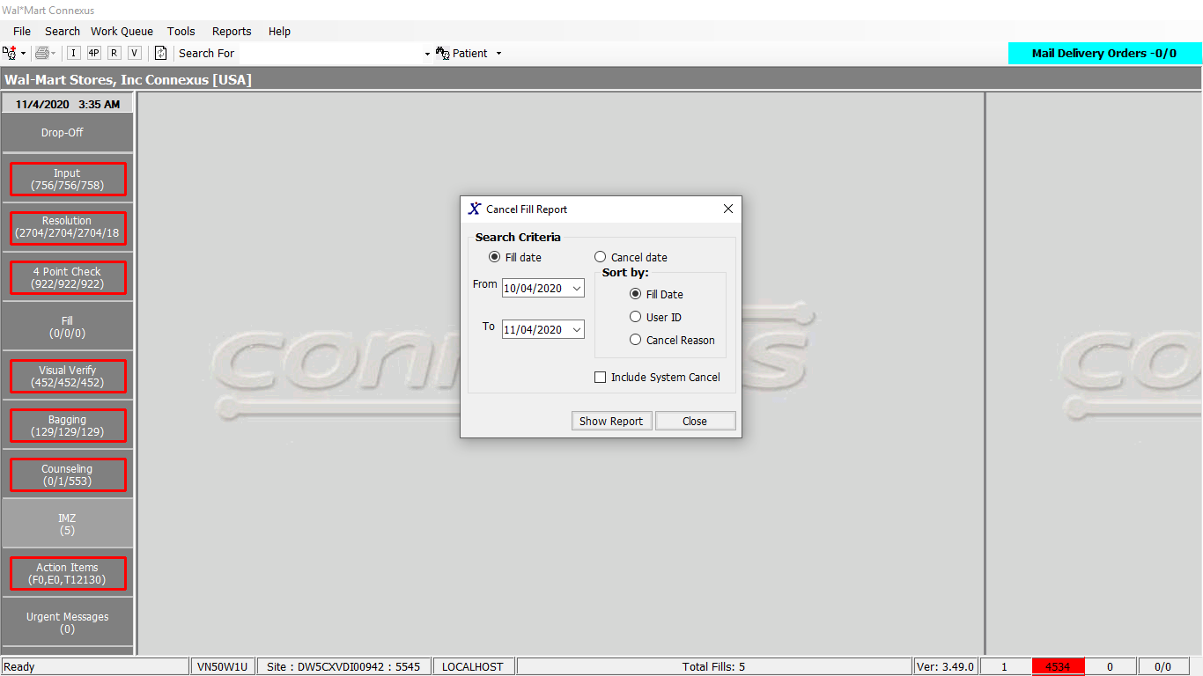

Response:

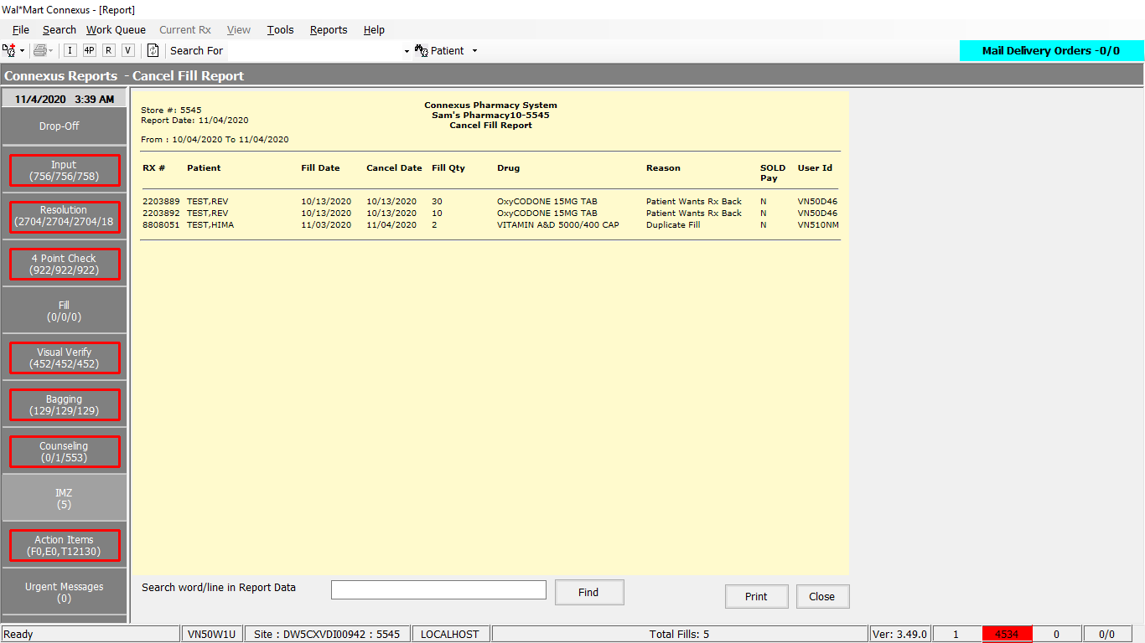

DAL Query:

1. Friend Const GetCancelFillReportDataSelectPart1 As String = "SELECT rx.rx_id, rx.rx_nbr, TRIM(NVL(pat.last_name,'')) || ',' || TRIM(NVL(pat.first_name,'')) || ' ' || TRIM(NVL(pat.middle_name,'')) pat_name, rf.rx_fill_id, rf.fill_date, date(rfa.activity_ts) cancel_date, CASE WHEN rx.compound_ind ='Y' THEN c.compound_name WHEN rx.compound_ind !='Y' THEN pp.short_name END drug_name, CASE WHEN 0 < (SELECT COUNT(*) FROM pos_activity pa WHERE pa.rx_fill_id = rf.rx_fill_id AND pos_txn_type_code = 5700) THEN 'Y' ELSE 'N' END Sold, NVL(rf.fill_qty, 0) fill_qty, "
2. Friend Const GetCancelFillReportDataSelectPart3 As String = " AND rf.rx_fill_id = rfa.rx_fill_id AND rfa.activity_code IN (29107, 29108, 29109) AND rf.rx_fill_id = rod.rx_fill_id AND rod.order_id = roda.order_id AND rod.order_seq_nbr = roda.order_seq_nbr AND roda.activity_code IN (?, ?, ?, ?,?, ?, ?, ?) AND roda.activity_seq_nbr = (SELECT MIN(roda2.activity_seq_nbr) FROM rx_ord_dtl_activty roda2 WHERE roda2.order_id = roda.order_id AND roda2.order_seq_nbr = roda.order_seq_nbr AND roda2.activity_code IN (?, ?, ?, ?, ?,?, ?, ?)) AND roda.activity_code = act.activity_code AND rf.rx_fill_id = rod1.rx_fill_id AND rod1.order_id = roda1.order_id AND rod1.order_seq_nbr = roda1.order_seq_nbr AND roda1.activity_code = ? AND roda1.activity_code = act1.activity_code AND roda1.activity_seq_nbr = (SELECT MIN(roda3.activity_seq_nbr) FROM rx_ord_dtl_activty roda3 WHERE roda3.order_id = roda1.order_id AND roda3.order_seq_nbr = roda1.order_seq_nbr AND roda3.activity_code = ? )"
3. Friend Const GetCancelFillReportDataSelectPart4 As String = " AND rfa1.rx_fill_id=rf.rx_fill_id AND rfa1.activity_code in (?, ?, ?, ?, ?, ?,?, ?,?) AND rfa1.activity_seq_nbr=(SELECT MIN(rfa2.activity_seq_nbr) FROM rx_fill_activity rfa2 WHERE rfa2.rx_fill_id = rfa1.rx_fill_id AND rfa2.activity_code in (?, ?, ?, ?, ?,?, ?, ?,?)) AND rfa1.activity_code=act2.activity_code "

# 3. Reports/ Rx Reports/ Complaince Report

Request:

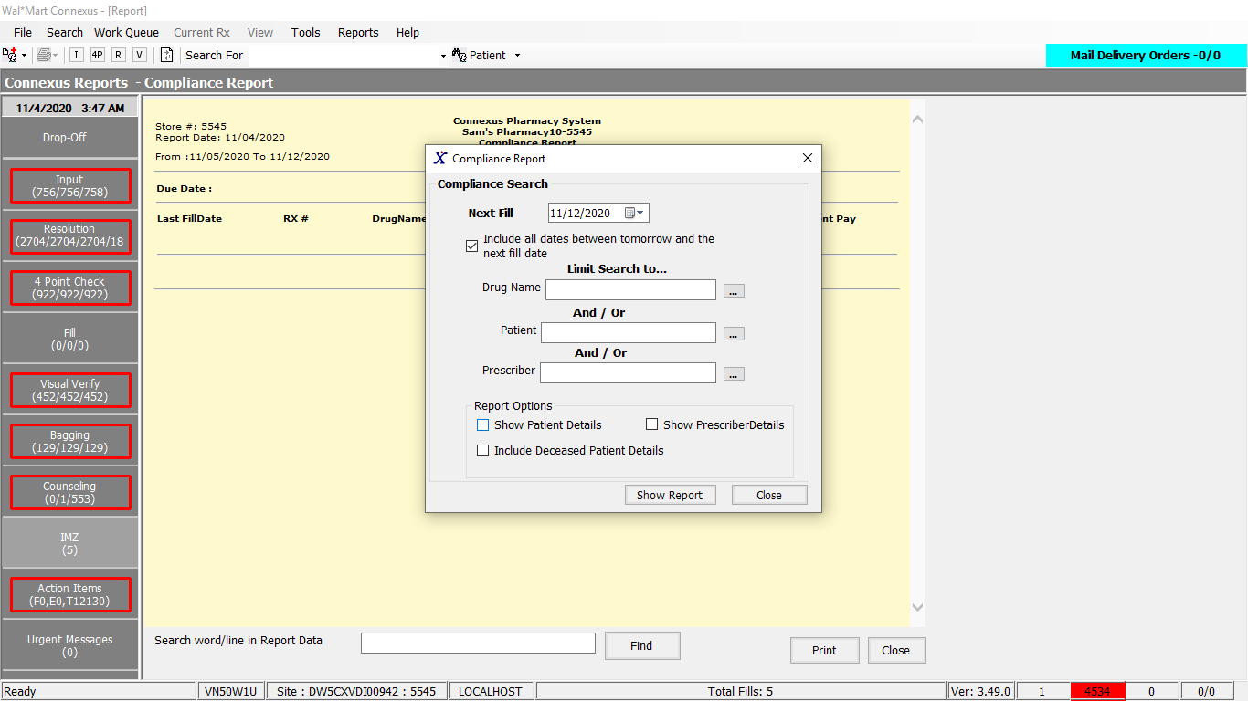

Child Popup:

Drug Name:

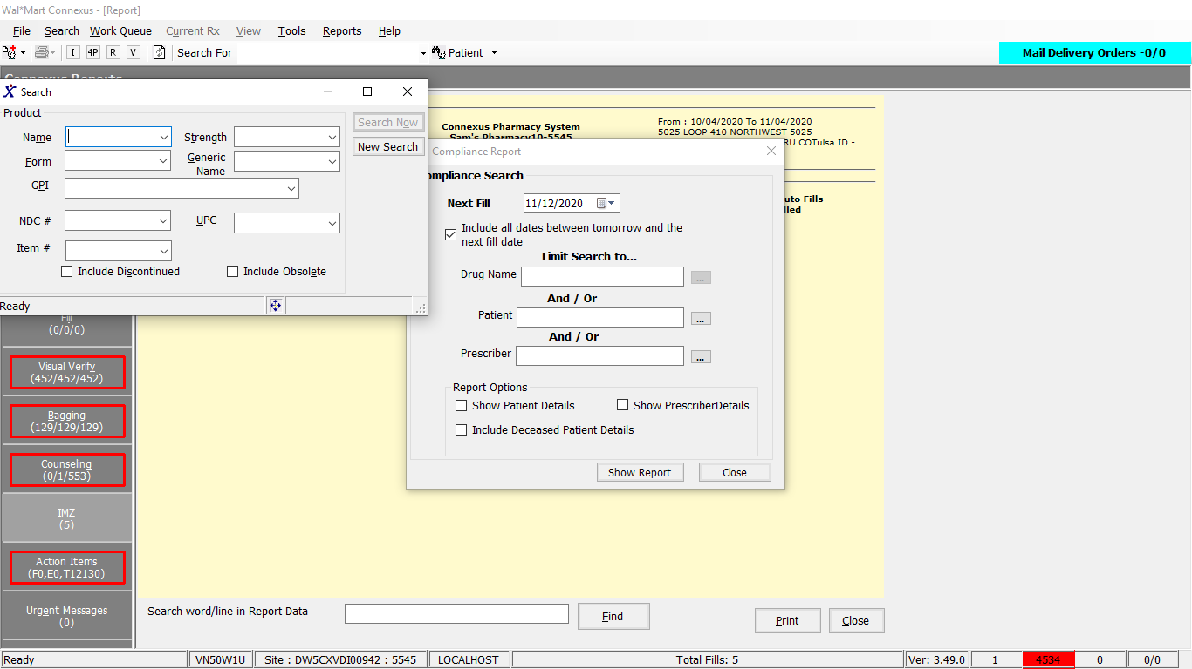

Patient Name:

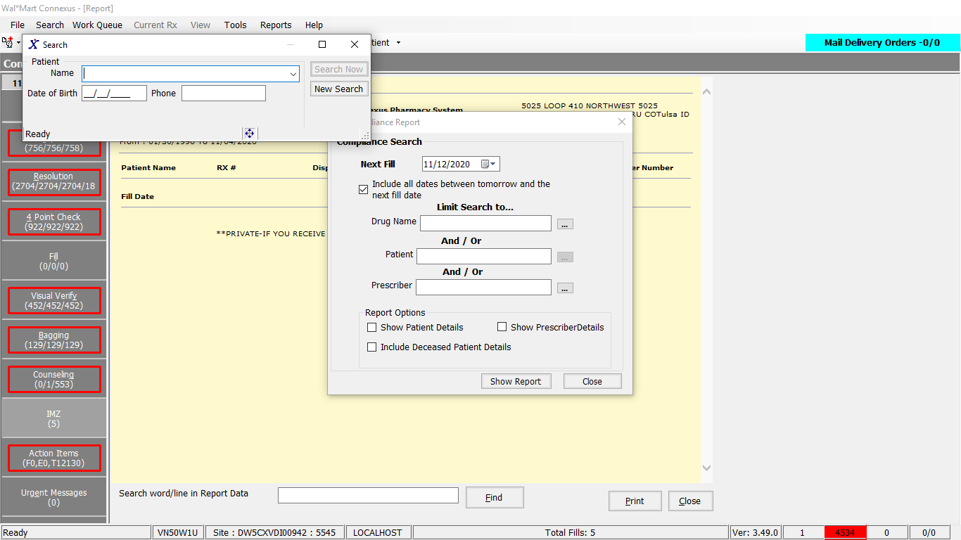

Prescriber:

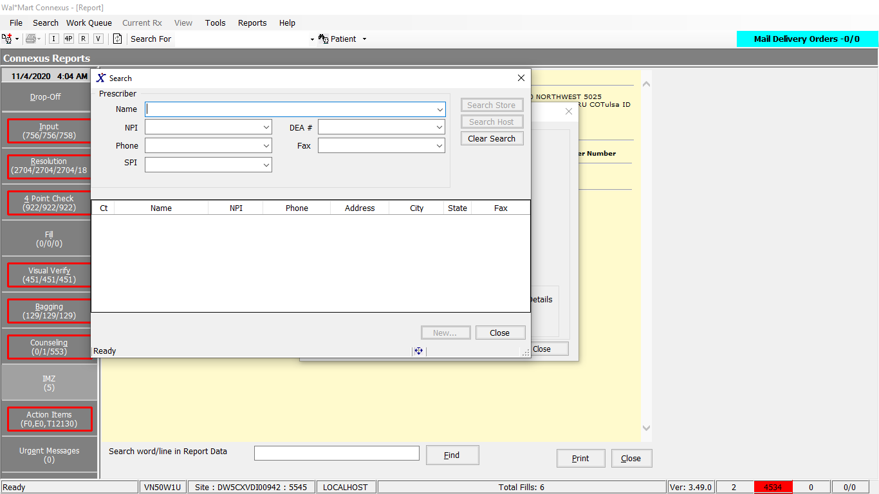

Response:

Below Screenshots are based on different input parameters

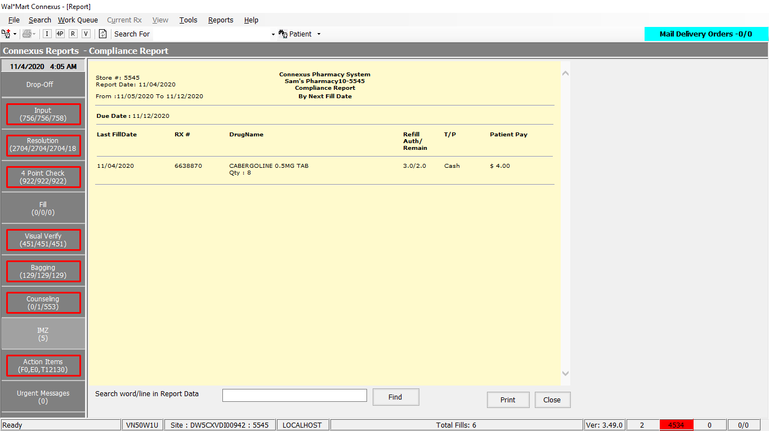

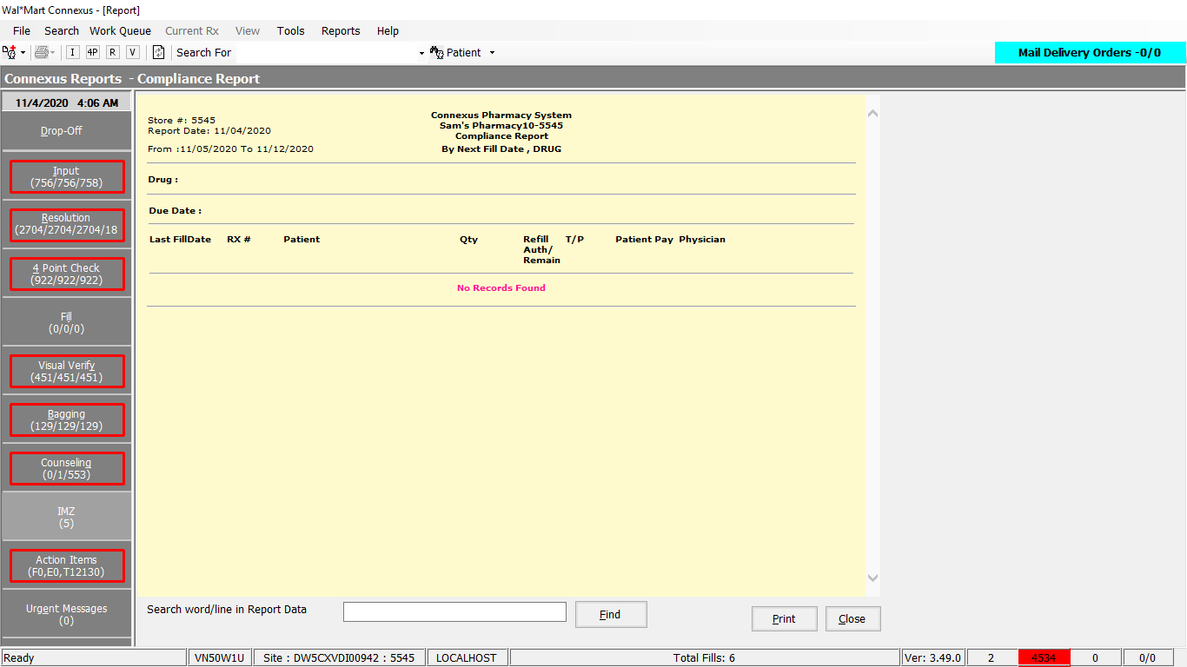

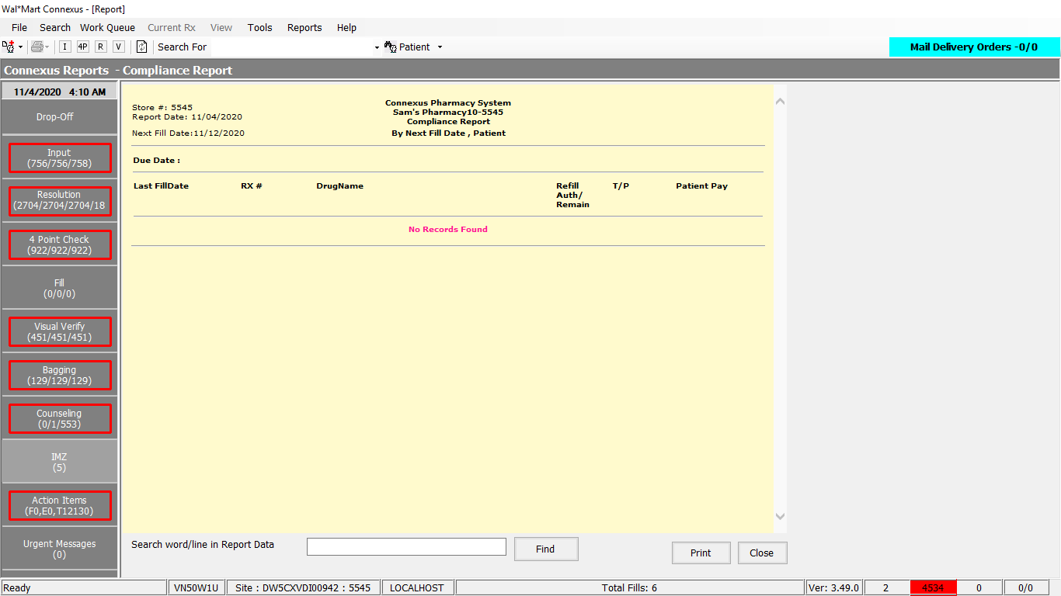

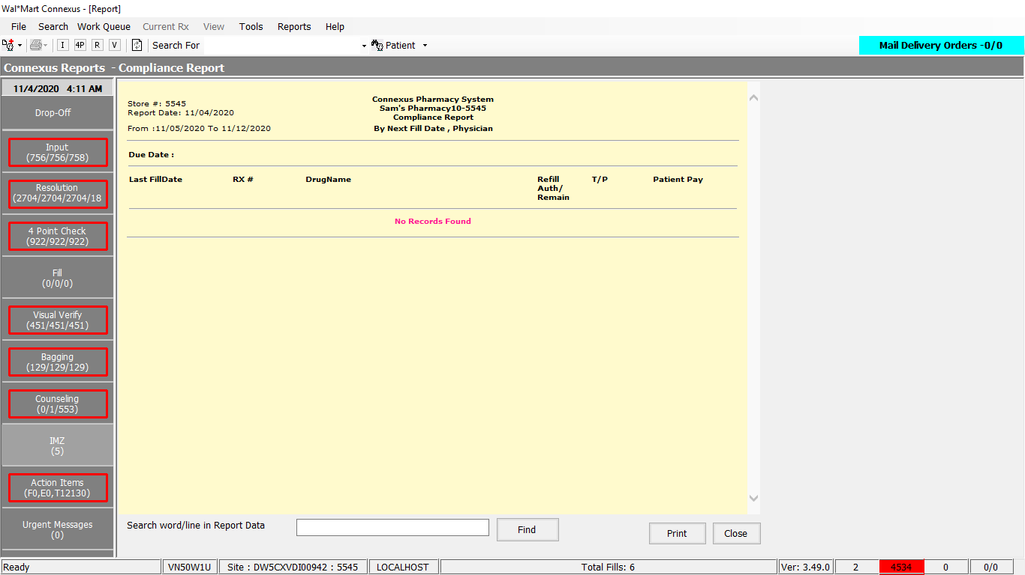

DAL Query:

1. Friend Const GetComplianceSelectPart1 As String = " SELECT rx.rx_nbr, rxf.fill_date,pa.birth_date, dr.prescriber_id," & " TRIM(NVL(pa.last_name,'')) || ', ' || TRIM(NVL(pa.first_name,'')) || ' ' || TRIM(NVL(pa.middle_name,'')) PatientName," & " TRIM(NVL(dr.last_name,'')) || ', ' || TRIM(NVL(dr.first_name,'')) || ' ' || TRIM(NVL(dr.middle_name,'')) DrName," & " NVL(rpl.license_nbr,drl.license_nbr) DEA, pp.short_name, rx.expanded_sig_txt," & " (rxf.fill_date + nvl(rxf.fill_days_sply_qty,0) UNITS DAY) nextfilldate, CASE WHEN rx.refill_auth_code IS NULL " & " THEN CAST(rx.refills_auth_nbr as VARCHAR(3)) WHEN rx.refill_auth_code IS NOT NULL THEN" & " (SELECT code_desc FROM pharmacy_code_txt WHERE code_id = rx.refill_auth_code) END refill_auth_nbr, rxf.fill_qty," & " rx.rx_written_date, rx.last_rx_fill_id, rxf.patient_due_amt, sa1.address_line_1 p_add1, sa1.address_line_2 p_add2," & " sa1.city_name p_city, sa1.state_prov_code p_state, sa1.postal_code p_postal, sa2.address_line_1 d_add1," & " sa2.address_line_2 d_add2, sa2.city_name d_city, sa2.state_prov_code d_state, sa2.postal_code d_postal," & " sc1.communication_id p_phone, sc2.communication_id d_phone, CASE WHEN rxf.third_party_ind = 'Y' Then" & " ( SELECT phm_co_name_abbr FROM phm_company WHERE phm_co_id = (SELECT aff_party_id FROM rx_sale_detail rsd" & " WHERE rsd.rx_fill_id = rxf.rx_fill_id AND rsd.txn_type_code = ? AND rsd.status_code IN (?, ?, ?, ?))) ELSE 'Cash' END TP," & " CASE WHEN rx.refill_auth_code IS NOT NULL THEN pct.code_abbr WHEN rx.refill_auth_code IS NULL AND rx.remaining_qty = 0.0" & " THEN '0' WHEN rx.refill_auth_code IS NULL AND rxf.fill_qty = 0.0 AND rx.fill_qty != 0.0 " & " THEN TRIM(CAST(ROUND(rx.remaining_qty/rx.fill_qty,1) as CHAR(6)))WHEN rx.refill_auth_code IS NULL AND rxf.fill_qty = 0.0 AND" & " rx.fill_qty = 0.0 THEN '0'ELSE TRIM(CAST(ROUND(rx.remaining_qty / rxf.fill_qty,1) AS CHAR(6)))END RefillsRemain" & " FROM rx rx, rx_fill rxf, patient pa, rx_fill_item rfi,OUTER Subject_address sa1,OUTER Subject_address sa2," & " OUTER Subject_Comm sc1, OUTER Subject_Comm sc2, prescriber dr, pharmacy_offering:pharmacy_product pp," & " pharmacy_offering:pharmacy_item pi, OUTER prescriber_license drl, OUTER rx_prsbr_license rpl, OUTER pharmacy_code_txt pct" & " WHERE rx.last_rx_fill_id = rxf.rx_fill_id AND rx.refill_auth_code = pct.code_id AND rxf.status_code = ? AND " & " rx.status_code = ? AND rxf.fill_type_code = ? AND rx.patient_id = pa.patient_id AND" & " rx.patient_id = sa1.subject_id AND sa1.subject_type_code = ? AND sa1.addr_type_code = pa.dflt_addr_type_cd " & " AND rx.prescriber_id = dr.prescriber_id AND dr.prescriber_id > 0 AND rx.prescriber_id = sa2.subject_id " & " AND sa2.subject_type_code = ? AND sa2.address_seq_nbr = ? AND sc1.subject_type_code = ? AND " & " sc1.comm_method_code = ? AND sc1.comm_seq_nbr= ( case when pa.dflt_addr_type_cd = 3 then 1 else 10 end ) " & " AND rx.patient_id= sc1.subject_id AND sc2.subject_type_code = ? AND sc2.comm_method_code = ?

" & " AND rx.prescriber_id= sc2.subject_id AND sc2.comm_seq_nbr = ? AND rx.prescriber_id = drl.prescriber_id" & " AND drl.license_seq_nbr = (SELECT MIN(drls.license_seq_nbr) FROM prescriber_license drls WHERE" & " drls.prescriber_id = drl.prescriber_id AND (drls.expiration_date IS NULL OR drls.expiration_date >= TODAY) " & " AND (drls.effective_date is NULL OR drls.effective_date <= TODAY) "

2. Friend Const GetComplianceSelectPart2 As String = " AND rpl.rx_id = rx.rx_id AND rpl.prescriber_id = rx.prescriber_id AND rpl.license_type_code = ? AND (((SELECT count(rfa1.activity_code) FROM rx_fill_activity rfa1 WHERE rfa1.rx_fill_id = rxf.rx_fill_id AND rfa1.activity_code = 15116) > 0 AND rpl.license_nbr like 'X%') OR ((SELECT count(rfa2.activity_code) FROM rx_fill_activity rfa2 WHERE rfa2.rx_fill_id = rxf.rx_fill_id AND rfa2.activity_code = 15115) > 0 AND rpl.license_nbr not like 'X%') OR ((SELECT count(rfa2.activity_code) FROM rx_fill_activity rfa2 WHERE rfa2.rx_fill_id = rxf.rx_fill_id AND rfa2.activity_code in (15115,15116)) = 0)) AND rxf.rph_of_rec_userid is not NULL AND rxf.rph_of_rec_userid <> '' AND rxf.rx_fill_id = rfi.rx_fill_id AND rfi.item_seq_nbr = 1 AND rfi.item_mds_fam_id = pi.mds_fam_id AND pi.product_mds_fam_id = pp.product_mds_fam_id AND ((rx.refills_auth_nbr > 0 AND rx.remaining_qty > 0) or (rx.refill_auth_code is not null)) AND rx.rx_exp_date > (rxf.fill_date + nvl(rxf.fill_days_sply_qty,0) UNITS DAY) AND rx.rx_exp_date > (TODAY + 1 UNITS DAY) AND rx.patient_id > 0 AND rx.rx_nbr IS NOT NULL "

# 4. Reports/ Rx Reports/ On Hold Report

Request

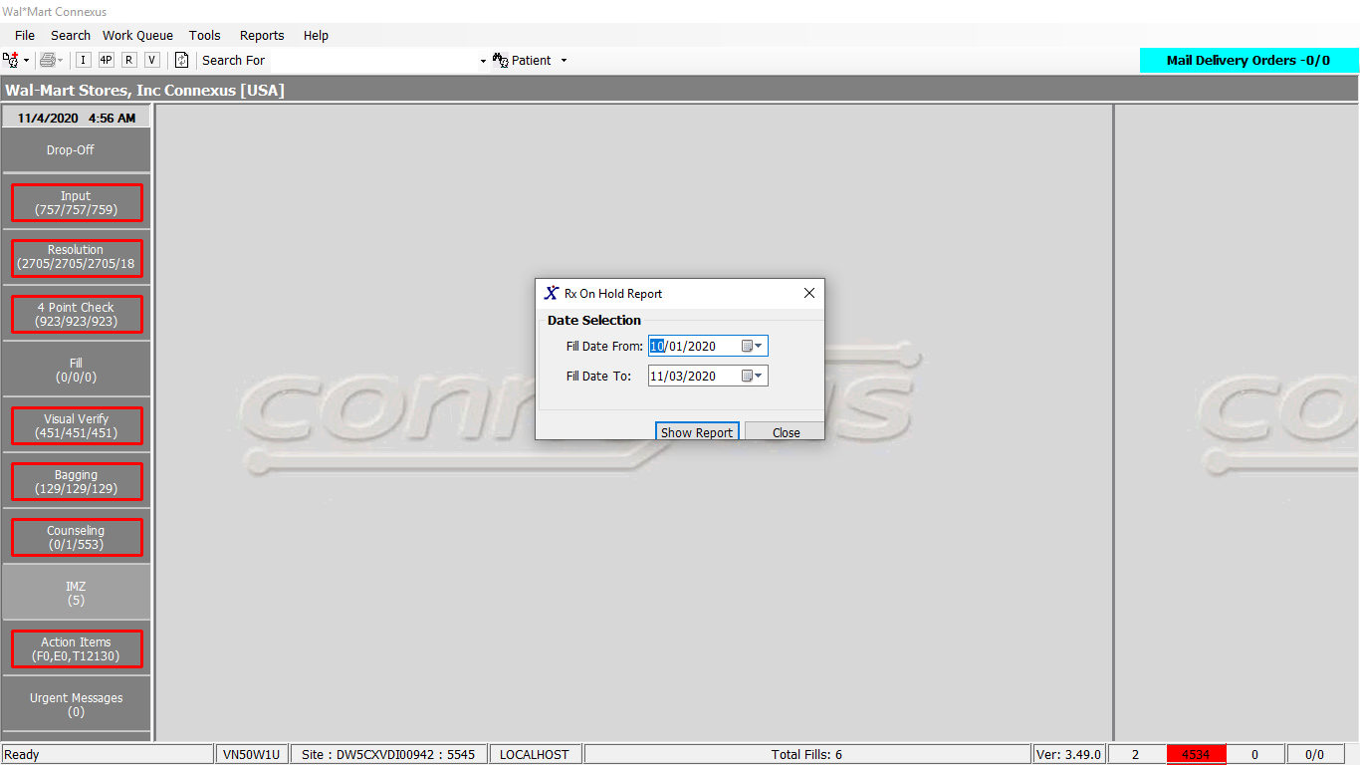

Response:

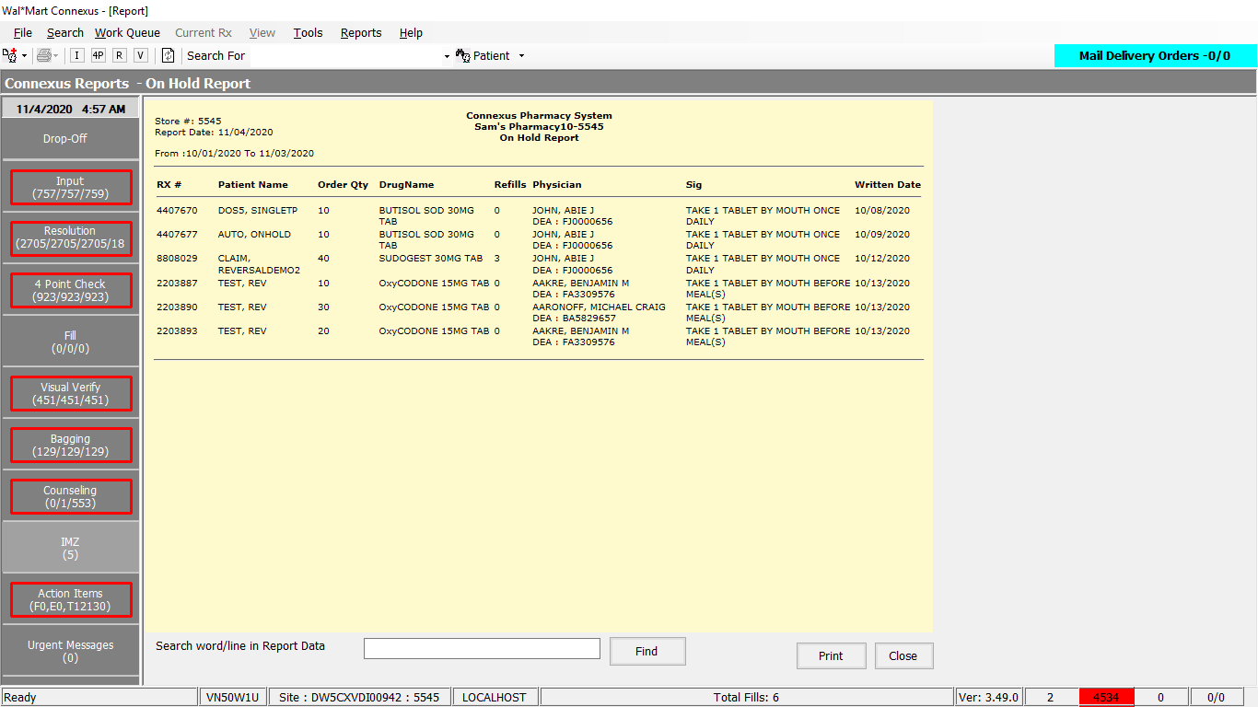

DAL

Query:

GetOnHoldReportSelectPart1 As String = " SELECT rx.rx_nbr, TRIM(NVL(pa.last_name,'')) || ', ' || TRIM(NVL(pa.first_name,'')) || ' ' || TRIM(NVL(pa.middle_name,'')) PatientName, TRIM(NVL(dr.last_name,'')) || ', ' || TRIM(NVL(dr.first_name,'')) || ' ' || TRIM(NVL(dr.middle_name,'')) DrName, NVL(rpl.license_nbr,drl.license_nbr) DEA, pp.short_name, Trim(NVL(rx.expanded_sig_txt,'')) Sig, CASE WHEN rx.refill_auth_code IS NULL THEN CAST(rx.refills_auth_nbr as VARCHAR(3)) WHEN rx.refill_auth_code IS NOT NULL THEN (SELECT code_desc FROM pharmacy_code_txt WHERE code_id = rx.refill_auth_code) END refill_auth_nbr, rxf.fill_qty, rx.rx_written_date, rx.last_rx_fill_id " Friend Const GetOnHoldReportSelectPart2 As String = " patient pa, prescriber dr, rx_fill_item rfi, pharmacy_offering:pharmacy_product pp, pharmacy_offering:pharmacy_item pi, OUTER prescriber_license drl, OUTER rx_prsbr_license rpl WHERE rx.patient_id > 0 " Friend Const GetOnHoldReportSelectPart3 As String = " AND rx.rx_nbr IS NOT NULL AND rx.patient_id = pa.patient_id AND rx.last_rx_fill_id = rxf.rx_fill_id AND rx.prescriber_id = dr.prescriber_id AND dr.prescriber_id > 0 AND dr.prescriber_id = drl.prescriber_id AND rpl.rx_id = rx.rx_id AND rpl.prescriber_id = rx.prescriber_id AND drl.license_seq_nbr = (SELECT MIN (drls.license_seq_nbr) FROM prescriber_license drls WHERE drls.prescriber_id = dr.prescriber_id AND (drls.expiration_date IS NULL OR drls.expiration_date >= TODAY) AND (drls.effective_date is NULL OR drls.effective_date <= TODAY) " Friend Const GetOnHoldReportSelectPart4 As String = " AND rxf.rx_fill_id = rfi.rx_fill_id AND rfi.item_seq_nbr = 1 AND rfi.item_mds_fam_id = pi.mds_fam_id AND pi.product_mds_fam_id = pp.product_mds_fam_id AND rx.status_code = 20604" Friend Const GetOnHoldReportSelectPart5 As String = " AND rod.rx_id = rx.rx_id AND rod.rx_fill_id = rxf.rx_fill_id AND roda.order_id = rod.order_id AND roda.order_seq_nbr = rod.order_seq_nbr AND roda.activity_seq_nbr = (SELECT NVL(MAX(roda1.activity_seq_nbr),0) FROM rx_ord_dtl_activty roda1 WHERE roda1.order_id = rod.order_id AND roda1.order_seq_nbr= rod.order_seq_nbr AND roda1.activity_code = ( 1141 )) AND roda.activity_code = 1141 AND rod.request_type_code = 1602 AND (DATE(roda.activity_ts) >= ? AND DATE(roda.activity_ts) <= ? )"

# 5.Reports/ Rx Reports/ Wait For Drug Report

Request:

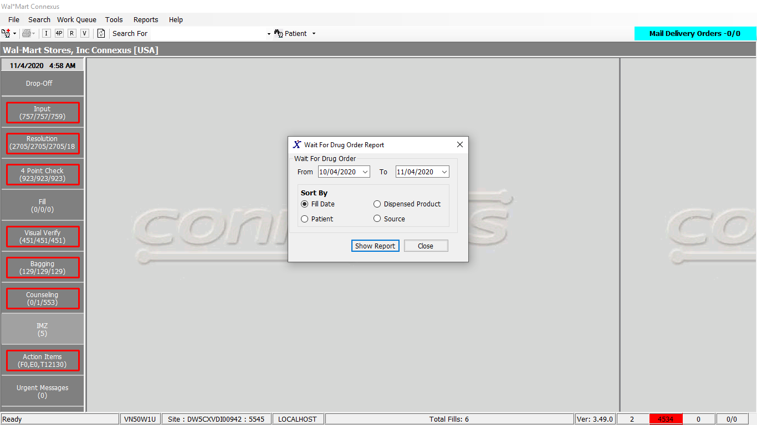

Response:

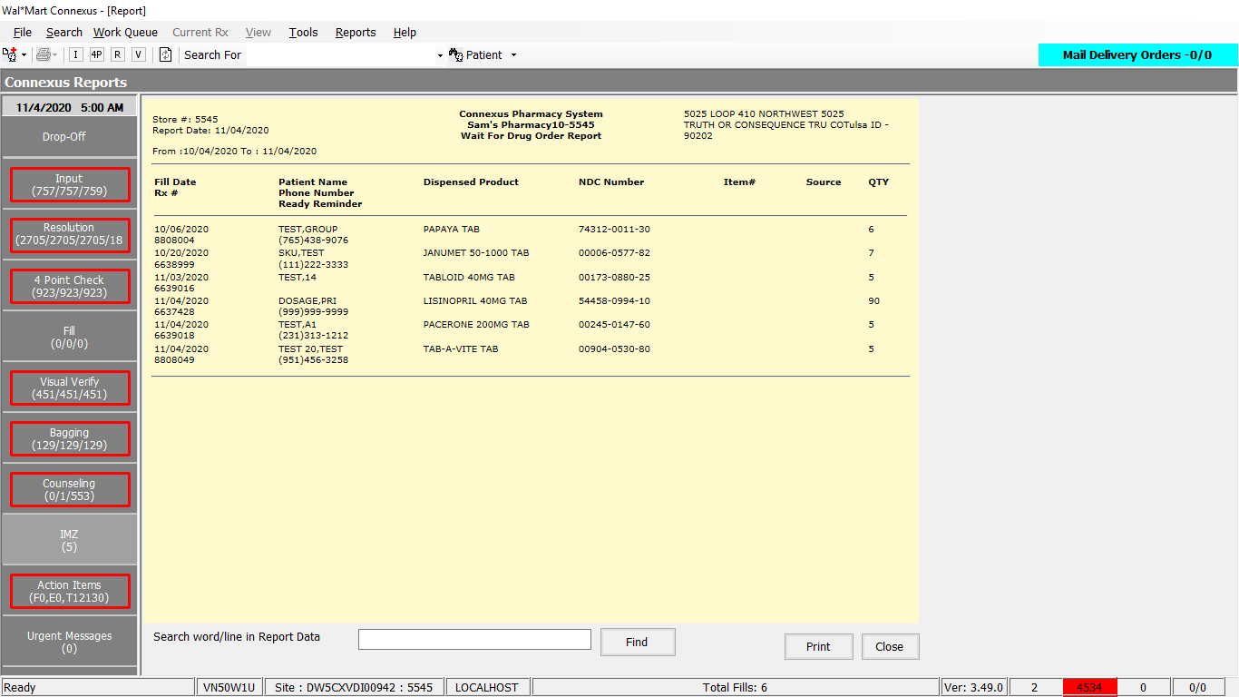

DAL:

Friend Const WaitForDrugOrderQuery As String = "SELECT pi.mds_fam_id, rxf.fill_date, trim(nvl(pt.last_name,'')) || ',' || trim(nvl(pt.first_name,'')) || ' ' || trim(nvl(pt.middle_name,'')) Name," &

# 6.Reports/ Rx Reports/ Partial Fill Report

Request:

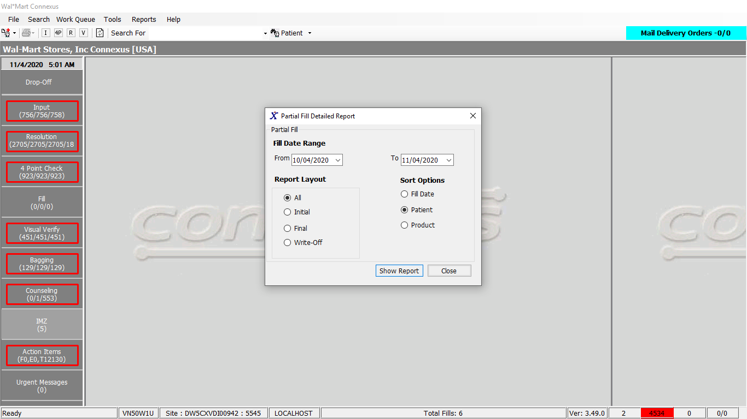

Response:

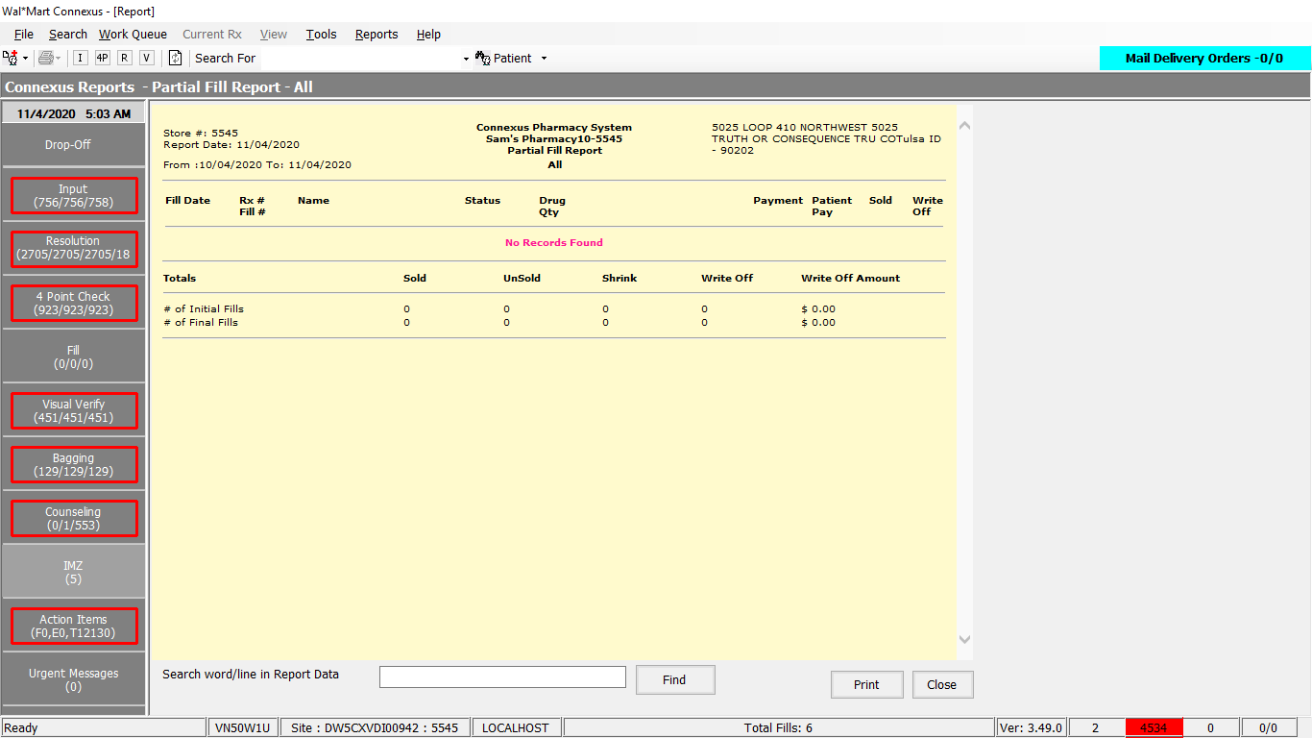

DAL:

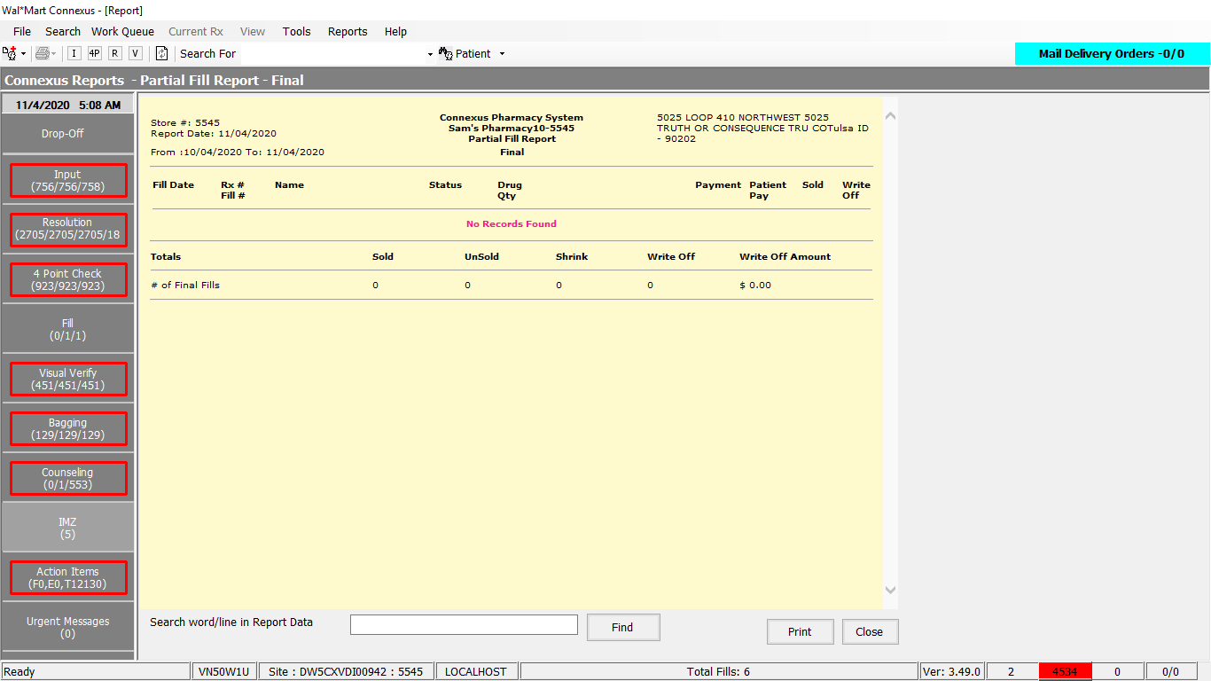

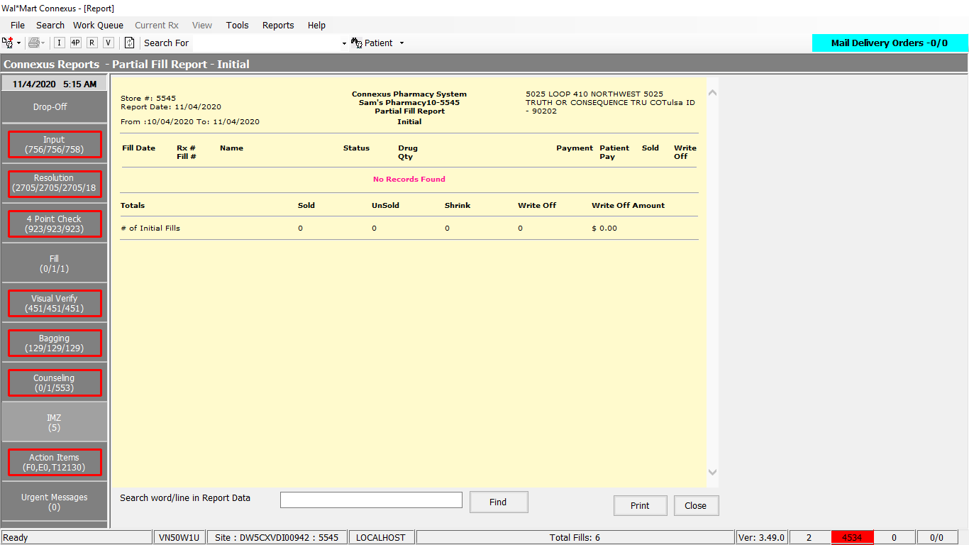

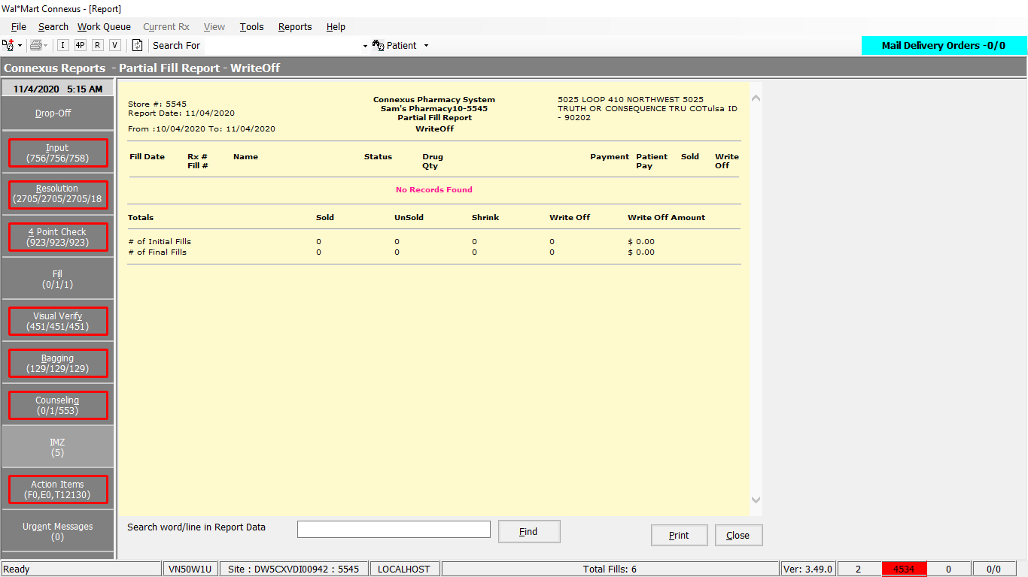

DAL:

GetPartialFillReportSelectPart1 As String = "SELECT rx_nbr,rxf.fill_date,rxf.rx_fill_id, TRIM(NVL(pat.last_name,'')) || ',' || TRIM(NVL(pat.first_name,'')) || ' ' || TRIM(NVL(pat.middle_name,'')) Name, rxf.fill_type_code,rxf.fill_qty, CASE WHEN rx.compound_ind = 'N' THEN TRIM(pp.short_name) WHEN rx.compound_ind = 'Y' THEN TRIM(co.compound_name) END drug_name, (SELECT phm_co_name_abbr FROM phm_company WHERE phm_co_id = (SELECT aff_party_id FROM rx_sale_detail rsd WHERE rsd.rx_fill_id = rxf.rx_fill_id AND rsd.txn_type_code = 21400 AND rsd.status_code IN (21011,21002,21005,21010))) TP, rxf.patient_due_amt,rx.rx_check_userid,rxf.rph_of_rec_userid,rxf.pos_ts,rxf.third_party_ind,rxf.status_code, CASE WHEN rxf.fill_type_code = 7002 THEN (SELECT rxf1.status_code FROM partial_fill pf,rx_fill rxf1 WHERE pf.init_partl_fill_id = rxf.rx_fill_id AND pf.init_partl_fill_id = rxf1.rx_fill_id AND rxf1.rx_fill_id = rxf.rx_fill_id) WHEN rxf.fill_type_code = 7003 THEN (SELECT rxf1.status_code FROM partial_fill pf,rx_fill rxf1 WHERE pf.fnl_partl_fill_id = rxf.rx_fill_id AND pf.fnl_partl_fill_id = rxf1.rx_fill_id AND rxf1.rx_fill_id = rxf.rx_fill_id) END part_status_code,rxf.pos_sale_amt,rxf.rx_id,rxf.rx_fill_seq_nbr FROM rx, OUTER (rx_compound rxc, compound co), patient pat, rx_fill rxf, rx_fill_item rfi, pharmacy_offering:pharmacy_item pi, pharmacy_offering:pharmacy_product pp WHERE rxf.rx_id = rx.rx_id AND rxf.rx_version_seq_nbr = rx.rx_version_seq_nbr AND rx.patient_id = pat.patient_id AND rfi.rx_fill_id = rxf.rx_fill_id AND ("

Friend Const GetPartialFillReportSelectPart2 As String = " AND rxf.fill_date >= ? AND rxf.fill_date <= ? AND rxc.rx_id = rx.rx_id AND co.compound_id = rxc.compound_id AND pi.product_mds_fam_id = pp.product_mds_fam_id AND rfi.item_mds_fam_id = pi.mds_fam_id AND rfi.item_seq_nbr = (SELECT NVL(MIN(rfi2.item_seq_nbr),1) FROM rx_fill_item rfi2 WHERE rfi2.rx_fill_id = rfi.rx_fill_id) AND rxf.emergency_fill_ind = 'N' GROUP BY 1,2,3,4,5,6,7,8,9,10,11,12,13,14,15,16,17,18 "

# 7.Reports/ Rx Reports/Current on-hold Inventory method

The landing pages of the report is as shown:

Detailed Report:

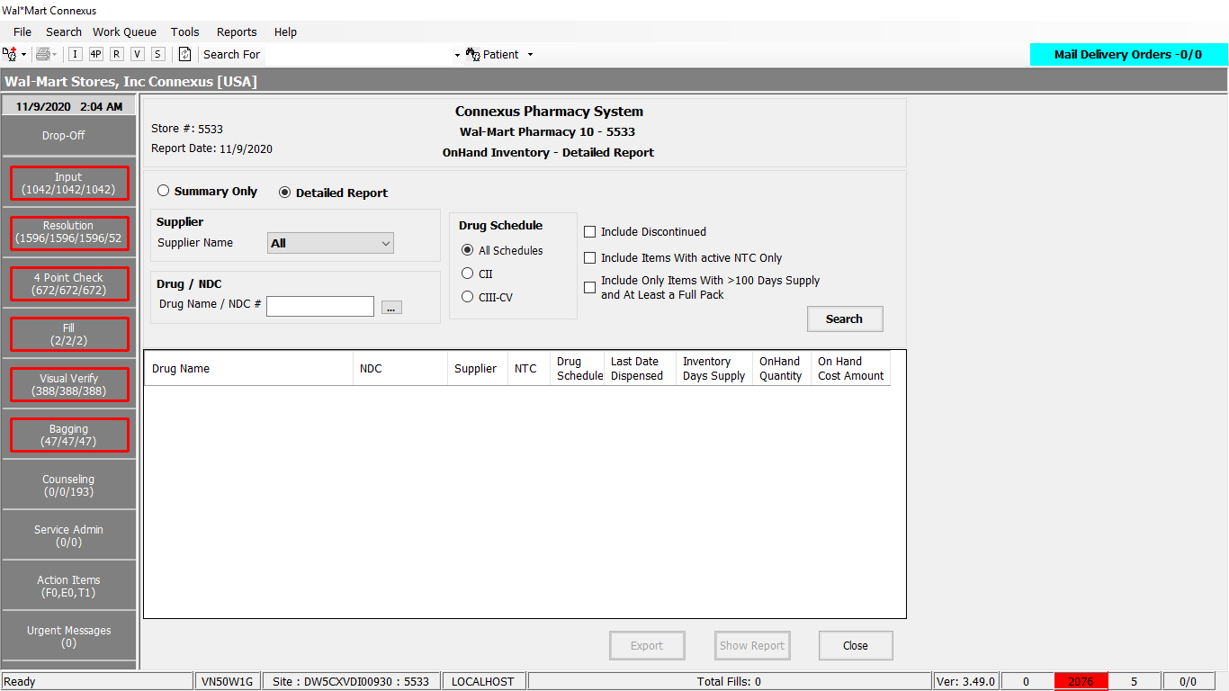

Summary Report: (“Summary Only” Check box)

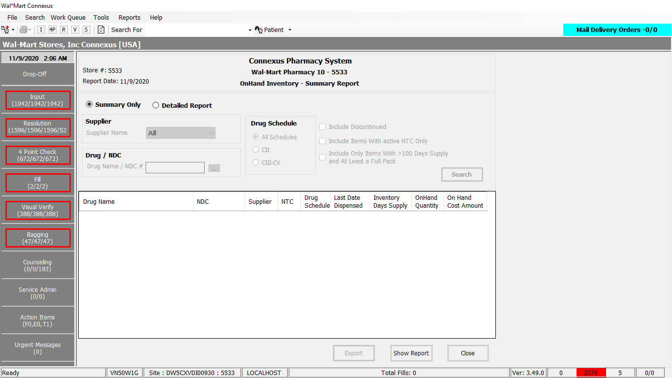

Child View for “Drug/NDC” :

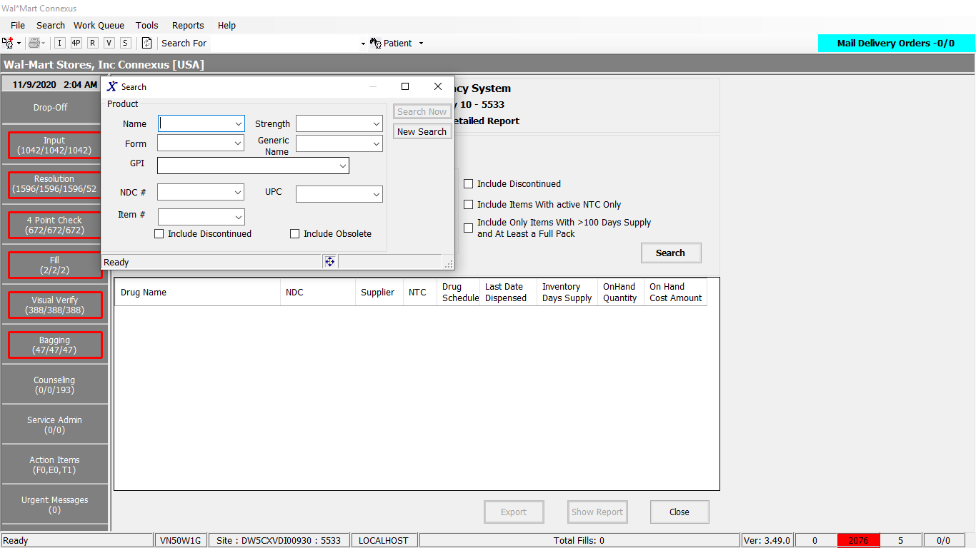

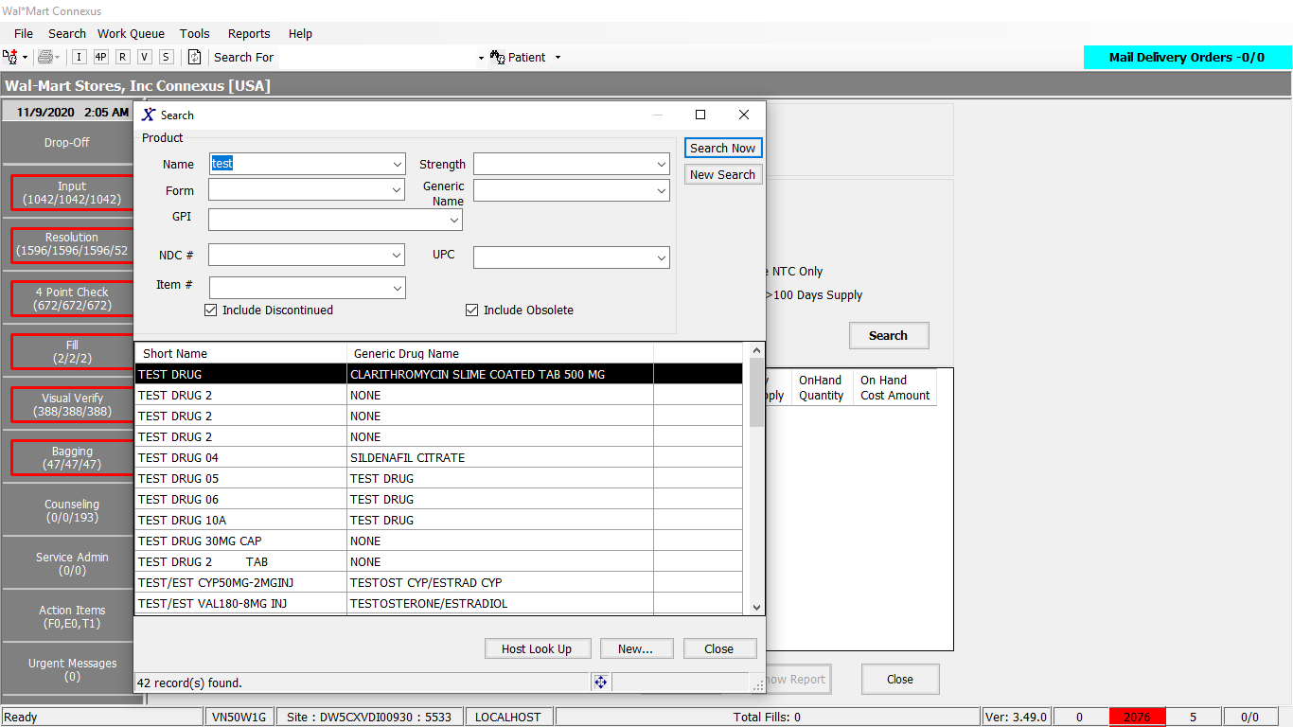

Responses: (also PDF’s have attached in the mail)

Detailed:

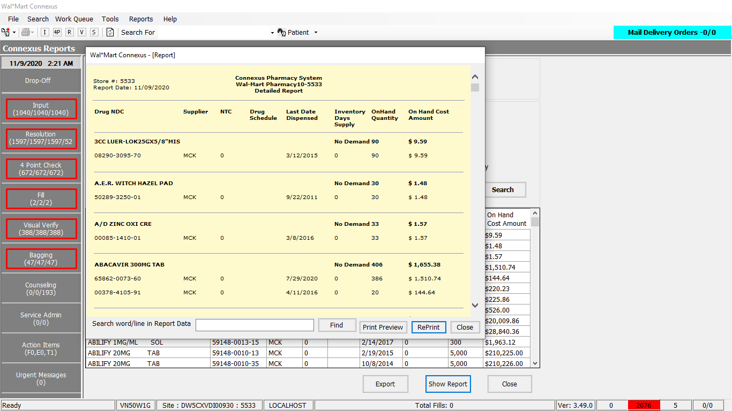

Summary:

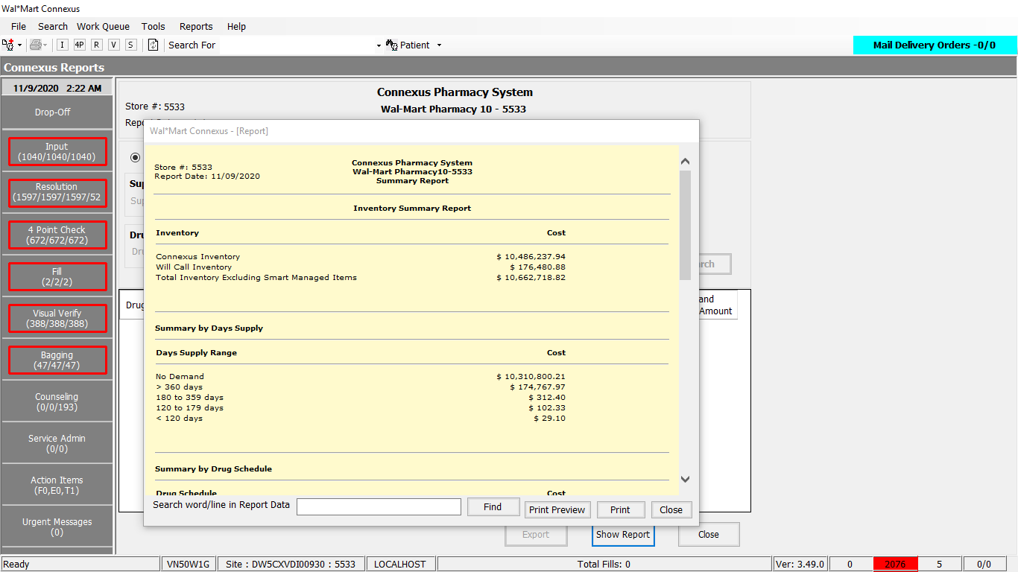

DAL Queries:

1.Friend Const GetOnHandKioskInventoryReportData As String = "SELECT pp.short_name, temp_pc.phm_co_name_abbr ,pp.drug_control_code,pi.mds_fam_id ,pic.phm_item_cost_amt " &

                                                                   "FROM Pharmacy_offering:pharmacy_item pi " &

                                                                    "Join pharmacy_offering:pharmacy_product pp " &

                                                                      "ON pp.product_mds_fam_id = pi.product_mds_fam_id " &

                                                                    "JOIN pharmacy_offering:phm_item_cost pic " &

                                                                      "ON pic.mds_fam_id = pi.mds_fam_id " &

                                                                         "AND pic.cost_type_code = ? " &

                                                                         "AND pic.effective_date = (SELECT MAX(pic2.effective_date) " &

                                                                                                 "FROM pharmacy_offering:phm_item_cost pic2 " &

                                                                                                 "WHERE pi.mds_fam_id = pic2.mds_fam_id " &

                                                                                                 "AND pic2.cost_type_code = ?) " &

                                                                   "LEFT OUTER JOIN (Select pc.phm_co_name_abbr ,pir.mds_fam_id, pir.phm_co_id  " &

                                                                                          "From pharmacy_offering:phm_item_repl pir " &

                                                                                          "JOIN rx21c:phm_company pc On  ( pir.phm_co_id = pc.phm_co_id And pc.phm_co_type_cd = ? ) " &

                                                                                          "WHERE pri_supplier_ind = 'Y') temp_pc  " &

                                                                      "On pi.mds_fam_id = temp_pc.mds_fam_id " &

                                                                   "WHERE pi.status_code = ? AND pic.mds_fam_id IN ({0}) order by pp.short_name "

2.     Friend Const GetOnHandSummaryReportData As String = "SELECT pp.drug_control_code,  SUM(pi.on_hand_qty * pic1.phm_item_cost_amt) on_hand_retail_amount  " &

                "FROM pharmacy_offering:pharmacy_item pi, " &

                "pharmacy_offering:pharmacy_product pp, " &

                "pharmacy_offering:phm_item_cost pic1 " &

                "WHERE pic1.cost_type_code = 3001 " &

                "AND pi.product_mds_fam_id = pp.product_mds_fam_id " &

                "AND pi.mds_fam_id = pic1.mds_fam_id " &

                "AND pic1.effective_date = ( SELECT MAX(pic2.effective_date) " &

                "FROM pharmacy_offering:phm_item_cost pic2 " &

                " WHERE pic2.cost_type_code = 3001 " &

                " AND pic2.mds_fam_id = pi.mds_fam_id) " &

                "AND pi.status_code in(20909,20910) " &

                "GROUP BY 1 ORDER BY 1 "

3.  Public Const WilCalValueInfo As String = "SELECT sum(rxf.fill_item_qty*pic.phm_item_cost_amt) as InvValue " &

                                                    " FROM rx21c:pharmacy_bu pb, rx21c:rx_fill rf " &

                                                    " JOIN rx21c:rx_fill_item rxf ON rf.rx_fill_id = rxf.rx_fill_id " &

                                                    " JOIN rx21c:rx_order_detail rod ON rf.rx_fill_id =rod.rx_fill_id " &

                                                    " JOIN pharmacy_offering:phm_item_cost pic  ON ( pic.mds_fam_id = rxf.item_mds_fam_id " &

                                                    " AND pic.cost_type_code = 3001  AND pic.effective_date = (SELECT MAX(effective_date) " &

                                                    " FROM pharmacy_offering:phm_item_cost pic2 " &

                                                    " WHERE pic2.mds_fam_id=rxf.item_mds_fam_id  AND pic2.cost_type_code = 3001 ))   " &

                                                    " WHERE rf.tech_of_rec_userid is not null " &

                                                    " AND rf.status_code = 20401 " &

                                                    " AND rod.status_code = 20501 " &

                                                    " AND rod.need_pickup_ind = 'Y' "

4. Public Const InvValueInfo As String = "SELECT SUM(pi.on_hand_qty*pic.phm_item_cost_amt) as InvValue " &

            " FROM pharmacy_offering:pharmacy_item pi " &

            " JOIN pharmacy_offering:phm_item_cost pic  ON ( pi.mds_fam_id = pic.mds_fam_id  " &

            " AND pic.cost_type_code = 3001  AND pic.effective_date = (SELECT MAX(effective_date) " &

            " FROM pharmacy_offering:phm_item_cost pic2  " &

            " WHERE pi.mds_fam_id = pic2.mds_fam_id   AND pic2.cost_type_code = 3001 ))  "

5. Public Const top5DrugsByCostInventoryData As String = " SELECT first 5 pi.ndc_nbr ndc, pp.short_name, " &

                                                                " (pic.phm_item_cost_amt * pi.on_hand_qty) item_on_hand_cost " &

                                                                " FROM pharmacy_offering:pharmacy_item pi, " &

                                                                " pharmacy_offering:pharmacy_product pp, " &

                                                                " pharmacy_offering:phm_item_cost pic " &

                                                                " WHERE pi.product_mds_fam_id=pp.product_mds_fam_id " &

                                                                " and pi.mds_fam_id = pic.mds_fam_id " &

                                                                " and pi.on_hand_qty > 0 " &

                                                                " AND pic.cost_type_code = 3001 " &

                                                                " AND pic.effective_date = (SELECT MAX(effective_date) " &

                                                                " FROM pharmacy_offering:phm_item_cost pic2 " &

                                                                " WHERE pi.mds_fam_id = pic2.mds_fam_id " &

                                                                " AND pic2.cost_type_code = 3001 ) " &

                                                                " ORDER BY item_on_hand_cost DESC "

6.  Public Const LocationDataForInventorySummaryReport As String = " SELECT " &

                                                                   "  SUM (pic.phm_item_cost_amt * pi.on_hand_qty) item_on_hand_cost, " &

                                                                    " NVL(pir.issued_id_nbr,     ''     ) AS location " &

                                                             " FROM " &

                                                                    " pharmacy_offering:pharmacy_item pi, " &

                                                                    " pharmacy_offering:phm_item_cost pic, " &

                                                                    " OUTER(pharmacy_offering:phm_item_ref pir) " &

                                                             " WHERE " &

                                                                    " pi.mds_fam_id = pic.mds_fam_id " &

                                                                    " AND pi.on_hand_qty > 0 " &

                                                                    " AND pic.cost_type_code = 3001 " &

                                                                    " AND pic.effective_date =(SELECT MAX( effective_date ) " &

                                                                           " FROM pharmacy_offering:phm_item_cost pic2 " &

                                                                           " WHERE pi.mds_fam_id = pic2.mds_fam_id " &

                                                                                  " AND pic2.cost_type_code = 3001 ) " &

                                                                    " AND pir.mds_fam_id = pi.mds_fam_id GROUP BY location "

7.  Public Const onHandSummaryDaysSupplyReportData As String = " SELECT distinct pi.ndc_nbr, " &

                                                                    " pp.short_name, " &

                                                                    " ((pi.on_hand_qty /(sum(rfi.fill_item_qty)/120))::INT) item_days_supply , " &

                                                                    " pi.on_hand_qty, " &

                                                                    " (pic.phm_item_cost_amt * pi.on_hand_qty) item_on_hand_cost " &

                                                                    " from " &

                                                                    " pharmacy_offering:pharmacy_item pi, " &

                                                                    " pharmacy_offering:pharmacy_product pp, " &

                                                                    " pharmacy_offering:phm_item_cost pic, " &

                                                                    " OUTER (rx21c:rx_fill rf, " &

                                                                    " rx21c:rx_fill_item rfi) " &

                                                                    " where rf.rx_fill_id = rfi.rx_fill_id " &

                                                                    " and rfi.item_mds_fam_id = pi.mds_fam_id " &

                                                                    " and pi.product_mds_fam_id = pp.product_mds_fam_id " &

                                                                    " and pi.mds_fam_id = pic.mds_fam_id " &

                                                                    " and rf.status_code = 20401 " &

                                                                    " and date(rf.pos_ts) > today - 120 " &

                                                                    " and pic.cost_type_code = 3001 " &

                                                                    " AND pi.on_hand_qty > 0 " &

                                                                    " and pic.effective_date in (SELECT MAX(effective_date) " &

                                                                    " FROM pharmacy_offering:phm_item_cost pic2 " &

                                                                    " WHERE pi.mds_fam_id = pic2.mds_fam_id " &

                                                                    " AND pic2.cost_type_code = 3001 ) " &

                                                                    " group by 1,2,4,5 " &

                                                                    " order by item_days_supply DESC "

# 8. Reports Menu/HIPAA/Insurance Auditing

Request:

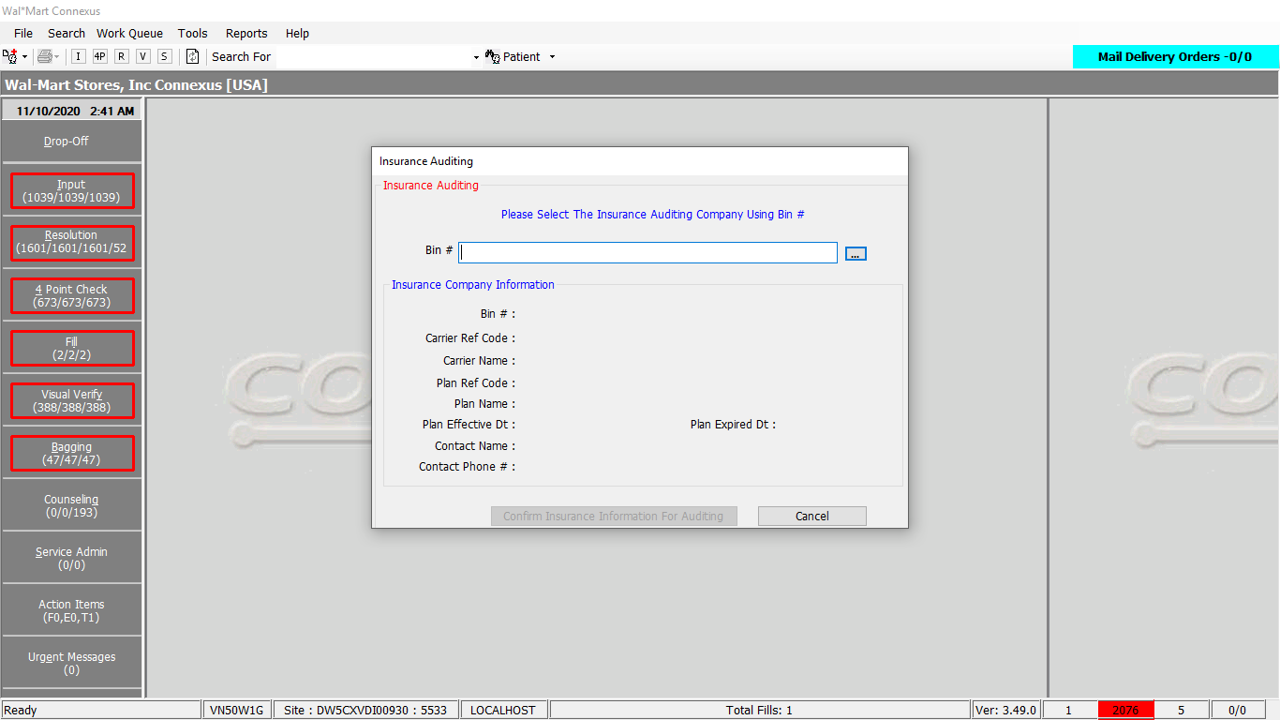

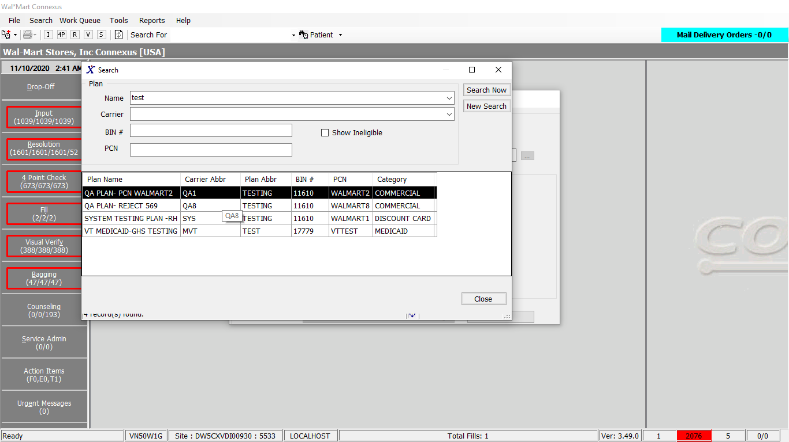

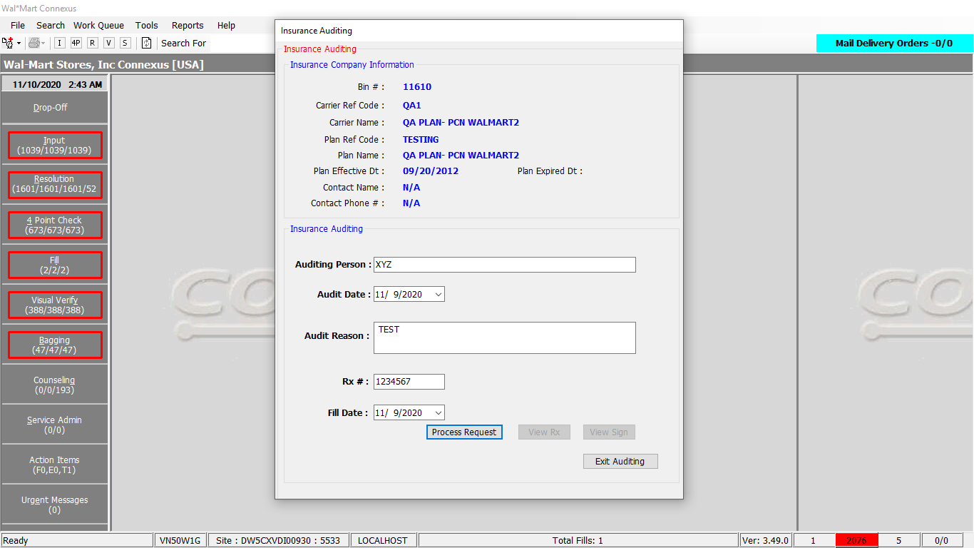

**Query:**

Friend Const GetHIPAAInsuranceInfoCall As String = "{Call hipaaInsuranceInfo(?,?,?)}"

**Procedure:**

**create** **procedure** hipaainsuranceinfo(rxnbr **integer**,

ibinnbr **integer**,dtrxfilldate **date**,

idebug **smallint** **default** 0)

**RETURNING** **integer**,**integer**, **integer**,**DATE**,**char**(1),**char**(30),**char**(40),**integer**,**integer**,**date**,**decimal**(9,4),**decimal**(9,4),**smallint**,**smallint**,

**datetime** **year** **to** **second**,**integer**,**decimal**(9,2),**decimal**(9,2),

**char**(30),**char**(13),**decimal**(9,4),**varchar**(90),

**date**,**char**(1),**char**(35),**char**(35),**char**(30),**char**(25),**char**(2),

**char**(10),**varchar**(90),**char**(35),**char**(35),**char**(30),**char**(30),**char**(25),

**char**(2),**char**(10),**varchar**(30),**smallint**,**integer**,**integer**,**decimal**(7,2),

**char**(20),**smallint**,**smallint**,**decimal**(9,2);

**define** irxnbr **integer**;

**define** irxid **integer**;

**define** ipresID **integer**;

**define** dtrx_written_date **DATE**;

**define** ccompound_ind **char**(1);

**define** cpres_prod_name **char**(30);

**define** ccompound_name **char**(40);

**define** irx_input_id **integer**;

**define** irx_fill_id **integer**;

**define** dtrx_fill_date **date**;

**define** dcpresc_qty **decimal**(9,4);

**define** dcdispensed_qty **decimal**(9,4);

**define** sdays_supply **smallint**;

**define** sdaw_code **smallint**;

**define** dtpos_ts **datetime** **year** **to** **second**;

**define** iphm_signature_id **integer**;

**define** dcpos_sale_amt **decimal**(9,2);

**define** dcpos_due_amt **decimal**(9,2);

**define** cdisp_prod_name **char**(30);

**define** cndc_nbr **char**(13);

**define** dcpack_size **decimal**(9,4);

**define** cpatient_name **varchar**(90);

**define** dtpat_birth_date **date**;

**define** cpat_gender_code **char**(1);

**define** cpat_addr1 **char**(35);

**define** cpat_addr2 **char**(35);

definecpat_home_phone **char**(30);

**define** cpat_city_name **char**(25);

**define** cpat_state **char**(2);

**define** cpat_zip_code **char**(10);

**define** cpresc_name **varchar**(90);

**define** cpresc_addr1 **char**(35);

**define** cpresc_addr2 **char**(35);

**define** cpresc_home_phone **char**(30);

definecpresc_work_phone **char**(30);

**define** cpresc_city_name **char**(25);

**define** cpresc_state **char**(2);

**define** cpresc_zip_code **char**(10);

**define** cpresc_lic_nbr **varchar**(30);

**define** srefill_auth_code **smallint**;

**define** icarrier_id **integer**;

**define** iplan_id **integer**;

**define** ccardholder_id **char**(20);

**define** dctxn_amt **decimal**(7,2);

**define** stp_status_code **smallint**;

**define** crefills_remain **char**(6);

**define** srefill_auth_nbr **smallint**;

**define** dcpat_due_amt **decimal**(9,2);

**define** CONST_TP **smallint**;

**define** CONST_PAT_SUBJ_CODE **smallint**;

**define** CONST_PRESC_SUBJ_CODE **smallint**;

**define** CONST_PAT_ADDR_TYPE_CODE **smallint**;

**define** CONST_COMM_METHOD **smallint**;

**define** CONST_HOME_SEQ_NBR **smallint**;

**define** CONST_WORK_SEQ_NBR **smallint**;

**define** CONST_PRES_AGENCY_CODE **smallint**;

**define** CONST_PRES_LICENSE_CODE **smallint**;

**define** CONST_STATUS_CLAIMSUB **integer**;

**define** CONST_STATUS_NOCHARGE **integer**;

-- For Canada

**define** CONST_COUNTRY_US **varchar**(2);

**define** CONST_COUNTRY_CA **varchar**(2);

**define** cCountryCode **varchar**(3);

**define** CONST_CA_PRES_LICENSE_CODE **smallint**;

-- SCCSID: @(#) %name: % stored_procedure scid=%version: % %date_modified: % %derived_by: %

**IF** idebug = 1 **THEN**

**SET** **DEBUG** **FILE** **TO** '/tmp/hipaainsuranceinfo.trace';

**TRACE** **ON**;

**END** **IF**

-- assigning values to variables and constants

**let** CONST_TP = 1201;

**let** CONST_PAT_SUBJ_CODE = 300;

**let** CONST_PRESC_SUBJ_CODE = 303;

**let** CONST_PAT_ADDR_TYPE_CODE = 3;

**let** CONST_COMM_METHOD = 2;

**let** CONST_HOME_SEQ_NBR = 1;

**let** CONST_WORK_SEQ_NBR = 2;

**let** CONST_PRES_AGENCY_CODE = 100;

**let** CONST_PRES_LICENSE_CODE = 800;

**let** CONST_STATUS_CLAIMSUB = 21005;

**let** CONST_STATUS_NOCHARGE = 21011;

**LET** CONST_CA_PRES_LICENSE_CODE = 31101;

**let** CONST_COUNTRY_CA = "CA";

**let** CONST_COUNTRY_US = "US" ;

**Execute** **procedure** rx21c:fngetcountrycode() **into** cCountryCode ;

**If** cCountryCode = CONST_COUNTRY_CA **then**

**LET** CONST_PRES_LICENSE_CODE = CONST_CA_PRES_LICENSE_CODE ;

**end** **if**

**FOREACH**

**select** rx.rx_nbr,rx.rx_id, rx.prescriber_id, rx.rx_written_date,rx.compound_ind,

**case** **when** rx.compound_ind = 'N' thenpp1.short_name

**end** presProdName,

**case** **when** rx.compound_ind = 'Y' **then**

co.compound_name

**end** CompoundName ,

-- rx and fill information

rxi.input_id,rf.rx_fill_id ,rf.fill_date, rx.fill_qty ,

rf.fill_qty , rf.fill_days_sply_qty,rf.daw_code,rf.pos_ts,

rf.phm_signature_id,rf.pos_sale_amt,rf.pos_due_amt,

-- Dispensed Product Information

pp.short_name DispProdName, pi.ndc_nbr,

pi.inner_pack_qty Packsize,

-- Patient Information

**trim**(nvl(pat.last_name,'')) || ',' || **trim**(nvl(pat.first_name,'')) || ' ' || **trim**(nvl(pat.middle_name,'')) Patientname,

pat.birth_date,pat.gender_code,sa.address_line_1,sa.address_line_2,

sc.communication_id HomePhone,sa.city_name, sa.state_prov_code, sa.postal_code,

-- Prescriber Information

**trim**(nvl(pres.last_name,'')) || ',' || **trim**(nvl(pres.first_name,'')) || ' ' ||

**trim**(nvl(pres.middle_name,'')) PrescriberName,

sad.address_line_1,sad.address_line_2,scd.communication_id PrescHomePhone,

scd1.communication_id PrescWorkPhone,sad.city_name,sad.state_prov_code,sad.postal_code,pl.license_nbr,

-- TP Information

rx.refill_auth_code,rsd.aff_party_id, rsd.ins_carr_plan_id,rsd.txn_amt,

rsd.aff_prty_ref_id, rsd.status_code,

rx.refills_auth_nbr,

rf.patient_due_amt

**INTO**

irxnbr,irxid, ipresID,dtrx_written_date,ccompound_ind,cpres_prod_name,ccompound_name,

irx_input_id,irx_fill_id,dtrx_fill_date,dcpresc_qty,dcdispensed_qty,sdays_supply,

sdaw_code,dtpos_ts,iphm_signature_id,dcpos_sale_amt,dcpos_due_amt,cdisp_prod_name, cndc_nbr,dcpack_size,cpatient_name, dtpat_birth_date,cpat_gender_code,cpat_addr1, cpat_addr2,cpat_home_phone,cpat_city_name,cpat_state,cpat_zip_code,cpresc_name,

cpresc_addr1,cpresc_addr2,cpresc_home_phone,cpresc_work_phone,cpresc_city_name,

cpresc_state,cpresc_zip_code,cpresc_lic_nbr,srefill_auth_code,icarrier_id, iplan_id,dctxn_amt,ccardholder_id,stp_status_code,

srefill_auth_nbr,dcpat_due_amt

**FROM**

rx rx, rx_input rxi, rx_fill rf, rx_fill_item rfi, patient pat,

prescriber pres,

pharmacy_offering:pharmacy_productpp,

pharmacy_offering:pharmacy_item pi,

rx_sale_detail rsd, phm_company phm,

phm_carr_processor phmcp,

**outer** phm_signature ps,

**outer** subject_address sa,**outer** subject_comm sc,

**outer** subject_address sad, **outer** subject_comm scd,

**outer** subject_comm scd1,

**outer** pharmacy_offering:pharmacy_product pp1,

**outer** (rx_compound rxc , compound co),

**outer** prescriber_license pl,

**outer** pharmacy_code_txt pct

**WHERE**

rx.patient_id = pat.patient_id **AND** pat.patient_id=sa.subject_id

**AND** pat.patient_id=sc.subject_id **AND** rx.prescriber_id = pres.prescriber_id

**AND** pres.prescriber_id = sad.subject_id **AND** pres.prescriber_id = scd.subject_id

**AND** Pres.prescriber_id = scd1.subject_id **AND** pres.prescriber_id = pl.prescriber_id

**AND** rx.input_id = rxi.input_id **AND** rx.rx_id = rf.rx_id

**AND** rf.rx_fill_id = rfi.rx_fill_id **AND** rfi.item_mds_fam_id = pi.mds_fam_id

**AND** pi.product_mds_fam_id =pp.product_mds_fam_id

**AND** rx.product_mds_fam_id = pp1.product_mds_fam_id

**AND** rx.rx_id = rxc.rx_id **AND** rxc.compound_id = co.compound_id

**AND** rf.phm_signature_id = ps.phm_signature_id

**AND** rsd.rx_fill_id = rf.rx_fill_id **AND** rsd.aff_party_id=phm.phm_co_id

**AND** rx.refill_auth_code = pct.code_id

**AND** rsd.aff_prty_type_code=CONST_TP

**AND** rx.rx_nbr = rxnbrAND ( ( rsd.status_code = CONST_STATUS_CLAIMSUB)

**or** ( rsd.status_code = CONST_STATUS_NOCHARGE) )

**AND** sa.subject_type_code= CONST_PAT_SUBJ_CODE

**AND** sc.subject_type_code = CONST_PAT_SUBJ_CODE

**AND** sa.addr_type_code = CONST_PAT_ADDR_TYPE_CODE

**AND** sc.comm_method_code = CONST_COMM_METHOD

**AND** sc.comm_seq_nbr = CONST_HOME_SEQ_NBR

**AND** sad.subject_type_code= CONST_PRESC_SUBJ_CODE

**AND** scd.subject_type_code = CONST_PRESC_SUBJ_CODE

**AND** scd.comm_method_code = CONST_COMM_METHODAND scd.comm_seq_nbr = CONST_HOME_SEQ_NBR

**AND** scd1.subject_type_code = CONST_PRESC_SUBJ_CODE

**AND** scd1.comm_method_code = CONST_COMM_METHOD

**AND** scd1.comm_seq_nbr = CONST_WORK_SEQ_NBR

-- AND pl.issue_agency_code = CONST_PRES_AGENCY_CODE

ANDpl.license_type_code = CONST_PRES_LICENSE_CODE

**AND** rsd.aff_party_id = phmcp.carrier_co_id

**AND** rsd.ins_carr_plan_id = phmcp.ins_carr_plan_id

**AND** phmcp.bin_nbr = ibinnbr

**AND** rf.fill_date = dtrxfilldate

**RETURN** irxnbr,irxid,ipresID,dtrx_written_date,ccompound_ind,cpres_prod_name,ccompound_name,

irx_input_id,irx_fill_id,dtrx_fill_date,dcpresc_qty,dcdispensed_qty,sdays_supply,

sdaw_code,dtpos_ts,iphm_signature_id,dcpos_sale_amt,dcpos_due_amt,cdisp_prod_name, cndc_nbr,dcpack_size,cpatient_name, dtpat_birth_date,cpat_gender_code,cpat_addr1, cpat_addr2,cpat_home_phone,cpat_city_name,cpat_state,cpat_zip_code,cpresc_name,

cpresc_addr1,cpresc_addr2,cpresc_home_phone,cpresc_work_phone,cpresc_city_name,

cpresc_state,cpresc_zip_code,cpresc_lic_nbr,srefill_auth_code,icarrier_id, iplan_id,dctxn_amt,ccardholder_id,stp_status_code,

srefill_auth_nbr,dcpat_due_amt

**WITH** **RESUME**;

**END** **FOREACH**;

**IF** iDebug = 1 **THEN**

**TRACE** **OFF**;

**END** **IF**

**END** **PROCEDURE**;

# 9.Reports Menu/Pickup/POS Reports/Bagging Detail Report:

Note: 🡪In any of the three filters (select user , patient , Disp Item) only one can be selected other two will blocked.

For Summary report Sort by will blocked(can not sort in summart report case)

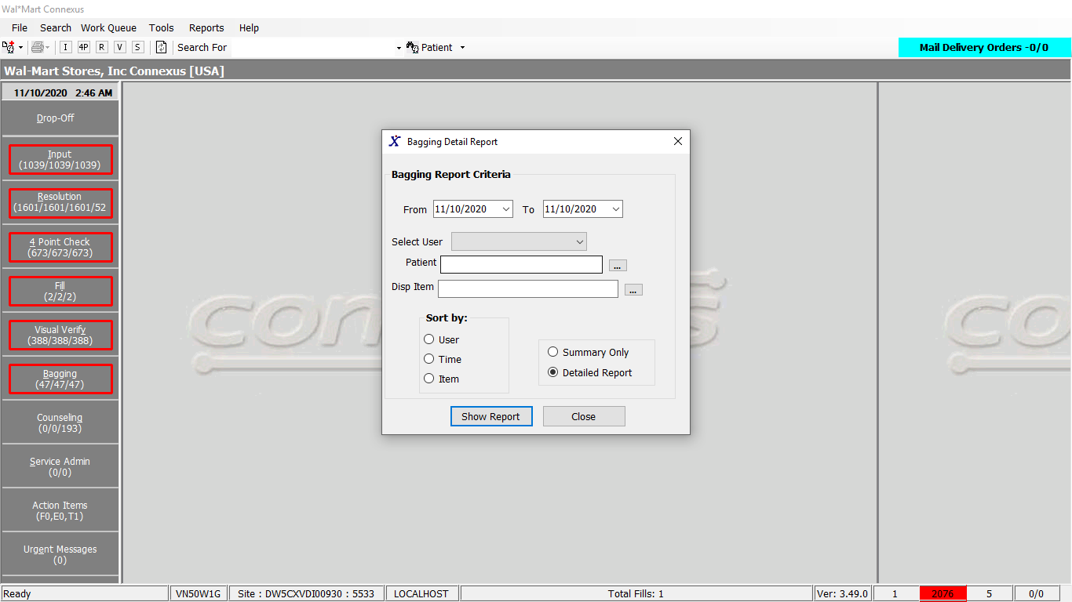

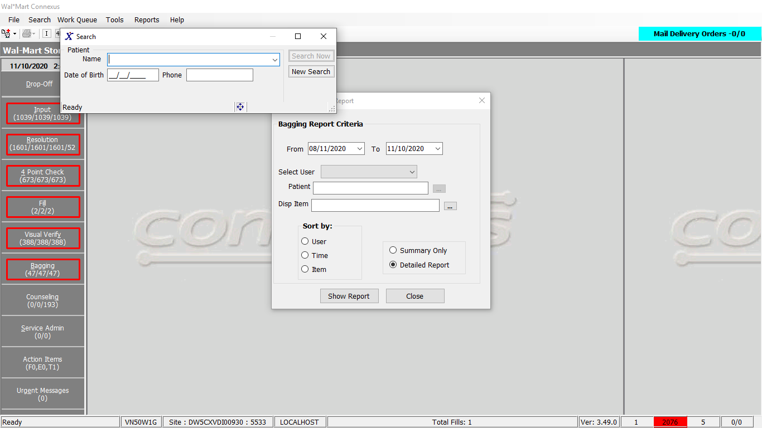

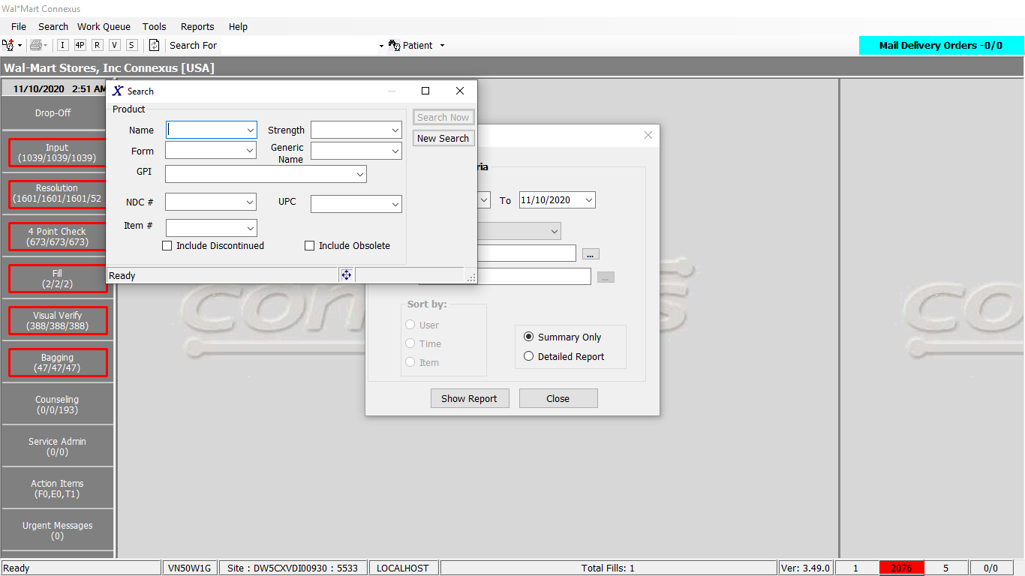

Response:

Detailed report response:

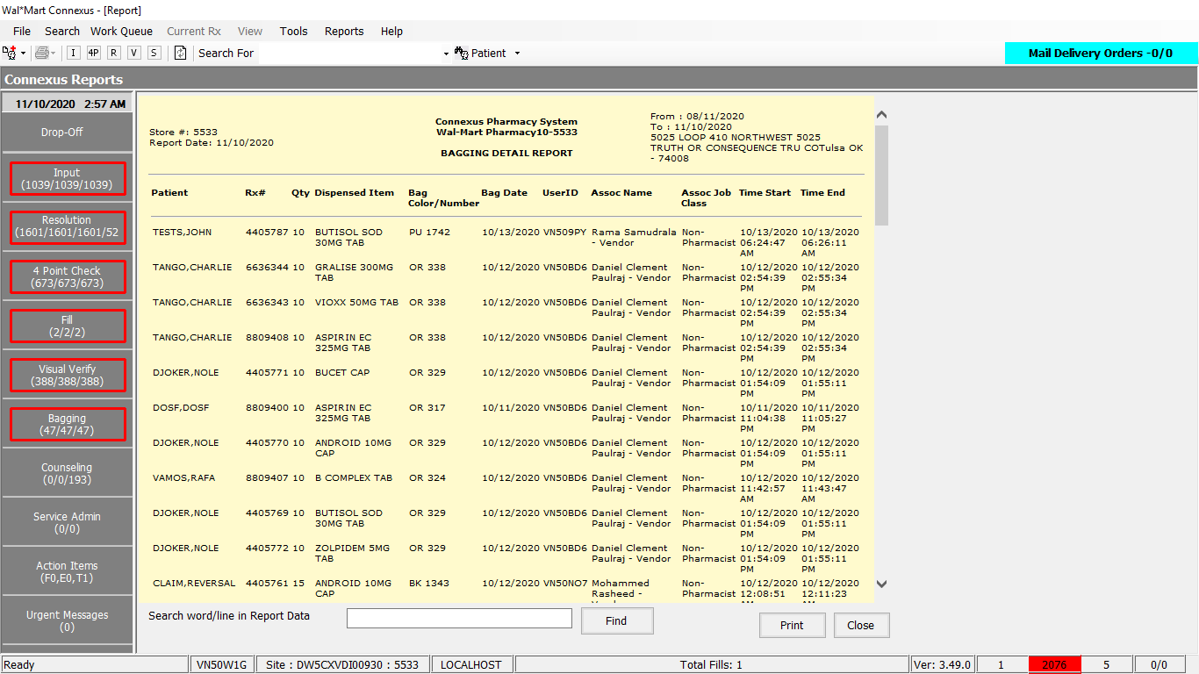

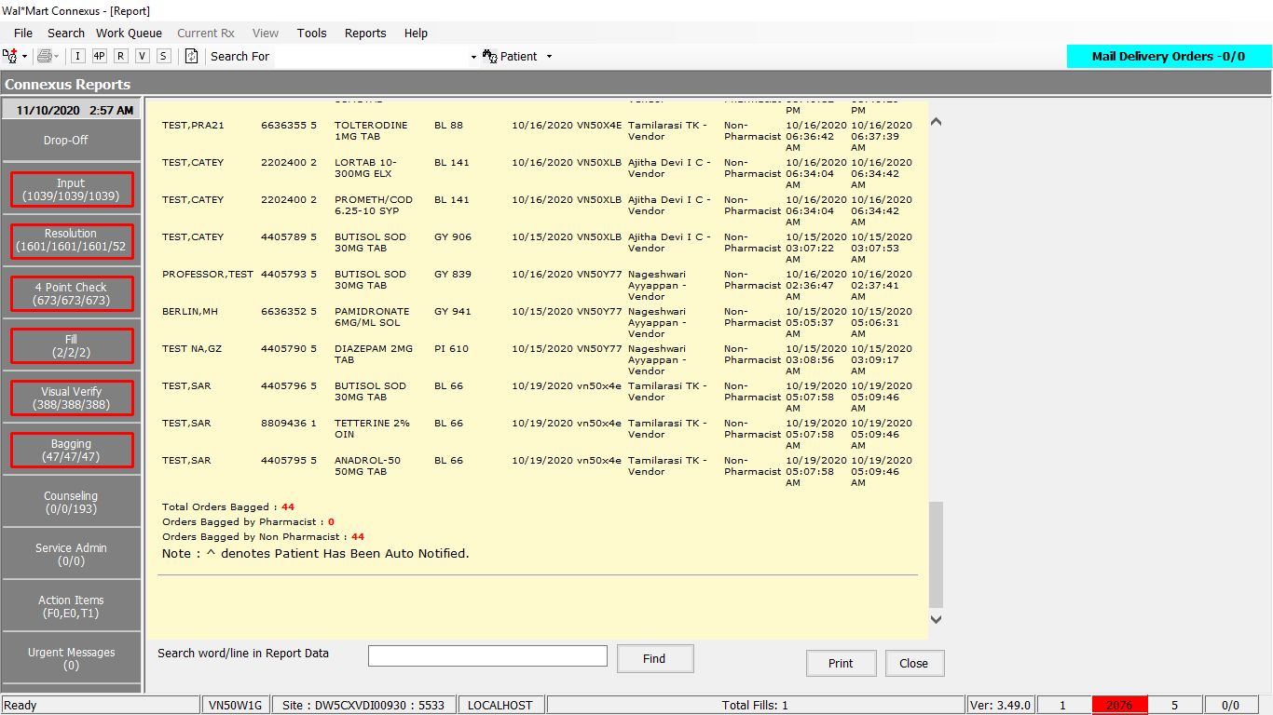

Summary report response:

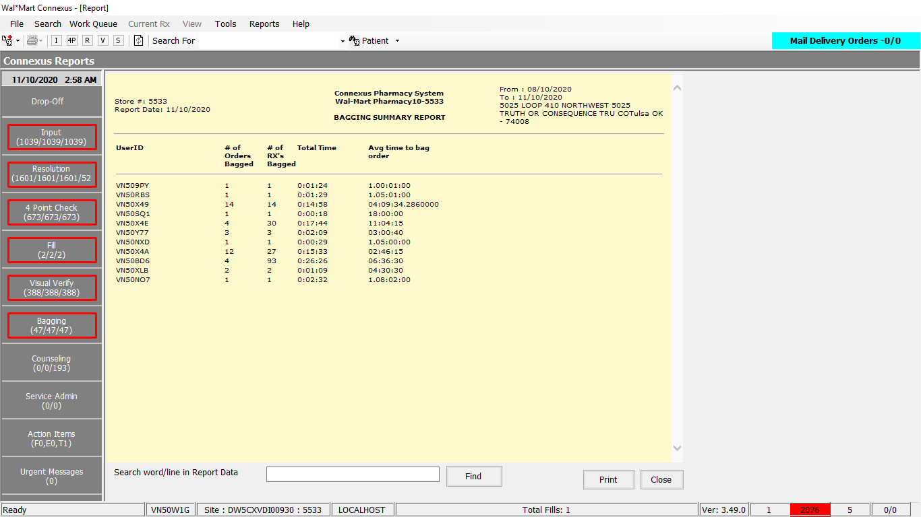

Queries:

1. Friend Const GetBaggingReportData_Beacon As String = "SELECT p.patient_id, p.last_name, p.first_name, rx.rx_nbr, rfi.fill_item_qty, pp.short_name, rod.order_id AS orderid, rod.next_work_que_code,

obg.tote_nbr, DATE(roda1.activity_ts) AS filldate, roda1.activity_userid,

su.user_descr, su.user_type_code,sutype.user_type_descr,su.security_level,roda2.activity_ts AS starttime,roda3.activity_ts AS endtime

FROM rx_order_detail rod,

rx_ord_dtl_activty roda1,

rx,

order_bag obg,

rx_fill rxf,

outer rx_ord_dtl_activty roda2,

outer rx_ord_dtl_activty roda3,

patient p,

pharmacy_offering:pharmacy_product pp,

pharmacy_offering:pharmacy_item pi,

rx_fill_item rfi,

phm_appl_security:system_user su,

phm_appl_security:sys_user_type_txt sutype

WHERE rod.order_id=roda1.order_id

AND rod.order_seq_nbr = roda1.order_seq_nbr

AND rxf.rx_fill_id=rod.rx_fill_id

AND (rod.next_work_que_code IN (3,6,15,16) OR

(rod.next_work_que_code is null AND rxf.pos_ts is not null)AND

rod.status_code IN (20501,20502) OR

(rod.next_work_que_code is null ) AND rod.status_code IN (20503) )

AND roda1.activity_code = 1101

AND roda1.work_que_code = 28

AND rx.rx_id=rod.rx_id

AND roda1.order_bag_id=obg.order_bag_id

AND rod.order_id = obg.order_id

AND roda1.order_id = roda2.order_id

AND roda1.order_id = roda3.order_id

AND roda1.order_bag_id = roda3.order_bag_id

AND roda2.work_que_code = 28

AND roda3.work_que_code = 28

AND roda2.activity_code = 1100

AND roda3.activity_code = 1101

AND su.user_type_code = sutype.user_type_code

AND p.patient_id=rx.patient_id

AND rfi.rx_fill_id = rod.rx_fill_id

AND pi.mds_fam_id = rfi.item_mds_fam_id

AND pp.product_mds_fam_id = pi.product_mds_fam_id

AND UPPER(su.userid)=UPPER(roda1.activity_userid)

AND roda2.activity_ts = (SELECT MAX(roda3.activity_ts)

FROM rx_ord_dtl_activty roda3

WHERE roda2.order_id=roda3.order_id

AND roda2.order_seq_nbr=roda3.order_seq_nbr

AND roda3.work_que_code = 28

AND roda3.activity_code = 1100 )

AND roda3.activity_ts = (SELECT MAX(roda4.activity_ts)

FROM rx_ord_dtl_activty roda4

WHERE roda3.order_id=roda4.order_id

AND roda3.order_seq_nbr=roda4.order_seq_nbr

AND roda3.order_bag_id = roda4.order_bag_id

AND roda4.work_que_code = 28

AND roda4.activity_code = 1101)

AND rod.order_id=roda2.order_id

AND rod.order_seq_nbr = roda2.order_seq_nbr

AND rod.order_id=roda3.order_id

AND rod.order_seq_nbr = roda3.order_seq_nbr "

2. Friend Const SummaryOrderRxCount_Beacon As String = "SELECT count (distinct rod.order_id) AS ordcount,

count( roda1.order_seq_nbr) AS rxcount,

UPPER(su.userid) AS userid, su.security_level

FROM rx_order_detail rod,

phm_appl_security:system_user su,

rx_ord_dtl_activty roda1,

rx_fill rxf,

outer rx_ord_dtl_activty roda2,

rx_ord_dtl_activty roda3 ,

rx

WHERE rod.order_id=roda1.order_id

AND rx.rx_id=rod.rx_id

AND rod.order_seq_nbr = roda1.order_seq_nbr

AND roda1.order_id=roda2.order_id

AND roda1.order_bag_id = roda2.order_bag_id

AND roda1.order_id = roda3.order_id

AND roda1.order_bag_id = roda3.order_bag_id

AND roda1.work_que_code = 28

AND roda2.work_que_code = 28

AND roda3.work_que_code = 28

AND roda1.activity_code = 1101

AND roda2.activity_code = 1100

AND roda3.activity_code = 1101

AND rxf.rx_fill_id=rod.rx_fill_id

AND (rod.next_work_que_code IN (3,6,15,16) OR

(rod.next_work_que_code is null AND rxf.pos_ts is not null) AND

rod.status_code IN (20501,20502) OR

(rod.next_work_que_code is null ) AND rod.status_code IN (20503) )

AND UPPER(su.userid)=UPPER(roda1.activity_userid)

AND roda2.activity_ts = (SELECT MAX(roda3.activity_ts)

FROM rx_ord_dtl_activty roda3

WHERE roda2.order_id=roda3.order_id

AND roda3.work_que_code = 28

AND roda3.activity_code = 1100)

AND roda3.activity_ts = (SELECT MAX(roda4.activity_ts)

FROM rx_ord_dtl_activty roda4

WHERE roda3.order_id=roda4.order_id

AND roda3.order_bag_id = roda4.order_bag_id

AND roda4.work_que_code = 28

AND roda4.activity_code = 1101) "

3. Friend Const GetBaggingReportData As String = "SELECT p.patient_id, p.last_name, p.first_name, rx.rx_nbr, rfi.fill_item_qty, pp.short_name, rod.order_id AS orderid, rod.next_work_que_code, " &

" c.color_abbr, obg.tote_nbr, DATE(roda1.activity_ts) AS filldate, roda1.activity_userid, " &

" su.user_descr, su.user_type_code,sutype.user_type_descr,su.security_level,roda2.activity_ts AS starttime, " &

" roda3.activity_ts AS endtime " &

" FROM rx_order_detail rod, rx_ord_dtl_activty roda1, rx,order_bag obg, rx_fill rxf, outer " &

" rx_ord_dtl_activty roda2, rx_ord_dtl_activty roda3, patient p, " &

" pharmacy_offering:pharmacy_product pp, pharmacy_offering:pharmacy_item pi, rx_fill_item rfi, " &

" bag_range br, color c, " &

" phm_appl_security:system_user su, " &

" phm_appl_security:sys_user_type_txt sutype " &

" WHERE rod.order_id=roda1.order_id " &

" AND rod.order_seq_nbr = roda1.order_seq_nbr " &

" AND rxf.rx_fill_id=rod.rx_fill_id " &

" AND (rod.next_work_que_code IN (3,6,15,16) OR (rod.next_work_que_code is null AND rxf.pos_ts is not null)AND rod.status_code IN (20501,20502) " &

"OR (rod.next_work_que_code is null ) AND rod.status_code IN (20503) ) " &

" AND roda1.activity_code = 1101 " &

" AND roda1.work_que_code = 28 " &

" AND rx.rx_id=rod.rx_id " &

" AND roda1.order_bag_id=obg.order_bag_id " &

" AND rod.order_id = obg.order_id " &

" AND roda1.order_id = roda2.order_id " &

" AND roda1.order_bag_id = roda2.order_bag_id " &

" AND roda1.order_id = roda3.order_id " &

" AND roda1.order_bag_id = roda3.order_bag_id " &

" AND roda2.work_que_code = 28 " &

" AND roda3.work_que_code = 28 " &

" AND roda2.activity_code = 8686 " &

" AND roda3.activity_code = 8687 " &

" AND su.user_type_code = sutype.user_type_code " &

" AND p.patient_id=rx.patient_id " &

" AND (br.bag_range_start_nbr<=obg.tote_nbr " &

" AND br.bag_range_end_nbr>=obg.tote_nbr) " &

" AND c.color_code=br.color_code " &

" AND rfi.rx_fill_id = rod.rx_fill_id " &

" AND pi.mds_fam_id = rfi.item_mds_fam_id " &

" AND pp.product_mds_fam_id = pi.product_mds_fam_id " &

" AND UPPER(su.userid)=UPPER(roda1.activity_userid) " &

" AND roda2.activity_ts = " &

" (SELECT MAX(roda3.activity_ts) From rx_ord_dtl_activty roda3 " &

" WHERE roda2.order_id=roda3.order_id AND roda2.order_seq_nbr=roda3.order_seq_nbr AND roda2.order_bag_id = roda3.order_bag_id " &

" AND roda3.work_que_code = 28 " &

" AND roda3.activity_code = 8686 ) " &

" AND roda3.activity_ts = " &

" (SELECT MAX(roda4.activity_ts) From rx_ord_dtl_activty roda4 " &

" WHERE roda3.order_id=roda4.order_id AND roda3.order_seq_nbr=roda4.order_seq_nbr AND roda3.order_bag_id = roda4.order_bag_id " &

" AND roda4.work_que_code = 28 " &

" AND roda4.activity_code = 8687) " &

" AND roda1.activity_ts between " &

" (SELECT MAX(roda3.activity_ts) From rx_ord_dtl_activty roda3 " &

" WHERE roda1.order_id=roda3.order_id AND roda1.order_seq_nbr=roda3.order_seq_nbr AND roda1.order_bag_id = roda3.order_bag_id " &

" AND roda3.work_que_code = 28 " &

" AND roda3.activity_code = 8686 ) " &

" AND " &

" (SELECT MAX(roda4.activity_ts) From rx_ord_dtl_activty roda4 " &

" WHERE roda1.order_id=roda4.order_id AND roda1.order_seq_nbr=roda4.order_seq_nbr AND roda1.order_bag_id = roda4.order_bag_id " &

" AND roda4.work_que_code = 28 " &

" AND roda4.activity_code = 8687) " &

" AND rod.order_id=roda2.order_id " &

"AND rod.order_seq_nbr = roda2.order_seq_nbr " &

" AND rod.order_id=roda3.order_id " &

"AND rod.order_seq_nbr = roda3.order_seq_nbr "

4. Friend Const SummaryTotalAvgTime_Beacon As String = "SELECT UPPER(su.userid) AS userid,

SUM (extend(roda3.activity_ts, hour to second) - extend(roda2.activity_ts, hour to second) )AS TotTime

FROM phm_appl_security:system_user su,

rx_ord_dtl_activty roda2,

rx_ord_dtl_activty roda3

WHERE roda2.order_id=roda3.order_id

AND roda2.order_seq_nbr = roda3.order_seq_nbr

AND roda2.work_que_code = 28

AND roda3.work_que_code = 28

AND roda2.activity_code = 1100

AND roda3.activity_code = 1101

AND UPPER(su.userid)=UPPER(roda2.activity_userid)

AND roda2.activity_ts = (SELECT MAX(roda3.activity_ts)

FROM rx_ord_dtl_activty roda3

WHERE roda2.order_id=roda3.order_id

AND roda2.order_seq_nbr = roda3.order_seq_nbr

AND roda3.work_que_code = 28

AND roda3.activity_code = 1100 )

AND roda3.activity_ts = (SELECT MAX(roda4.activity_ts)

FROM rx_ord_dtl_activty roda4

WHERE roda3.order_id=roda4.order_id

AND roda4.order_seq_nbr = roda3.order_seq_nbr

AND roda4.work_que_code = 28

AND roda4.activity_code = 1101)

AND roda2.order_id IN(SELECT DISTINCT rod.order_id

FROM rx_order_detail rod ,

rx

WHERE rod.order_id = roda2.order_id

AND rx.rx_id = rod.rx_id

AND rod.status_code IN (20501,20502,20503) "

5. Friend Const SummaryOrderRxCount As String = "SELECT count (distinct rod.order_id) AS ordcount, count( roda1.order_seq_nbr) AS rxcount," &

" UPPER(su.userid) AS userid, su.security_level " &

" FROM rx_order_detail rod, phm_appl_security:system_user su, rx_ord_dtl_activty roda1,rx_fill rxf, outer " &

" rx_ord_dtl_activty roda2, rx_ord_dtl_activty roda3 ,rx " &

" WHERE rod.order_id=roda1.order_id " &

" AND rx.rx_id=rod.rx_id " &

" AND rod.order_seq_nbr = roda1.order_seq_nbr " &

" AND roda1.order_id=roda2.order_id " &

" AND roda1.order_bag_id = roda2.order_bag_id " &

" AND roda1.order_id = roda3.order_id " &

" AND roda1.order_bag_id = roda3.order_bag_id " &

" AND roda1.work_que_code = 28 " &

" AND roda2.work_que_code = 28 " &

" AND roda3.work_que_code = 28 " &

" AND roda1.activity_code = 1101 " &

" AND roda2.activity_code = 8686 " &

" AND roda3.activity_code = 8687 " &

" AND rxf.rx_fill_id=rod.rx_fill_id " &

" AND (rod.next_work_que_code IN (3,6,15,16) OR (rod.next_work_que_code is null AND rxf.pos_ts is not null)AND rod.status_code IN (20501,20502) " &

"OR(rod.next_work_que_code is null ) AND rod.status_code IN (20503) ) " &

" AND UPPER(su.userid)=UPPER(roda1.activity_userid) " &

" AND roda2.activity_ts = " &

" (SELECT MAX(roda3.activity_ts) From rx_ord_dtl_activty roda3 " &

" WHERE roda2.order_id=roda3.order_id and roda2.order_bag_id = roda3.order_bag_id " &

" AND roda3.work_que_code = 28 " &

" AND roda3.activity_code = 8686 ) " &

" AND roda3.activity_ts = " &

" (SELECT MAX(roda4.activity_ts) From rx_ord_dtl_activty roda4 " &

" WHERE roda3.order_id=roda4.order_id and roda3.order_bag_id = roda4.order_bag_id " &

" AND roda4.work_que_code = 28 " &

" AND roda4.activity_code = 8687) " &

" AND roda1.activity_ts BETWEEN " &

" (SELECT MAX(roda3.activity_ts) From rx_ord_dtl_activty roda3 " &

" WHERE roda1.order_id=roda3.order_id and roda1.order_bag_id = roda3.order_bag_id " &

" AND roda3.work_que_code = 28 " &

" AND roda3.activity_code = 8686 ) " &

" AND " &

" (SELECT MAX(roda4.activity_ts) From rx_ord_dtl_activty roda4 " &

" WHERE roda1.order_id=roda4.order_id and roda1.order_bag_id = roda4.order_bag_id " &

" AND roda4.work_que_code = 28 " &

" AND roda4.activity_code = 8687) "

6. Friend Const SummaryTotalAvgTime As String = "SELECT UPPER(su.userid) AS userid," &

" SUM (extend(roda3.activity_ts, hour to second) - extend(roda2.activity_ts, hour to second) )AS TotTime " &

" FROM phm_appl_security:system_user su, rx_ord_dtl_activty roda2, " &

" rx_ord_dtl_activty roda3" &

" WHERE roda2.order_id=roda3.order_id " &

" AND roda2.order_bag_id = roda3.order_bag_id " &

" AND roda2.work_que_code = 28 " &

" AND roda3.work_que_code = 28 " &

" AND roda2.activity_code = 8686 " &

" AND roda3.activity_code = 8687 " &

" AND UPPER(su.userid)=UPPER(roda2.activity_userid) " &

" AND roda2.activity_ts = " &

" (SELECT MAX(roda3.activity_ts) From rx_ord_dtl_activty roda3 " &

" WHERE roda2.order_id=roda3.order_id and roda2.order_bag_id = " &

" roda3.order_bag_id " &

" AND roda3.work_que_code = 28 " &

" AND roda3.activity_code = 8686 ) " &

" AND roda3.activity_ts = " &

" (SELECT MAX(roda4.activity_ts) From rx_ord_dtl_activty roda4 " &

" WHERE roda3.order_id=roda4.order_id and roda3.order_bag_id = " &

" roda4.order_bag_id " &

" AND roda4.work_que_code = 28 " &

" AND roda4.activity_code = 8687) " &

" AND roda2.order_id IN( " &

" SELECT distinct rod.order_id from rx_order_detail rod , rx " &

" WHERE rod.order_id = roda2.order_id " &

" AND rx.rx_id = rod.rx_id " &

" AND rod.status_code IN (20501,20502,20503) "

7. Friend Const SearchByPatient As String = " AND rx.patient_id = ?"

8. Friend Const SearchByPatientSummary As String = " AND rx.patient_id = ?"

9. Friend Const SearchByPatientSummary As String = " AND rx.patient_id = ?"

10. Friend Const SearchByItem As String = " AND rx.product_mds_fam_id = ?"

11. Friend Const SearchByItemSummary As String = " AND rx.product_mds_fam_id = ?"

12. Friend Const SearchByItemSummary As String = " AND rx.product_mds_fam_id = ?"

13. Friend Const SearchByUser As String = " AND UPPER(roda1.activity_userid) = ?"

14. Friend Const SearchByUser As String = " AND UPPER(roda1.activity_userid) = ?"

15. Friend Const SearchByUserSummary As String = " AND UPPER(roda2.activity_userid) = ?"

16. Friend Const SearchByDateSummary As String = " AND DATE(roda1.activity_ts) BETWEEN ? AND ? GROUP BY su.userid, su.security_level "

17. Friend Const SearchByDateDetailed As String = " AND DATE(roda1.activity_ts) BETWEEN ? AND ?"

18. Friend Const SearchByDateSummaryForTimeAvg As String = " ) AND DATE(roda2.activity_ts) BETWEEN ? AND ? GROUP BY su.userid "

19. Friend Const SortByUser As String = " ORDER BY roda1.activity_userid"

20. Friend Const SortByItem As String = " ORDER BY pp.short_name"

21. Friend Const SortByTime As String = " ORDER BY roda2.activity_ts"

DAL method:

Public Function GetBaggingReportData(ByVal siteId As Integer, ByVal BaggingReportCriteria As BaggingReportCriteriaBE) As List(Of GetPosPickupRptDataInfoBE) Implements IReportDAL.GetBaggingReportData

Using (New Tracer(ConnexusCommonConstants.ConnexusTracer))

Dim reportQuery As New StringBuilder

Dim IsBeaconEnabled As Boolean = ReportDAL.GetBUPhmParm(siteId, ConnexusCommonConstants.BeaconEnabledFlag).

EqualsIgnoreCase(ConnexusCommonConstants.TrueValue)

Dim ordRxCountQuery As New StringBuilder

Dim timeAvgQuery As New StringBuilder

Dim paramList As New List(Of DbParameter)

If IsBeaconEnabled Then

reportQuery.Append(ReportQueries.GetBaggingReportData_Beacon)

ordRxCountQuery.Append(ReportQueries.SummaryOrderRxCount_Beacon)

timeAvgQuery.Append(ReportQueries.SummaryTotalAvgTime_Beacon)

Else

reportQuery.Append(ReportQueries.GetBaggingReportData)

ordRxCountQuery.Append(ReportQueries.SummaryOrderRxCount)

timeAvgQuery.Append(ReportQueries.SummaryTotalAvgTime)

End If

If Not BaggingReportCriteria Is Nothing Then

If BaggingReportCriteria.PatientId > 0 Then

reportQuery.Append(ReportQueries.SearchByPatient)

ordRxCountQuery.Append(ReportQueries.SearchByPatientSummary)

timeAvgQuery.Append(ReportQueries.SearchByPatientSummary)

paramList.Add(ParameterHelper.BuildParameter("patient_id", DbType.Int32, BaggingReportCriteria.PatientId))

End If

If BaggingReportCriteria.ItemId > 0 Then

reportQuery.Append(ReportQueries.SearchByItem)

ordRxCountQuery.Append(ReportQueries.SearchByItemSummary)

timeAvgQuery.Append(ReportQueries.SearchByItemSummary)

paramList.Add(ParameterHelper.BuildParameter("rx.product_mds_fam_id", DbType.Int32, BaggingReportCriteria.ItemId))

End If

If BaggingReportCriteria.UserId IsNot Nothing Then

reportQuery.Append(ReportQueries.SearchByUser)

ordRxCountQuery.Append(ReportQueries.SearchByUser)

timeAvgQuery.Append(ReportQueries.SearchByUserSummary)

paramList.Add(ParameterHelper.BuildParameter("roda1.activity_userid", DbType.String, BaggingReportCriteria.UserId))

End If

If BaggingReportCriteria.FromDate > Date.MinValue AndAlso BaggingReportCriteria.ToDate > Date.MinValue Then

reportQuery.Append(ReportQueries.SearchByDateDetailed)

ordRxCountQuery.Append(ReportQueries.SearchByDateSummary)

timeAvgQuery.Append(ReportQueries.SearchByDateSummaryForTimeAvg)

paramList.Add(ParameterHelper.BuildParameter("from_date", DbType.Date, BaggingReportCriteria.FromDate))

paramList.Add(ParameterHelper.BuildParameter("to_date", DbType.Date, BaggingReportCriteria.ToDate))

End If

End If

'Add Sort by clause

Select Case BaggingReportCriteria.SortBy

Case BaggingReportSortOptions.User

reportQuery.Append(ReportQueries.SortByUser)

Case BaggingReportSortOptions.Item

reportQuery.Append(ReportQueries.SortByItem)

Case BaggingReportSortOptions.Time

reportQuery.Append(ReportQueries.SortByTime)

End Select

Dim reportDataList As New List(Of GetPosPickupRptDataInfoBE)

Using dr As IDataReader = ExecuteReader(DatabaseEnum.rx21c, siteId, reportQuery.ToString, paramList)

While dr.Read()

Dim reportData As New GetPosPickupRptDataInfoBE

If Not dr.IsDBNull(dr.GetOrdinal("patient_id")) Then

reportData.PatientId = dr.GetInt32(dr.GetOrdinal("patient_id"))

End If

If Not (dr.IsDBNull(dr.GetOrdinal("last_name")) AndAlso dr.IsDBNull(dr.GetOrdinal("first_name"))) Then

reportData.PatientName = dr.GetString(dr.GetOrdinal("last_name")).Trim() + "," + dr.GetString(dr.GetOrdinal("first_name")).Trim()

End If

If Not dr.IsDBNull(dr.GetOrdinal("rx_nbr")) Then

reportData.RxNbr = dr.GetInt32(dr.GetOrdinal("rx_nbr"))

End If

If Not dr.IsDBNull(dr.GetOrdinal("fill_item_qty")) Then

reportData.FillQty = Convert.ToInt32(dr.GetDecimal(dr.GetOrdinal("fill_item_qty")))

End If

If Not dr.IsDBNull(dr.GetOrdinal("filldate")) Then

reportData.FillDate = dr.GetDateTime(dr.GetOrdinal("filldate")).Date

End If

If Not dr.IsDBNull(dr.GetOrdinal("short_name")) Then

reportData.DrugName = dr.GetString(dr.GetOrdinal("short_name"))

End If

If IsBeaconEnabled Then

If dr.IsDBNull(dr.GetOrdinal("tote_nbr")) Then

reportData.BagColorNumber = dr.GetInt32(dr.GetOrdinal("tote_nbr")).ToString()

End If

Else

If Not (dr.IsDBNull(dr.GetOrdinal("color_abbr")) AndAlso dr.IsDBNull(dr.GetOrdinal("tote_nbr"))) Then

reportData.BagColorNumber = dr.GetString(dr.GetOrdinal("color_abbr")) + " " + dr.GetInt32(dr.GetOrdinal("tote_nbr")).ToString()

End If

End If

If Not dr.IsDBNull(dr.GetOrdinal("activity_userid")) Then

reportData.UserID = dr.GetString(dr.GetOrdinal("activity_userid"))

End If

If Not dr.IsDBNull(dr.GetOrdinal("user_descr")) Then

reportData.AssocName = dr.GetString(dr.GetOrdinal("user_descr"))

End If

If Not dr.IsDBNull(dr.GetOrdinal("user_type_descr")) Then

reportData.AssocJobClass = dr.GetString(dr.GetOrdinal("user_type_descr"))

End If

If Not dr.IsDBNull(dr.GetOrdinal("starttime")) Then

reportData.StartTime = (dr.GetDateTime(dr.GetOrdinal("starttime"))).ToString()

End If

If Not dr.IsDBNull(dr.GetOrdinal("endtime")) Then

reportData.EndTime = (dr.GetDateTime(dr.GetOrdinal("endtime"))).ToString()

End If

If Not dr.IsDBNull(dr.GetOrdinal("orderid")) Then

reportData.OrderId = (dr.GetInt32(dr.GetOrdinal("orderid")))

End If

'Infosys: Getting the security level to differentiate between temporary pharmacist and temporary technician.

'Also, to differentiate between moving pharmacist and moving technician.

If Not dr.IsDBNull(dr.GetOrdinal("security_level")) Then

reportData.SecurityLevel = dr.GetInt16(dr.GetOrdinal("security_level"))

End If

reportDataList.Add(reportData)

End While

End Using

' *********

'first--Query to get order count,rx count and user id

Using drSummary As IDataReader = ExecuteReader(DatabaseEnum.rx21c, siteId, ordRxCountQuery.ToString, paramList)

While drSummary.Read()

Dim summaryReportData As New GetPosPickupRptDataInfoBE

If Not drSummary.IsDBNull(drSummary.GetOrdinal("userid")) Then

summaryReportData.UserID = drSummary.GetString(drSummary.GetOrdinal("userid")).Trim()

End If

If Not drSummary.IsDBNull(drSummary.GetOrdinal("ordcount")) Then

summaryReportData.TotalOrderNumber = Convert.ToInt32(drSummary.GetDecimal(drSummary.GetOrdinal("ordcount")))

End If

If Not drSummary.IsDBNull(drSummary.GetOrdinal("rxcount")) Then

summaryReportData.TotalRxNumber = Convert.ToInt32(drSummary.GetDecimal(drSummary.GetOrdinal("rxcount")))

End If

'Infosys: Getting the security level to differentiate between temporary pharmacist and temporary technician.

'Also, to differentiate between moving pharmacist and moving technician.

If Not drSummary.IsDBNull(drSummary.GetOrdinal("security_level")) Then

summaryReportData.SecurityLevel = drSummary.GetInt16(drSummary.GetOrdinal("security_level"))

End If

reportDataList.Add(summaryReportData)

End While

End Using

'second --Query to get total time ,average time and user id

Dim reportDataTimeAvgList As New List(Of GetPosPickupRptDataInfoBE)

Using drSummary As IDataReader = ExecuteReader(DatabaseEnum.rx21c, siteId, timeAvgQuery.ToString, paramList)

While drSummary.Read()

Dim summaryReportTimeData As New GetPosPickupRptDataInfoBE

If Not drSummary.IsDBNull(drSummary.GetOrdinal("userid")) Then

summaryReportTimeData.UserID = drSummary.GetString(drSummary.GetOrdinal("userid")).Trim()

End If

summaryReportTimeData.TotalTime = drSummary.GetString(drSummary.GetOrdinal("TotTime")).Trim()

reportDataTimeAvgList.Add(summaryReportTimeData)

End While

End Using

'combine the above 2 results with respect to user id

Dim timeAvgData As New GetPosPickupRptDataInfoBE

Dim ordRxCountData As New GetPosPickupRptDataInfoBE

Dim avgTimeSeconds As New Double

Dim totalTimeSeconds As New Double

Dim listSeconds As String()

If Not reportDataList Is Nothing And Not reportDataTimeAvgList Is Nothing Then

For Each ordRxCountData In reportDataList

If ordRxCountData.TotalOrderNumber > 0 Then

For Each timeAvgData In reportDataTimeAvgList

If timeAvgData.UserID = ordRxCountData.UserID Then

'D4613[Calculating total seconds based on time stamp value]

listSeconds = timeAvgData.TotalTime.Split(CChar(":"))

totalTimeSeconds = Integer.Parse(listSeconds(0)) + 60 * Integer.Parse(listSeconds(1)) + 3600 * Integer.Parse(listSeconds(2))

ordRxCountData.TotalTime = timeAvgData.TotalTime

avgTimeSeconds = totalTimeSeconds / ordRxCountData.TotalOrderNumber

ordRxCountData.AvgTime = TimeSpan.FromSeconds(avgTimeSeconds).ToString()

End If

Next

End If

Next

End If

Return reportDataList

End Using

End Functions

# 10.Reports Menu/Pickup/POS Reports/Will Call Bin Report:

Request:

(Clicked screen shots at various situations)

Landing page when Detailed report is checked:

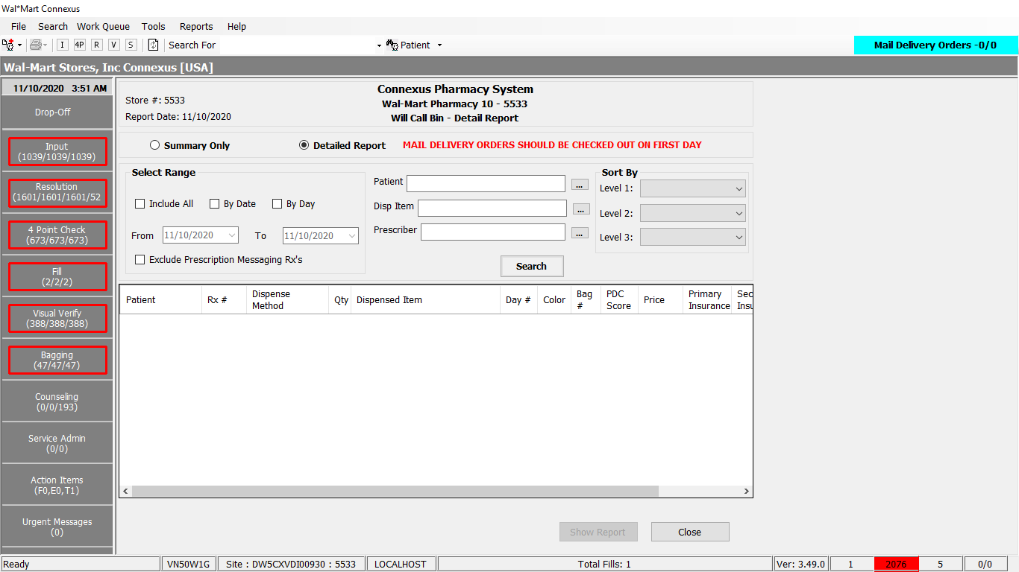

Landing page when summary report is checked(sort by and search are blocked ):

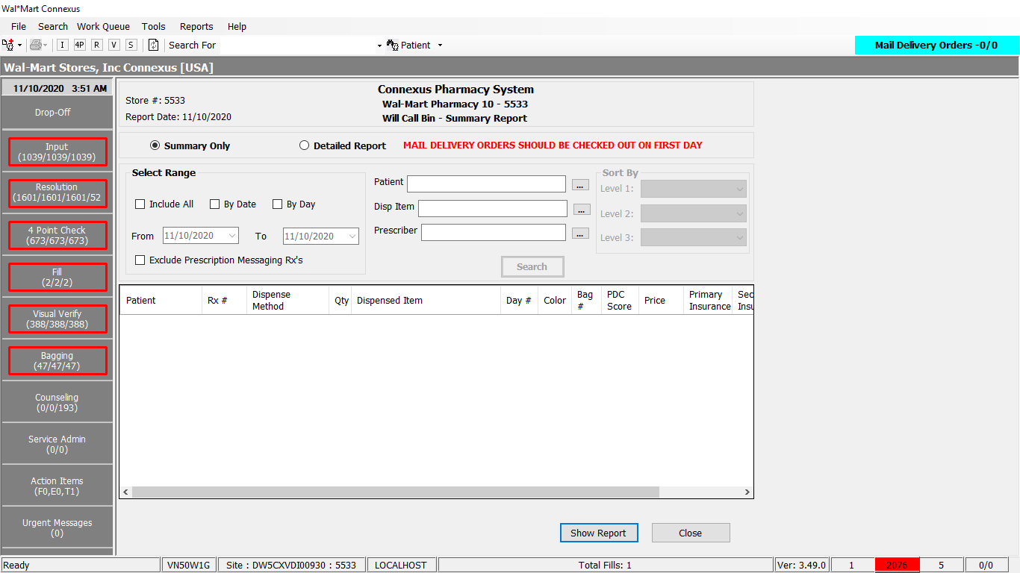

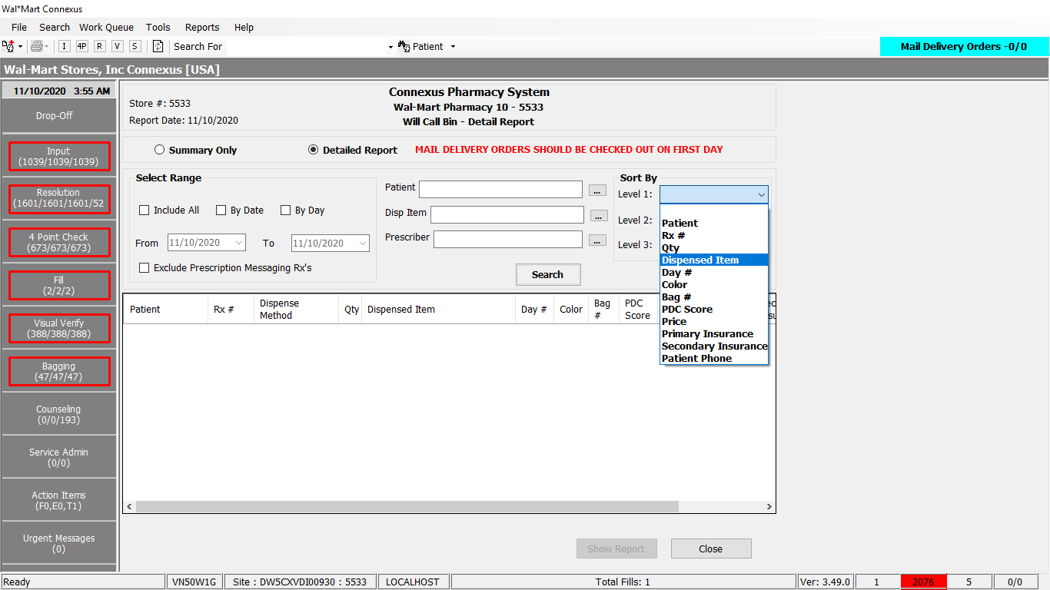

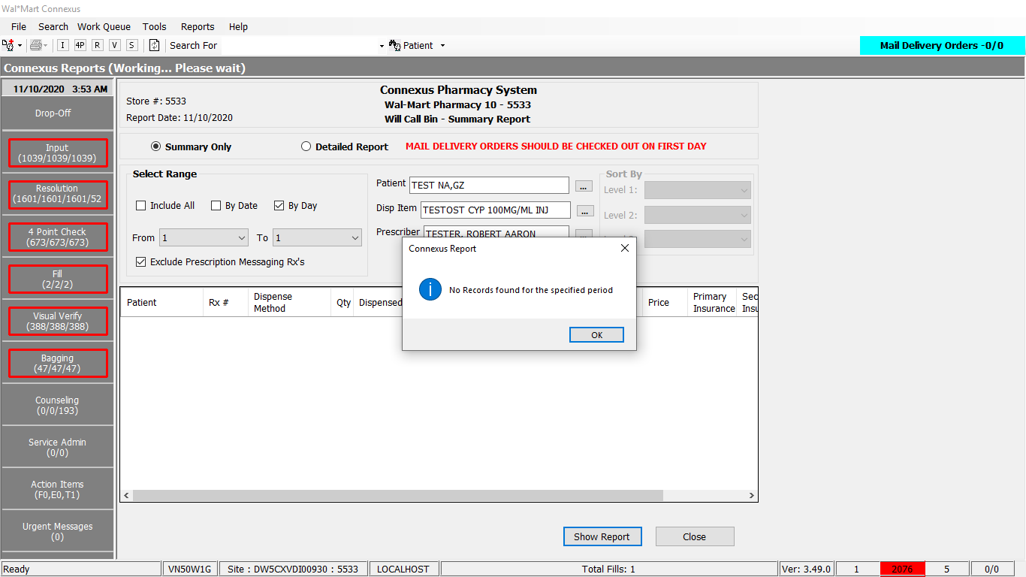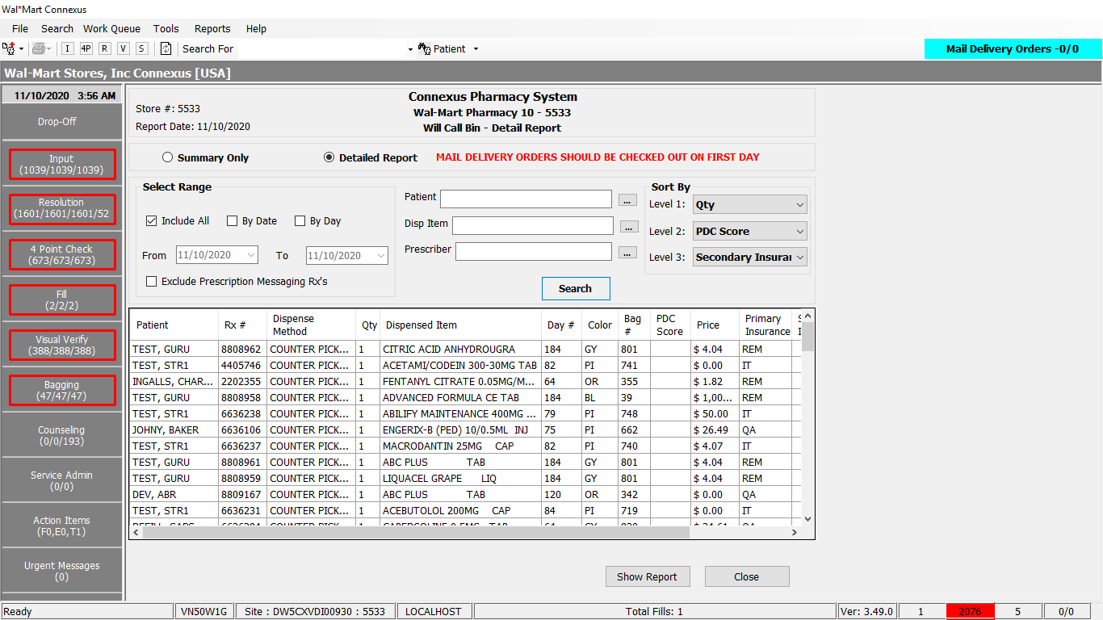

Response:

Summary report:

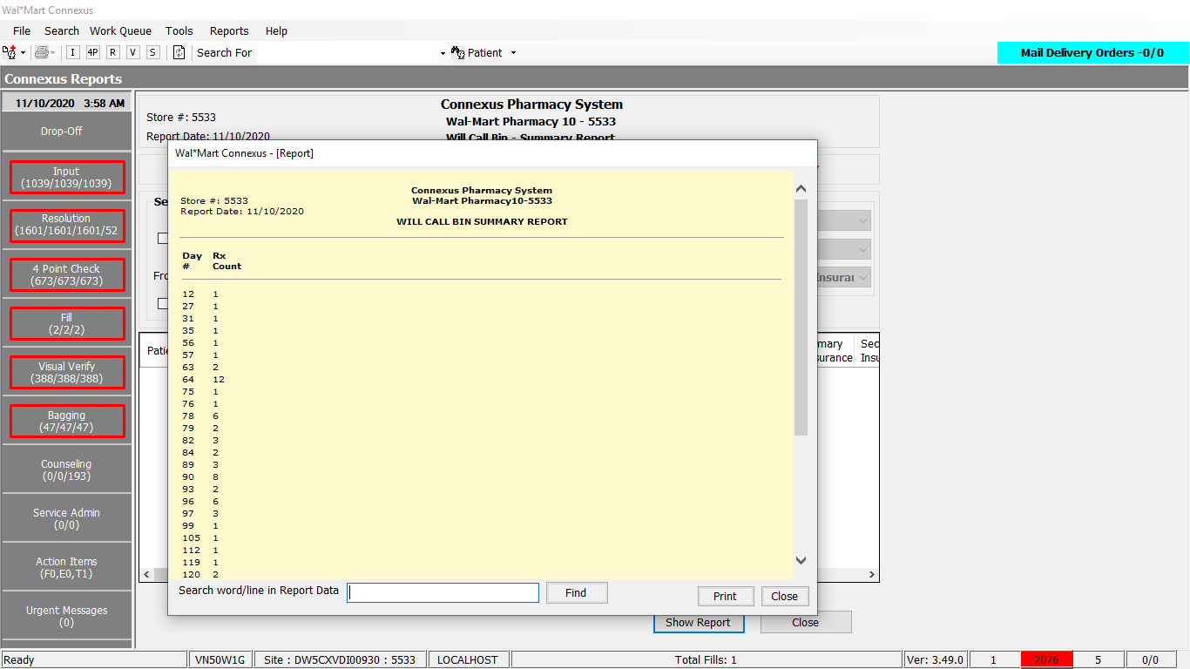

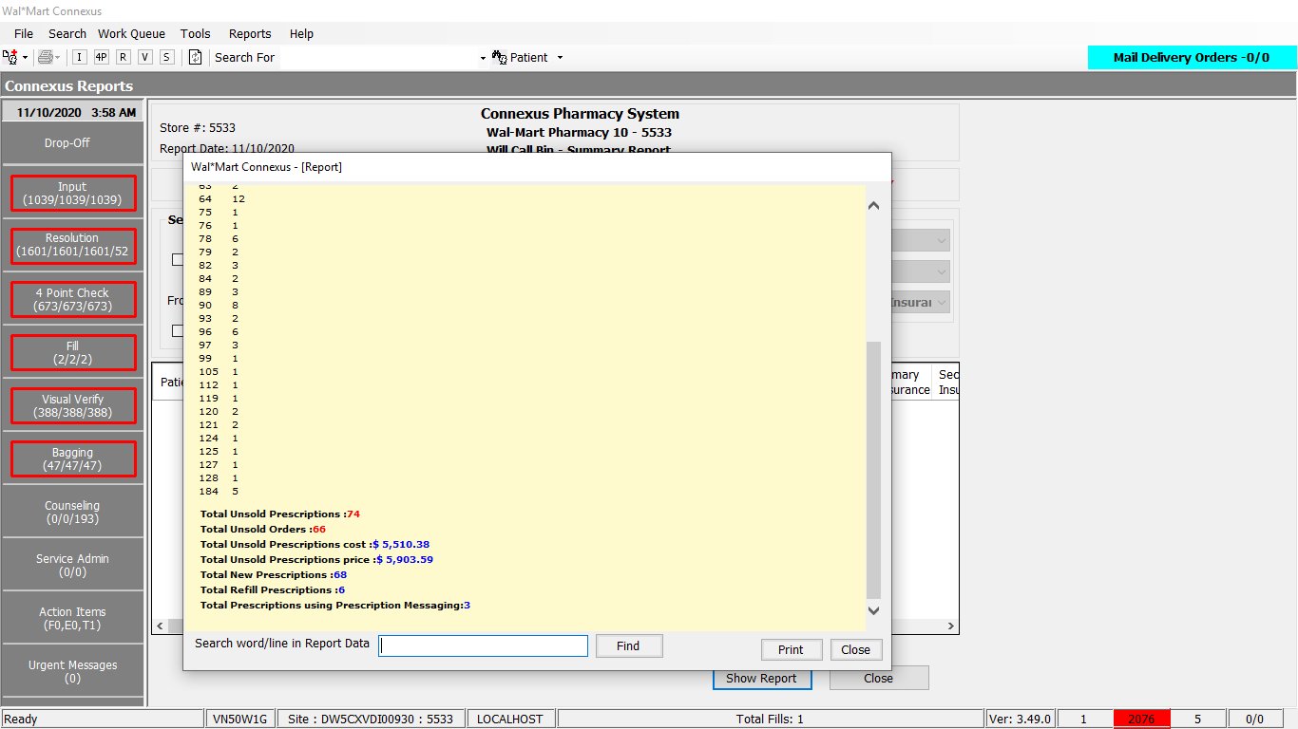

Detailed report:

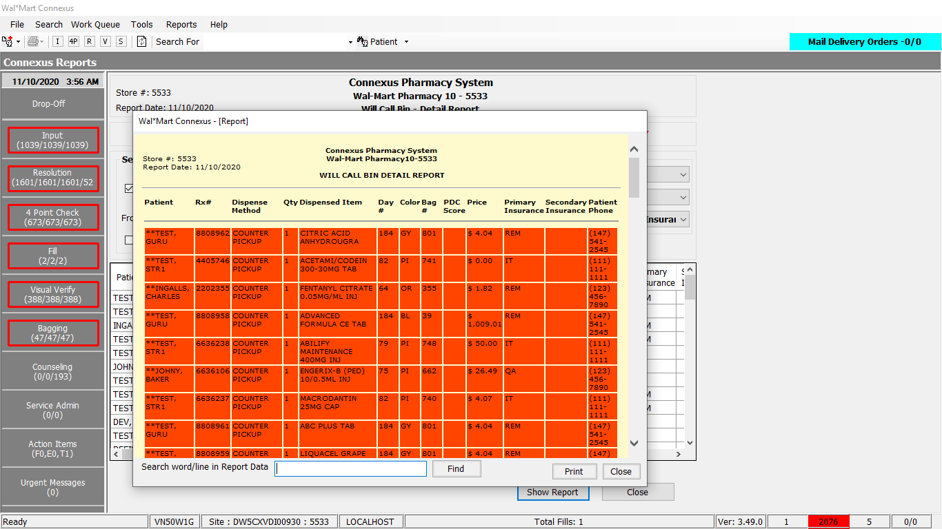

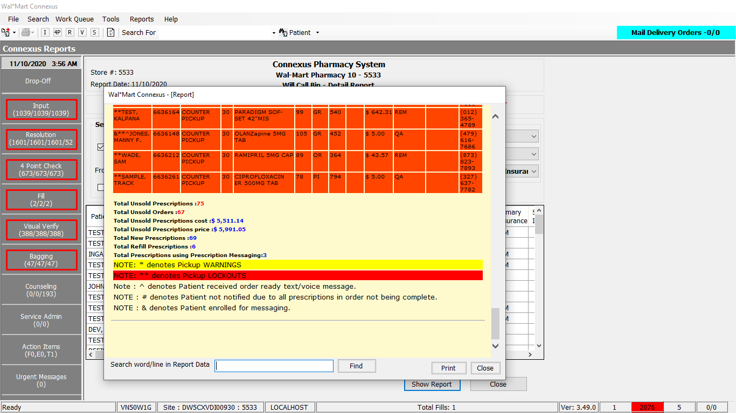

Query:

Friend Const GetWCBDetailedReportData As String =

" SELECT tmp.patient_id, tmp.order_id,tmp.rx_fill_id,tmp.patient,tmp.rx_nbr,tmp.fill_date,tmp.activity_ts,tmp.fill_qty,tmp.package_nbr, " &

" tmp.drug,tmp.price,tmp.cost,tmp.actual_pickup_ts,tmp.rx_id,tmp.rx_version_seq_nbr,tmp.communication_id,tmp.patnotify,tmp.day_nbr, " &

" tmp.bag_nbr,tmp.bag_color,tmp.new_refill,tmp.auto_refill,tmp.ready_reminder,tmp.is_tp,tmp.pdc,tmp.firstins,tmp.secondins, " &

" tmp.dlvry_method_desc, COUNT(rod2.rx_fill_id) as count from " &

" (SELECT pa.patient_id, rod.order_id, rf.rx_fill_id, " &

" TRIM(NVL(pa.last_name,' ')) || ', ' || TRIM(NVL(pa.first_name,' ')) || ' ' || TRIM(NVL(pa.middle_name,' ')) patient, " &

" rx.rx_nbr, rf.fill_date, EXTEND(rf.fill_date, YEAR TO SECOND) activity_ts, rf.fill_qty, NVL(rod.package_nbr, 0) package_nbr, " &

" Case WHEN rx.compound_ind = 'N' THEN TRIM(pp.short_name) WHEN rx.compound_ind = 'Y' THEN TRIM(comp.compound_name) END drug, " &

" rf.patient_due_amt price, SUM(rfi.actual_cost_amt) cost,TO_CHAR(rod.actual_pickup_ts) actual_pickup_ts, rx.rx_id, " &

" rx.rx_version_seq_nbr, " &

" CASE WHEN (sc.communication_id IS NOT NULL) THEN sc.communication_id " &

" WHEN (sc3.communication_id IS NOT NULL) THEN sc3.communication_id " &

" END communication_id, " &

" CASE WHEN rod.notif_status_code = ? THEN 1 ELSE 0 END patnotify, " &

" (TODAY - DATE(rfa.activity_ts)) + 1 day_nbr, rod.tote_nbr bag_nbr, c.color_abbr as bag_color, " &

" Case WHEN rod.request_type_code IN (1600, 1603) THEN 'N' " &

" WHEN rod.request_type_code IN (1601, 1607) THEN 'R' " &

" ELSE null End new_refill, " &

" rx.rx_auto_refill_ind auto_refill, sc2.communication_id ready_reminder, " &

" CASE WHEN rsd.aff_party_id Is Not NULL THEN 'Y' Else 'N' END is_tp , " &

" CASE WHEN rx.compound_ind = 'Y' THEN 0 " &

" WHEN pa.birth_date >= (EXTEND(CURRENT, YEAR to DAY) - (?) UNITS YEAR) THEN 0 " &

" ELSE ( SELECT A.pdc FROM table(Function CalculatePDC(pgx.gpi_code, rx.patient_id,rx.status_code,pa.patient_type_code)) " &

" AS A(pdc,daysMD,totDays) )END pdc, " &

" (SELECT tmp.phm_co_name_abbr from " &

" (SELECT ROW_NUMBER() OVER (ORDER BY clr1.txn_seq_nbr) AS Rownbr, pc1.phm_co_name_abbr " &

" FROM claim_response clr1, phm_company pc1 " &

" WHERE clr1.rx_fill_id = clr.rx_fill_id " &

" AND clr1.response_code IN (1901, 1902, 1904, 1905) " &

" AND pc1.phm_co_id=clr1.carrier_co_id)tmp " &

" WHERE tmp.rownbr=1) As firstins, " &

" (SELECT tmp.phm_co_name_abbr FROM " &

" (SELECT ROW_NUMBER() OVER (ORDER BY clr1.txn_seq_nbr) AS Rownbr, pc1.phm_co_name_abbr " &

" FROM claim_response clr1, phm_company pc1 " &

" WHERE clr1.rx_fill_id = clr.rx_fill_id " &

" AND clr1.response_code in (1901, 1902, 1904, 1905) " &

" AND pc1.phm_co_id=clr1.carrier_co_id)tmp " &

" WHERE tmp.rownbr=2) As secondins , CASE WHEN rod.dlvry_method_code IS NULL THEN 'COUNTER PICKUP' ELSE dmt.dlvry_method_desc END dlvry_method_desc " &

" FROM rx rx, patient pa, OUTER subject_comm sc, " &

" OUTER subject_comm sc2, OUTER subject_comm sc3, " &

" rx_fill rf, outer claim_response clr, color c , OUTER (dlvry_method dm, dlvry_method_text dmt), " &

" OUTER (pharmacy_offering:pharmacy_product pp, pharmacy_offering:pharmacy_item pi)," &

" OUTER (rx_compound rxc, compound comp), OUTER (rx_sale_detail rsd), " &

" OUTER (Pharmacy_offering:product_gpi_xref pgx), " &

" rx_fill_item rfi, rx_fill_activity rfa, prescriber prsc,rx_order_detail rod" &

" WHERE rod.next_work_que_code = 6 " &

" AND dm.dlvry_method_code = rod.dlvry_method_code " &

" AND dm.dlvry_method_code = dmt.dlvry_method_code " &

" AND rx.patient_id = pa.patient_id " &

" AND pa.patient_id = sc.subject_id " &

" AND sc.comm_seq_nbr= ? " &

" AND sc.subject_type_code = ? AND sc.comm_method_code = ? AND pa.patient_id = sc2.subject_id " &

" AND sc2.subject_type_code = ? AND sc2.comm_method_code = ? " &

" AND sc3.subject_type_code= ? AND sc3.comm_method_code= ? AND sc3.comm_seq_nbr = ? AND pa.patient_id = sc3.subject_id " &

" AND rfi.item_mds_fam_id = pi.mds_fam_id " &

" AND pi.product_mds_fam_id = pp.product_mds_fam_id AND rf.rx_fill_id = rsd.rx_fill_id AND rsd.txn_seq_nbr =1 " &

" AND rx.rx_id = rod.rx_id AND rx.rx_id = rxc.rx_id AND rxc.compound_id = comp.compound_id AND rod.rx_fill_id = rf.rx_fill_id " &

" AND rf.rx_fill_id = rfi.rx_fill_id AND rod.status_code = ? AND rfa.rx_fill_id = rf.rx_fill_id " &

" AND rfa.activity_seq_nbr = (SELECT MAX(activity_seq_nbr) " &

" FROM rx_fill_activity rfa1 " &

" WHERE rfa1.activity_code = 1104 " &

" AND rfa1.rx_fill_id = rf.rx_fill_id ) " &

" AND rx.prescriber_id = prsc.prescriber_id AND Date(rfa.activity_ts) <= TODAY " &

" AND rx.product_mds_fam_id = pgx.product_mds_fam_id " &

" AND c.color_code = (Select color_code FROM bag_range WHERE rod.tote_nbr " &

" BETWEEN bag_range_start_nbr AND bag_range_end_nbr) " &

" AND clr.rx_fill_id = rod.rx_fill_id " &

" AND clr.response_code In (1901, 1902, 1904, 1905) "

Friend Const GetWCBDetailedReportDataPart2 As String =

" ) tmp " &

" LEFT OUTER JOIN rx_order_detail rod2 " &

" ON rod2.order_id= tmp.order_id AND rod2.status_code = 20501 " &

" AND rod2.next_work_que_code In (1,2,4,5,7,8,9,10,11,12,28) " &

" AND rod2.notif_status_code Is null " &

" GROUP BY 1, 2, 3, 4, 5, 6, 7, 8, 9, 10, 11,12, 13, 14, 15, 16, 17, 18, 19, 20, 21, 22, 23,24,25,26,27,28 "

**DAL Method:**

Public Function GetWCBDetailedReportData(ByVal siteId As Integer, ByVal WCBReportCriteria As WCBReportCriteriaBE, ByVal EnableDispenseMethodSelectionFlag As Boolean) As List(Of GetPosPickupRptDataInfoBE) Implements IReportDAL.GetWCBDetailedReportData

Using (New Tracer(ConnexusCommonConstants.ConnexusTracer))

Dim reportQuery As New StringBuilder

Dim paramList As New List(Of DbParameter)

Dim minPDCAge As Integer = SafeConvert.ToInteger32(GetBUPhmParm(siteId, BuPhmParmCode.PDCAge))

reportQuery.Append(ReportQueries.GetWCBDetailedReportData)

'Add parameters to the query

paramList.Add(ParameterHelper.BuildParameter("notif_status", DbType.Int32, ServicesCommonConstants.PatientNotificationSentStatus))

paramList.Add(ParameterHelper.BuildParameter("PDC_Age", DbType.Int32, minPDCAge))

paramList.Add(ParameterHelper.BuildParameter("paramHome", DbType.Int32, CommSeqNumber.Home_1))

paramList.Add(ParameterHelper.BuildParameter("subject_Type_Code", DbType.Int16, SubjectCodeType.SubjCodeTypePatient))

paramList.Add(ParameterHelper.BuildParameter("paramPhone", DbType.Int32, CommMethod.Phone))

paramList.Add(ParameterHelper.BuildParameter("subject_Type_Code", DbType.Int16, SubjectCodeType.SubjCodeTypePatient))

paramList.Add(ParameterHelper.BuildParameter("paramCell", DbType.Int32, CommMethod.Cell))

paramList.Add(ParameterHelper.BuildParameter("subject_Type_Code", DbType.Int16, SubjectCodeType.SubjCodeTypePatient))

paramList.Add(ParameterHelper.BuildParameter("paramPhone", DbType.Int32, CommMethod.Phone))

paramList.Add(ParameterHelper.BuildParameter("paramHome", DbType.Int32, CommSeqNumber.AltHomePhone10))

paramList.Add(ParameterHelper.BuildParameter("Order_status", DbType.Int32, RxOrderStatus.RxOrderActive))

' Add search criteria to the query

If Not WCBReportCriteria Is Nothing Then

If WCBReportCriteria.PatientId > 0 Then

reportQuery.Append(" AND rx.patient_id = ? ")

paramList.Add(ParameterHelper.BuildParameter("patient_id", DbType.Int32, WCBReportCriteria.PatientId))

End If

If WCBReportCriteria.MdsFamId > 0 Then

If WCBReportCriteria.IsCompound Then

reportQuery.Append(" AND rxc.compound_id = ? ")

reportQuery.Replace("OUTER (rx_compound rxc, compound comp), ",

"rx_compound rxc, compound comp, ")

Else

reportQuery.Append(" AND rx.product_mds_fam_id = ? ")

reportQuery.Replace("OUTER (pharmacy_offering:pharmacy_product pp, pharmacy_offering:pharmacy_item pi), ",

"pharmacy_offering:pharmacy_product pp, pharmacy_offering:pharmacy_item pi, ")

End If

paramList.Add(ParameterHelper.BuildParameter("mds_fam_id", DbType.Int32, WCBReportCriteria.MdsFamId))

End If

If WCBReportCriteria.PrescriberId > 0 Then

reportQuery.Append(" AND rx.prescriber_id = ? ")

paramList.Add(ParameterHelper.BuildParameter("prescriber_id", DbType.Int32, WCBReportCriteria.PrescriberId))

End If

If Not WCBReportCriteria.IsIncludeAll AndAlso

WCBReportCriteria.FromDate > Date.MinValue AndAlso WCBReportCriteria.ToDate > Date.MinValue Then

reportQuery.Append(" AND DATE(rfa.activity_ts) BETWEEN ? AND ? ")

paramList.Add(ParameterHelper.BuildParameter("from_date", DbType.Date, WCBReportCriteria.FromDate))

paramList.Add(ParameterHelper.BuildParameter("to_date", DbType.Date, WCBReportCriteria.ToDate))

Else

reportQuery.Append(" AND DATE(rfa.activity_ts) <= TODAY ")

End If

End If

'Add Group by clause

reportQuery.Append(" GROUP BY 1, 2, 3, 4, 5, 6, 7, 8, 9, 10, 11, 13, 14, 15, 16, 17, 18, 19, 20, 21, 22, 23,24,25,26,27,28 ")

reportQuery.Append(ReportQueries.GetWCBDetailedReportDataPart2)

If WCBReportCriteria.SortLevel1 > 0 OrElse WCBReportCriteria.SortLevel2 > 0 OrElse WCBReportCriteria.SortLevel3 > 0 Then

reportQuery.Append(" ORDER BY ")

'Based on the sort level options selected in the report screen,

'add the order by condition to the query.

If WCBReportCriteria.SortLevel1 > 0 Then

'Get the order by contion for Sort Level 1.

WCBReportCriteria.SortBy = WCBReportCriteria.SortLevel1

Dim SortLevel = GetOrderByClauseForWCBDetailedReport(WCBReportCriteria)

reportQuery.Append(SortLevel)

End If

If WCBReportCriteria.SortLevel2 > 0 Then

'Get the order by contion for Sort Level 2.

WCBReportCriteria.SortBy = WCBReportCriteria.SortLevel2

Dim SortLevel = GetOrderByClauseForWCBDetailedReport(WCBReportCriteria)

If WCBReportCriteria.SortLevel1 > 0 Then

SortLevel = ", " + SortLevel

End If

reportQuery.Append(SortLevel)

End If

If WCBReportCriteria.SortLevel3 > 0 Then

'Get the order by contion for Sort Level 3.

WCBReportCriteria.SortBy = WCBReportCriteria.SortLevel3

Dim SortLevel = GetOrderByClauseForWCBDetailedReport(WCBReportCriteria)

If WCBReportCriteria.SortLevel1 > 0 OrElse WCBReportCriteria.SortLevel2 > 0 Then

SortLevel = ", " + SortLevel

End If

reportQuery.Append(SortLevel)

End If

End If

Dim reportDataList As New List(Of GetPosPickupRptDataInfoBE)

'Now we have the Query. Execute it to get the results

Using dr As IDataReader = ExecuteReader(DatabaseEnum.rx21c, siteId, reportQuery.ToString, paramList)

While dr.Read()

Dim reportData As New GetPosPickupRptDataInfoBE

If Not dr.IsDBNull(dr.GetOrdinal("patient_id")) Then

reportData.PatientId = dr.GetInt32(dr.GetOrdinal("patient_id"))

End If

If Not dr.IsDBNull(dr.GetOrdinal("rx_fill_id")) Then

reportData.RefillId = dr.GetInt32(dr.GetOrdinal("rx_fill_id"))

End If

If Not dr.IsDBNull(dr.GetOrdinal("patient")) Then

reportData.PatientName = dr.GetString(dr.GetOrdinal("patient")).Trim

End If

If Not dr.IsDBNull(dr.GetOrdinal("rx_nbr")) Then

reportData.RxNbr = dr.GetInt32(dr.GetOrdinal("rx_nbr"))

End If

If Not dr.IsDBNull(dr.GetOrdinal("fill_date")) Then

reportData.FillDate = dr.GetDateTime(dr.GetOrdinal("fill_date"))

End If

If Not dr.IsDBNull(dr.GetOrdinal("fill_qty")) Then

reportData.FillQty = Convert.ToInt32(dr.GetDecimal(dr.GetOrdinal("fill_qty")))

End If

If Not dr.IsDBNull(dr.GetOrdinal("drug")) Then

reportData.DrugName = dr.GetString(dr.GetOrdinal("drug"))

End If

If Not dr.IsDBNull(dr.GetOrdinal("price")) Then

reportData.Price = dr.GetDecimal(dr.GetOrdinal("price"))

End If

If Not dr.IsDBNull(dr.GetOrdinal("cost")) Then

reportData.Cost = dr.GetDecimal(dr.GetOrdinal("cost"))

End If

If Not dr.IsDBNull(dr.GetOrdinal("activity_ts")) Then

reportData.ActivityTs = dr.GetDateTime(dr.GetOrdinal("activity_ts"))

End If

If Not dr.IsDBNull(dr.GetOrdinal("actual_pickup_ts")) Then

reportData.PickupTs = dr.GetString(dr.GetOrdinal("actual_pickup_ts"))

End If

If Not dr.IsDBNull(dr.GetOrdinal("rx_id")) Then

reportData.RxId = dr.GetInt32(dr.GetOrdinal("rx_id"))

End If

If Not dr.IsDBNull(dr.GetOrdinal("rx_version_seq_nbr")) Then

reportData.RxVersionSeqNbr = dr.GetInt16(dr.GetOrdinal("rx_version_seq_nbr"))

End If

If Not dr.IsDBNull(dr.GetOrdinal("communication_id")) Then

reportData.Phone = dr.GetString(dr.GetOrdinal("communication_id")).Trim

End If

If Not dr.IsDBNull(dr.GetOrdinal("patnotify")) Then

reportData.PatNotifyInd = dr.GetInt32(dr.GetOrdinal("patnotify"))

End If

If Not dr.IsDBNull(dr.GetOrdinal("day_nbr")) Then

reportData.DayNumber = Convert.ToInt32(dr.GetDecimal(dr.GetOrdinal("day_nbr")))

End If

If Not dr.IsDBNull(dr.GetOrdinal("bag_nbr")) Then

reportData.BagNumber = dr.GetInt32(dr.GetOrdinal("bag_nbr"))

End If

If Not dr.IsDBNull(dr.GetOrdinal("bag_color")) Then

reportData.BagColor = dr.GetString(dr.GetOrdinal("bag_color"))

End If

If Not dr.IsDBNull(dr.GetOrdinal("ready_reminder")) Then

reportData.ReadyReminder = dr.GetString(dr.GetOrdinal("ready_reminder"))

End If

If Not dr.IsDBNull(dr.GetOrdinal("new_refill")) Then

reportData.NewOrRefill = dr.GetString(dr.GetOrdinal("new_refill"))

End If

If Not dr.IsDBNull(dr.GetOrdinal("auto_refill")) Then

reportData.IsAutoRefill = dr.GetString(dr.GetOrdinal("auto_refill"))

End If

If Not dr.IsDBNull(dr.GetOrdinal("is_tp")) Then

reportData.IsTP = dr.GetString(dr.GetOrdinal("is_tp"))

End If

If Not dr.IsDBNull(dr.GetOrdinal("order_id")) Then

reportData.OrderId = dr.GetInt32(dr.GetOrdinal("order_id"))

End If

'Logic to fetch the PDC score.

Dim PDCScore = dr.GetValueOrDefault(Of Integer)("pdc")

If PDCScore > 0 Then

reportData.PDCScore = If(PDCScore > 100, 100, PDCScore)

End If

' Dispense Method

If EnableDispenseMethodSelectionFlag Then

If Not dr.IsDBNull(dr.GetOrdinal("dlvry_method_desc")) Then

reportData.DispenseMethod = dr.GetString(dr.GetOrdinal("dlvry_method_desc"))

End If

End If

reportData.PrimaryInsurance = dr.GetValueOrDefault(Of String)("firstins").SafeTrim

reportData.SecondaryInsurance = dr.GetValueOrDefault(Of String)("secondins").SafeTrim

reportData.RxCount = SafeConvert.ToInteger32(dr.GetValueOrDefault(Of Decimal)("count"))

reportDataList.Add(reportData)

End While

End Using

If reportDataList.Count > 0 Then

Return reportDataList

Else

Return Nothing

End If

End Using

End Function

# 11.Reports Menu/Print Images/Pharmacist Report/Regulatory Patient Profile Report:

**Request:**

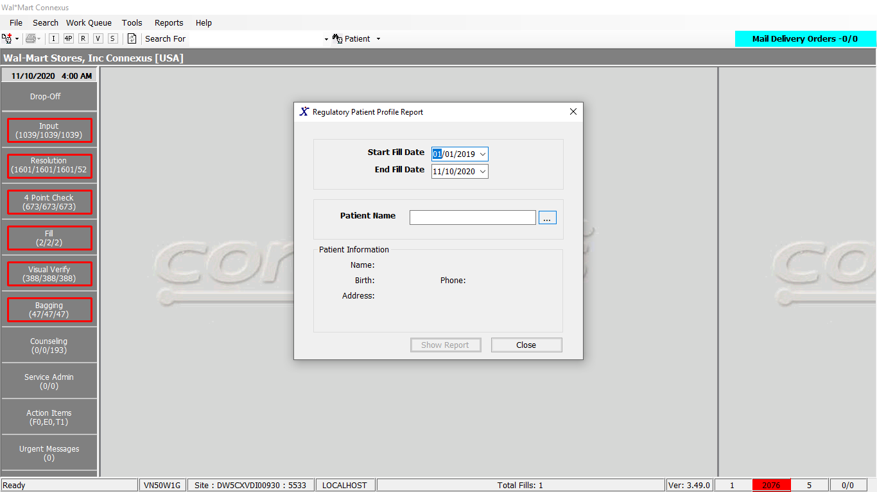

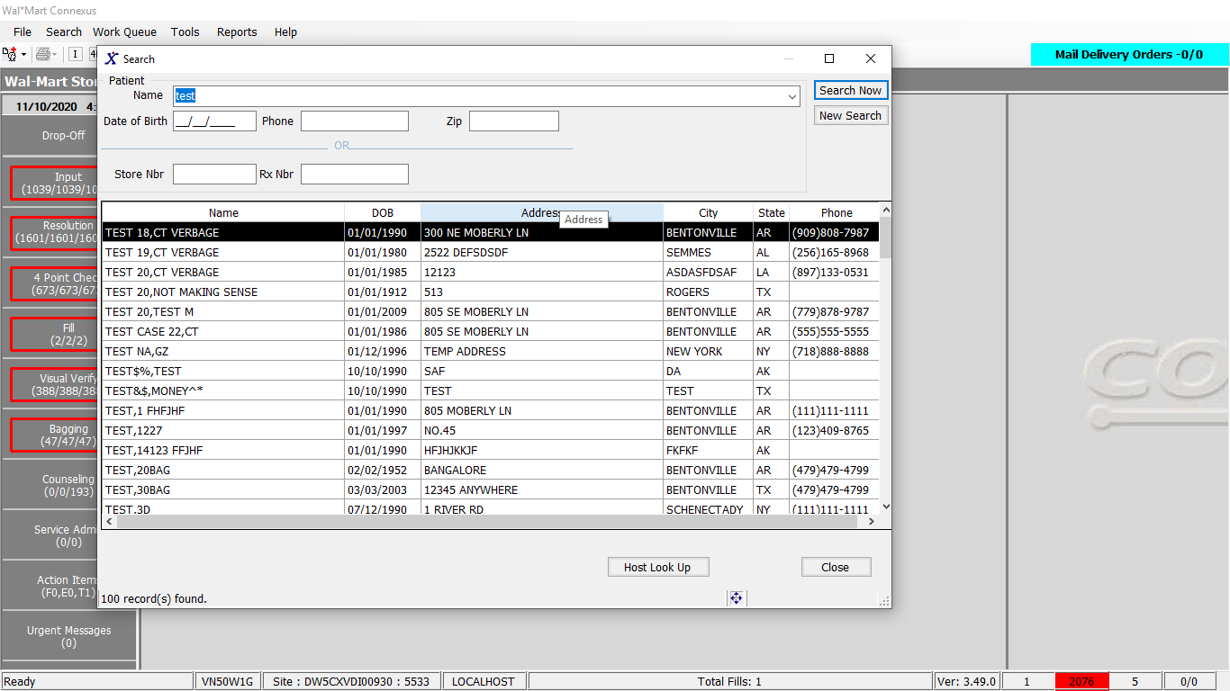

**Response:**

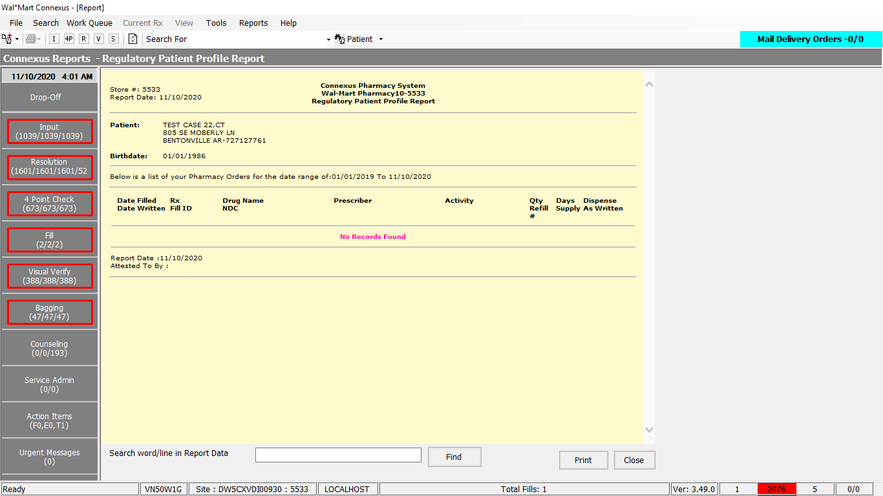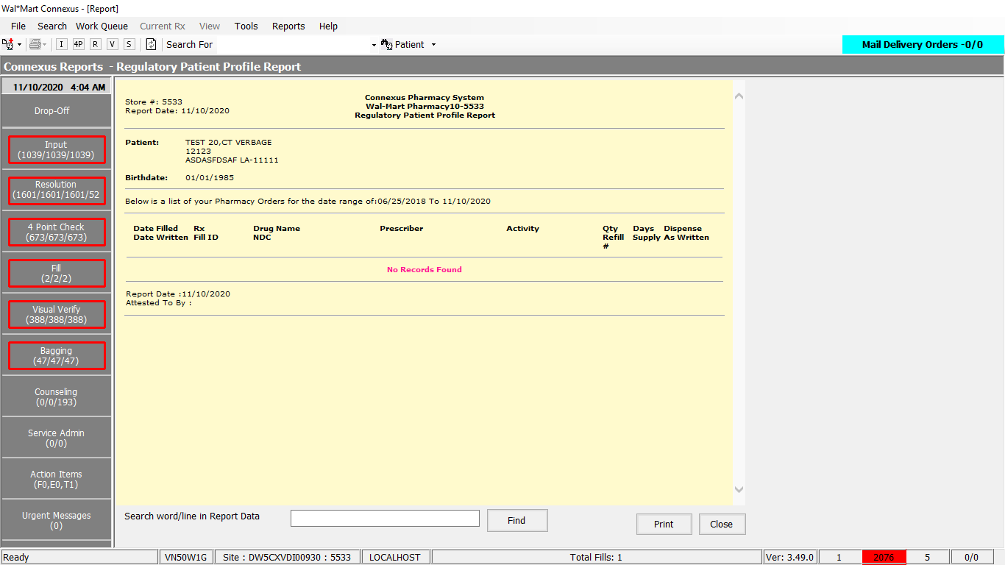

**Query:**

**1.** Friend Const GetMedicalExpensesDataSelectPart1 As String = "SELECT DISTINCT 0 RxStoreNbr, rxf.fill_date , CASE WHEN rx.compound_ind ='Y' then c.compound_name WHEN rx.compound_ind !='Y' then pp.short_name END drug_name, rxf.rx_fill_seq_nbr, rx.rx_nbr,rxf.fill_qty, pct.code_abbr, ref.rx_fill_id centralfill, NVL(rx.rx_check_userid,'N/A') rx_check_userid,NVL(rxf.tech_of_rec_userid,'N/A') tech_of_rec_userid,NVL(rxf.rph_of_rec_userid,'N/A') rph_of_rec_userid ,TRIM(NVL(pr.last_name,'')) || ',' || TRIM(NVL(pr.first_name,'')) || ' ' || TRIM(NVL(pr.middle_name,'')) PrescName, rx.rx_written_date, rx.expanded_sig_txt, rxf.rx_fill_id, CASE WHEN rx.compound_ind ='Y' then 'COMPOUND' ELSE pi.ndc_nbr END ndc_nbr, pgx.gpi_code, rxf.fill_days_sply_qty,NVL(rpl.license_nbr,pl.license_nbr) dea, pl2.license_nbr NPI, patient_due_amt, pos_sale_amt,"

2. GetMedicalExpensesDataExcludeCashPay As String = " ROUND((SELECT SUM(NVL(txn_amt,0)) as tp_amt FROM rx_sale_detail rsd1 WHERE rsd1.rx_fill_id = rxf.rx_fill_id AND rsd1.status_code IN (21005, 21010)), 2) tp_amt, (SELECT NVL(pos_patient_amt,0) FROM pos_activity pa WHERE pa.rx_fill_id = rxf.rx_fill_id AND pos_txn_type_code = 5700 AND pos_seq_nbr = (SELECT MAX(pos_seq_nbr) FROM pos_activity pa1 WHERE pa1.rx_fill_id = pa.rx_fill_id AND pa1.pos_txn_type_code = 5700)) posact_patamt, (SELECT NVL(COUNT(*),0) FROM pos_activity pa2 WHERE pa2.rx_fill_id = rxf.rx_fill_id AND pos_txn_type_code = 5700) posact_count, rxf.fill_type_code,phmc.phm_co_name_abbr,rxf.third_party_ind, rx.rx_id, rx.rx_version_seq_nbr,rx.patient_id,rxf.pos_ts,NVL(rxf.tax_amt,0) tax_amt,rxf.usual_price_amt,(SELECT claim_reference_id FROM claim_response cr WHERE claim_response_id = (SELECT NVL(MAX(claim_response_id),0) FROM claim_response cr1 WHERE cr1.rx_fill_id = rxf.rx_fill_id)) tpref FROM rx rx,rx_fill rxf,rx_fill_item rfi, pharmacy_code_txt pct, OUTER (rx_compound rxc, compound c), OUTER (rx_sale_detail rsd, phm_company phmc), pharmacy_offering:pharmacy_product pp,pharmacy_offering:pharmacy_item pi, prescriber pr,OUTER prescriber_license pl, OUTER rx_prsbr_license rpl, outer prescriber_license pl2, OUTER pharmacy_offering:product_gpi_xref pgx, OUTER rx_fill_activity rfa, OUTER rx_espn_fill ref WHERE rx.rx_id=rxf.rx_id AND rxf.rx_fill_id=rfi.rx_fill_id AND rxf.rx_fill_id = rfa.rx_fill_id AND rfa.activity_code in (32622,1167) AND rxf.rx_fill_id = ref.rx_fill_id AND rxf.daw_code=pct.code_id AND rxc.rx_id = rx.rx_id AND c.compound_id = rxc.compound_id AND pi.product_mds_fam_id=pp.product_mds_fam_id AND rfi.item_mds_fam_id=pi.mds_fam_id AND rpl.rx_id = rx.rx_id AND rx.rx_id NOT IN (SELECT rx_id FROM rx_restrict WHERE expiration_ts IS NULL AND restrict_type_code=400) AND rpl.prescriber_id = rx.prescriber_id AND rpl.license_type_code = 800 AND rfi.item_seq_nbr = (SELECT NVL(MIN(rfi2.item_seq_nbr),1) from rx_fill_item rfi2 where rfi2.rx_fill_id=rxf.rx_fill_id) AND pr.prescriber_id=rx.prescriber_id"

3. Friend Const GetMedicalExpensesDataSelectPart2 As String = " ROUND((SELECT SUM(NVL(txn_amt,0)) as tp_amt FROM rx_sale_detail rsd1 WHERE rsd1.rx_fill_id = rxf.rx_fill_id AND rsd1.status_code IN (21005, 21010)), 2) tp_amt, (SELECT NVL(pos_patient_amt,0) FROM pos_activity pa WHERE pa.rx_fill_id = rxf.rx_fill_id AND pos_txn_type_code = 5700 AND pos_seq_nbr = (SELECT MAX(pos_seq_nbr) FROM pos_activity pa1 WHERE pa1.rx_fill_id = pa.rx_fill_id AND pa1.pos_txn_type_code = 5700)) posact_patamt, (SELECT NVL(COUNT(*),0) FROM pos_activity pa2 WHERE pa2.rx_fill_id = rxf.rx_fill_id AND pos_txn_type_code = 5700) posact_count, rxf.fill_type_code,phmc.phm_co_name_abbr,rxf.third_party_ind, rx.rx_id, rx.rx_version_seq_nbr,rx.patient_id,rxf.pos_ts,NVL(rxf.tax_amt,0) tax_amt,rxf.usual_price_amt,(SELECT claim_reference_id FROM claim_response cr WHERE claim_response_id = (SELECT NVL(MAX(claim_response_id),0) FROM claim_response cr1 WHERE cr1.rx_fill_id = rxf.rx_fill_id)) tpref FROM rx rx,rx_fill rxf,rx_fill_item rfi, pharmacy_code_txt pct, OUTER (rx_compound rxc, compound c), OUTER (rx_sale_detail rsd, phm_company phmc), pharmacy_offering:pharmacy_product pp,pharmacy_offering:pharmacy_item pi, prescriber pr,OUTER prescriber_license pl, OUTER rx_prsbr_license rpl, outer prescriber_license pl2 , OUTER pharmacy_offering:product_gpi_xref pgx, OUTER rx_fill_activity rfa, OUTER rx_espn_fill ref WHERE rx.rx_id=rxf.rx_id AND rxf.rx_fill_id=rfi.rx_fill_id AND rxf.rx_fill_id = rfa.rx_fill_id AND rfa.activity_code in (32622,1167) AND rxf.rx_fill_id = ref.rx_fill_id AND rxf.daw_code=pct.code_id AND rxc.rx_id = rx.rx_id AND c.compound_id = rxc.compound_id AND pi.product_mds_fam_id=pp.product_mds_fam_id AND rfi.item_mds_fam_id=pi.mds_fam_id AND rpl.rx_id = rx.rx_id AND rpl.prescriber_id = rx.prescriber_id AND rpl.license_type_code = 800 AND rfi.item_seq_nbr = (SELECT NVL(MIN(rfi2.item_seq_nbr),1) from rx_fill_item rfi2 where rfi2.rx_fill_id=rxf.rx_fill_id) AND pr.prescriber_id=rx.prescriber_id"

**4.** Friend Const GetMedicalExpensesDataSelectPart3 As String = " AND rxf.rph_of_rec_userid IS NOT NULL AND rxf.status_code= 20401 AND rx.patient_id= ? AND rpl.license_nbr NOT LIKE 'X%' AND rxf.fill_date >= ? AND rxf.fill_date <= ? AND rsd.rx_fill_id = rxf.rx_fill_id AND (rsd.status_code = 21005 OR rsd.status_code = 21010) AND rsd.txn_type_code= 21400 AND rsd.aff_party_id = phmc.phm_co_id AND pgx.product_mds_fam_id = pi.product_mds_fam_id ORDER BY rxf.fill_date "

5. Public Const SetBuPhmParmValue As String = "UPDATE bu_phm_parm SET phm_parm_value = ? " & _

" WHERE phm_parm_code = ?"

# 12.Reports/Inventory Reports/Replenishment Reports/Replenishment Available Report:

Request:

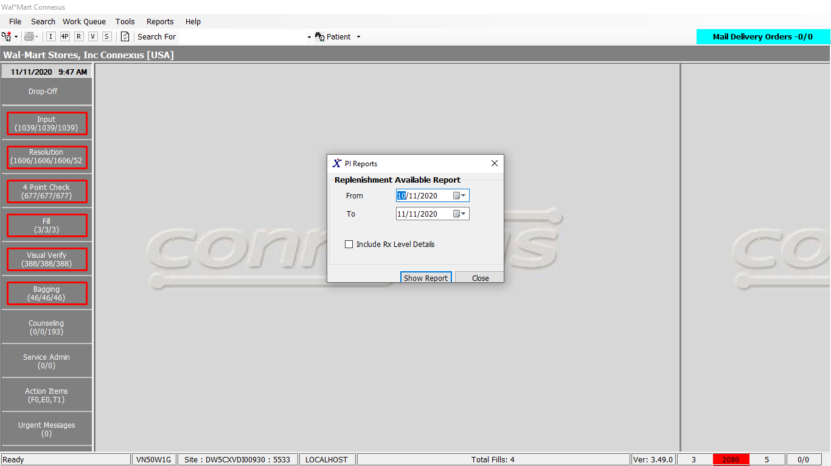

Response:

With “Include Rx level details” not checked:

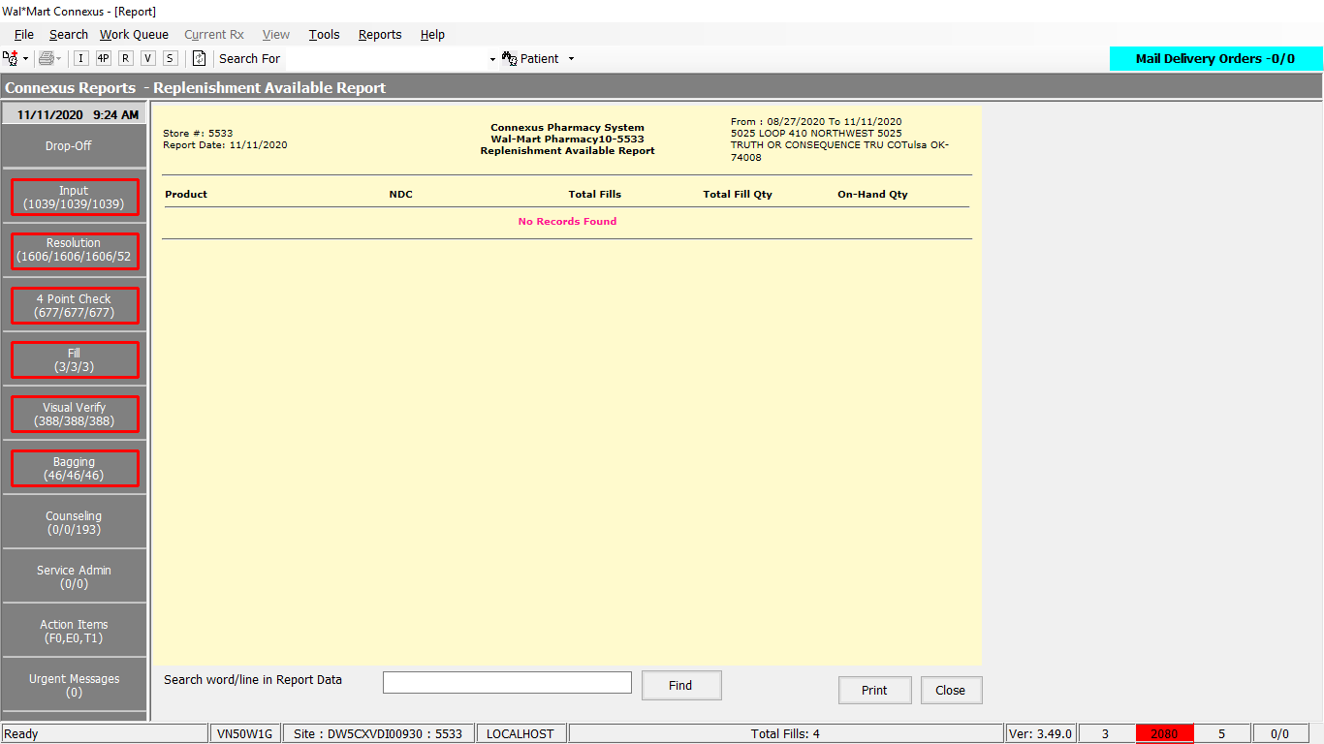

With “Include Rx level details” checked:

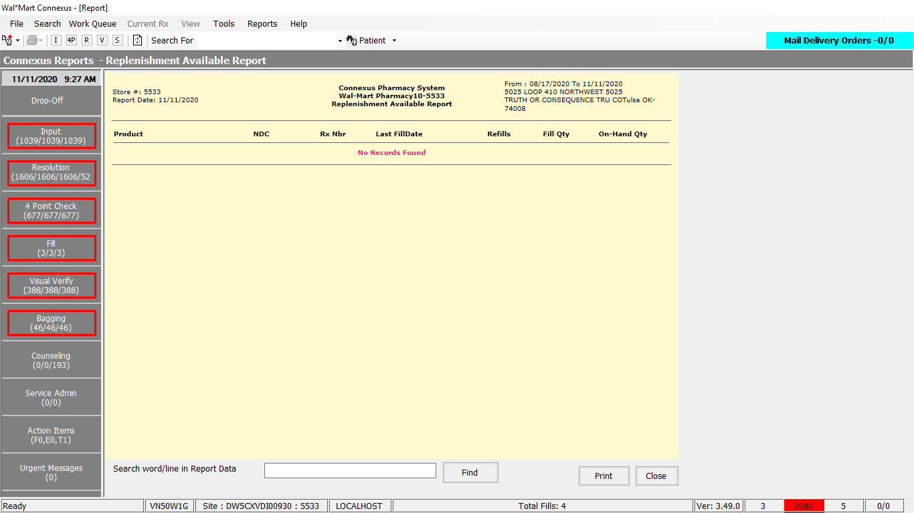

Query:

Friend Const GetReplenishmentAvailableReportSelect1 As String = "SELECT pp.short_name, pi.ndc_nbr, rx.rx_nbr, rf.fill_date, CASE WHEN rx.refill_auth_code IS NOT NULL THEN 'Y' WHEN rx.refill_auth_code IS NULL AND rx.remaining_qty > 0.0 THEN 'Y' ELSE 'N' END Refills, rf.fill_qty, pi.on_hand_qty FROM pharmacy_offering:pharmacy_product pp,pharmacy_offering:pharmacy_item pi, rx rx, rx_fill rf, rx_fill_item rfi WHERE rx.rx_id = rf.rx_id AND rx.rx_version_seq_nbr = (SELECT MAX(rx1.rx_version_seq_nbr) FROM rx rx1 WHERE rx1.rx_id = rx.rx_id) AND rx.rx_version_seq_nbr = rf.rx_version_seq_nbr AND rx.last_rx_fill_id = rf.rx_fill_id AND rf.tech_of_rec_userid is not null AND rf.status_code = 20401 AND rfi.rx_fill_id = rf.rx_fill_id AND rfi.item_mds_fam_id = pi.mds_fam_id AND pi.product_mds_fam_id = pp.product_mds_fam_id AND pi.repl_type_code = 6512 AND pi.repl_status_code = 6500 AND rf.fill_date >= ? AND rf.fill_date <= ? GROUP BY 2, 1, 3, 4, 5, 6, 7 ORDER BY 1, 4 "

Friend Const GetReplenishmentAvailableReportSelect2 As String = " SELECT pp.short_name, pi.ndc_nbr, pi.on_hand_qty, SUM(rf.fill_qty) total_fillqty, COUNT(rx.rx_nbr) total_fills FROM pharmacy_offering:pharmacy_product pp, pharmacy_offering:pharmacy_item pi, rx rx, rx_fill rf, rx_fill_item rfi WHERE rx.rx_id = rf.rx_id AND rx.rx_version_seq_nbr = (SELECT MAX(rx1.rx_version_seq_nbr) FROM rx rx1 WHERE rx1.rx_id = rx.rx_id) AND rf.tech_of_rec_userid is not null AND rf.status_code = 20401 AND rfi.rx_fill_id = rf.rx_fill_id and rfi.item_mds_fam_id = pi.mds_fam_id and pi.product_mds_fam_id = pp.product_mds_fam_id and pi.repl_type_code = 6512 and pi.repl_status_code = 6500 AND rf.fill_date >= ? AND rf.fill_date <= ? GROUP BY 2, 1, 3 ORDER BY 1, 2 "

DAL method:

Public Function GetReplenishmentAvailableReport(ByVal siteId As Integer,

ByVal startDate As DateTime,

ByVal endDate As DateTime,

ByVal includeRx As String) _

As List(Of GetReplenishmentReportInfoBE) Implements IReportDAL.GetReplenishmentAvailableReport

Using (New Tracer(ConnexusCommonConstants.ConnexusTracer))

Dim sqlString As New StringBuilder

Dim getReplenishmentAvailableReprtBEList As New List(Of GetReplenishmentReportInfoBE)

Dim paramList As New List(Of DbParameter)

Select Case includeRx

Case "Y"

sqlString.Append(ReportQueries.GetReplenishmentAvailableReportSelect1)

paramList.Add(ParameterHelper.BuildParameter("fillDate", DbType.Date,

startDate))

paramList.Add(ParameterHelper.BuildParameter("fillDate", DbType.Date,

endDate))

Case "N"

sqlString.Append(ReportQueries.GetReplenishmentAvailableReportSelect2)

paramList.Add(ParameterHelper.BuildParameter("fillDate", DbType.Date,

startDate))

paramList.Add(ParameterHelper.BuildParameter("fillDate", DbType.Date,

endDate))

End Select

Dim dataReader As IDataReader = ExecuteReader(DatabaseEnum.rx21c, siteId,

sqlString.ToString, paramList)

Dim getReplenishmentAvailableRprtBE As New GetReplenishmentReportInfoBE

While dataReader.Read

Select Case includeRx

Case "Y"

getReplenishmentAvailableRprtBE = New GetReplenishmentReportInfoBE

If Not dataReader.IsDBNull(dataReader.GetOrdinal("short_name")) Then

getReplenishmentAvailableRprtBE.ShortName = CStr(dataReader("short_name")).Trim

End If

If Not dataReader.IsDBNull(dataReader.GetOrdinal("ndc_nbr")) Then

getReplenishmentAvailableRprtBE.NdcNbr = CStr(dataReader("ndc_nbr")).Trim

End If

If Not dataReader.IsDBNull(dataReader.GetOrdinal("rx_nbr")) Then

getReplenishmentAvailableRprtBE.RxNbr = CInt(dataReader("rx_nbr"))

End If

If Not dataReader.IsDBNull(dataReader.GetOrdinal("fill_date")) Then

getReplenishmentAvailableRprtBE.FillDate = CDate(dataReader("fill_date"))

End If

If Not dataReader.IsDBNull(dataReader.GetOrdinal("fill_qty")) Then

getReplenishmentAvailableRprtBE.FillQty = CInt(dataReader("fill_qty"))

End If

If Not dataReader.IsDBNull(dataReader.GetOrdinal("Refills")) Then

getReplenishmentAvailableRprtBE.Refills = CStr(dataReader("Refills")).Trim

End If

If Not dataReader.IsDBNull(dataReader.GetOrdinal("on_hand_qty")) Then

getReplenishmentAvailableRprtBE.OnHandQty = CInt(dataReader("on_hand_qty"))

End If

Case "N"

getReplenishmentAvailableRprtBE = New GetReplenishmentReportInfoBE

If Not dataReader.IsDBNull(dataReader.GetOrdinal("short_name")) Then

getReplenishmentAvailableRprtBE.ShortName = CStr(dataReader("short_name")).Trim

End If

If Not dataReader.IsDBNull(dataReader.GetOrdinal("ndc_nbr")) Then

getReplenishmentAvailableRprtBE.NdcNbr = CStr(dataReader("ndc_nbr")).Trim

End If

If Not dataReader.IsDBNull(dataReader.GetOrdinal("total_fills")) Then

getReplenishmentAvailableRprtBE.TotalFills = CInt(dataReader("total_fills"))

End If

If Not dataReader.IsDBNull(dataReader.GetOrdinal("total_fillqty")) Then

getReplenishmentAvailableRprtBE.TotalFillQty = CInt(dataReader("total_fillqty"))

End If

If Not dataReader.IsDBNull(dataReader.GetOrdinal("on_hand_qty")) Then

getReplenishmentAvailableRprtBE.OnHandQty = CInt(dataReader("on_hand_qty"))

End If

End Select

getReplenishmentAvailableReprtBEList.Add(getReplenishmentAvailableRprtBE)

End While

If getReplenishmentAvailableReprtBEList.Count > 0 Then

Return getReplenishmentAvailableReprtBEList

Else

Return Nothing

End If

End Using

End Function

# 13.Reports/Inventory Reports/Replenishment Reports/Replenishment Un Available Report:

Request:

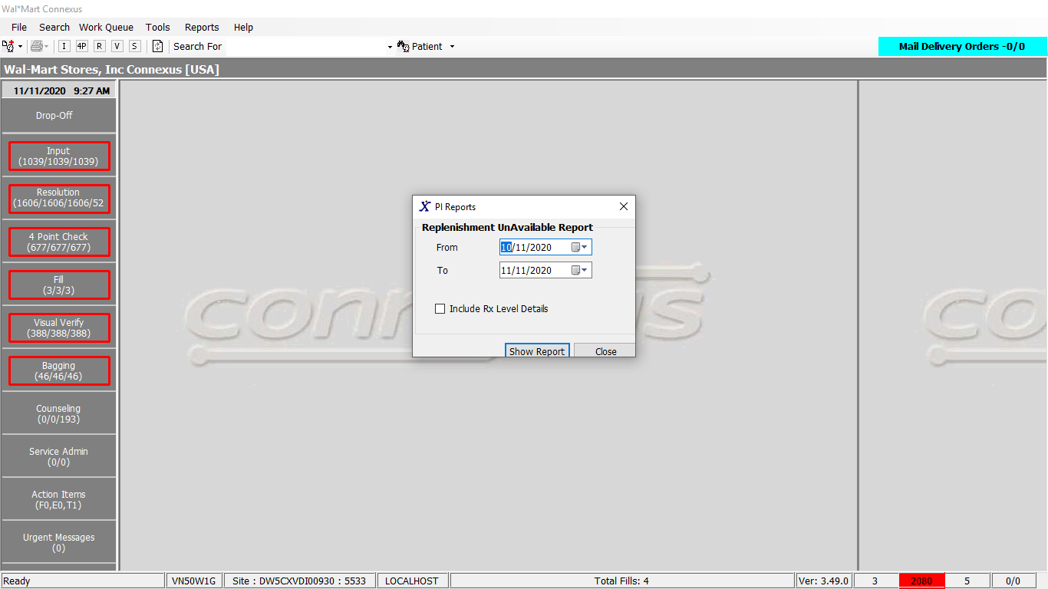

Response:

With “Include Rx Details” not checked:

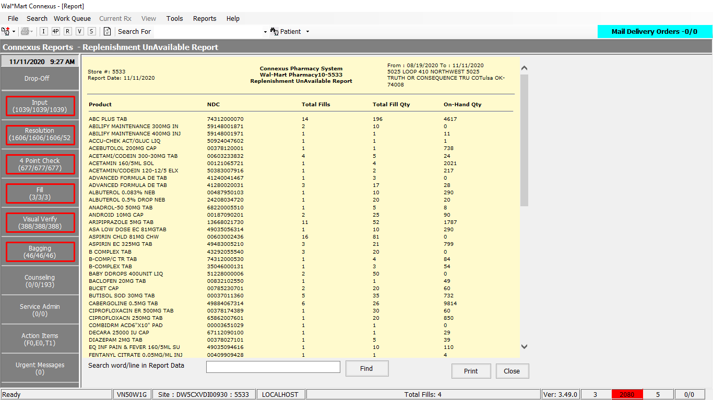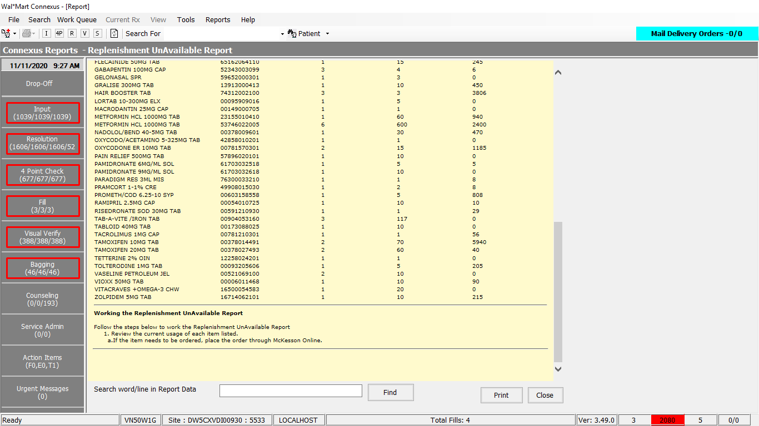

With “Include Rx Details ” checked:

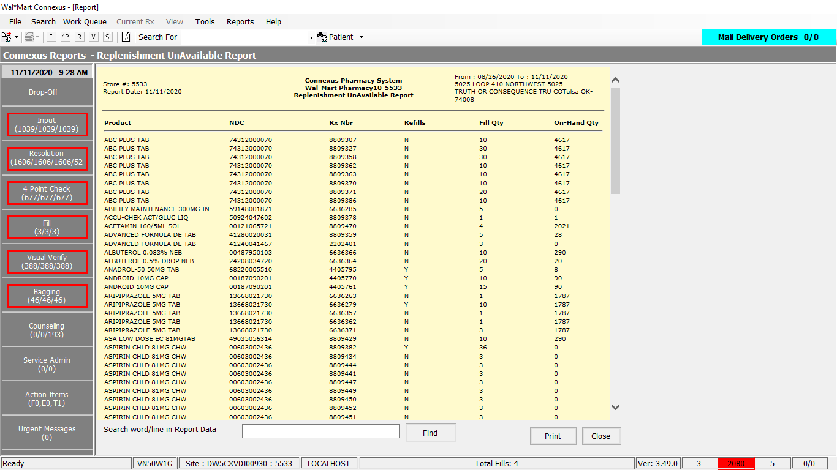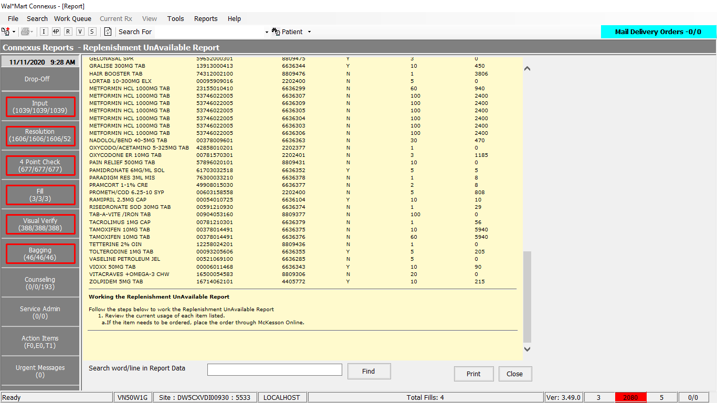

Query

Friend Const GetReplenishmentUnAvailableReportIncludeRxY As String = " SELECT pp.short_name, pi.ndc_nbr, rx.rx_nbr, rf.fill_date, CASE WHEN rx.refill_auth_code IS NOT NULL THEN 'Y' WHEN rx.refill_auth_code IS NULL AND rx.remaining_qty > 0.0 THEN 'Y' ELSE 'N' END Refills, rf.fill_qty, pi.on_hand_qty FROM pharmacy_offering:pharmacy_product pp, pharmacy_offering:pharmacy_item pi, rx rx, rx_fill rf, rx_fill_item rfi WHERE rx.rx_id = rf.rx_id AND rx.rx_version_seq_nbr = (SELECT MAX(rx1.rx_version_seq_nbr) FROM rx rx1 WHERE rx1.rx_id = rx.rx_id) AND rx.rx_version_seq_nbr = rf.rx_version_seq_nbr AND rx.last_rx_fill_id = rf.rx_fill_id AND rf.tech_of_rec_userid is not null AND rf.status_code = 20401 AND rfi.rx_fill_id = rf.rx_fill_id AND rfi.item_mds_fam_id = pi.mds_fam_id AND pi.product_mds_fam_id = pp.product_mds_fam_id AND pi.repl_type_code = 6510 "

GetReplenishmentUnAvailableReportIncludeRxN As String = " SELECT pp.short_name, pi.ndc_nbr, pi.on_hand_qty, SUM(rf.fill_qty) total_fill_qty, COUNT(rx.rx_nbr) total_fills FROM pharmacy_offering:pharmacy_product pp, pharmacy_offering:pharmacy_item pi, rx rx, rx_fill rf, rx_fill_item rfi WHERE rx.rx_id = rf.rx_id AND rx.rx_version_seq_nbr = (SELECT MAX(rx1.rx_version_seq_nbr) FROM rx rx1 WHERE rx1.rx_id = rx.rx_id) AND rf.tech_of_rec_userid is not null AND rf.status_code = 20401 AND rfi.rx_fill_id = rf.rx_fill_id AND rfi.item_mds_fam_id = pi.mds_fam_id AND pi.product_mds_fam_id = pp.product_mds_fam_id AND pi.repl_type_code = 6510 "

DAL :

Friend Shared Function GetReplenishmentUnAvailableReport _

(ByVal reporUE As CommonDatePickerUE) As List(Of CommonDatePickerUE)

Using tracer As New Tracer(ConnexusCommonConstants.ConnexusTracer)

Dim resultUE As List(Of CommonDatePickerUE) = Nothing

'Creating proxy,request and response objects for making the service call

Dim reportService As IReport = ProxyManager.GetWCFProxy(Of IReport)()

Dim requestReport As GetReplenishmentUnAvailableReportRequest = New GetReplenishmentUnAvailableReportRequest()

Dim responseReport As GetReplenishmentUnAvailableReportResponse = New GetReplenishmentUnAvailableReportResponse()

With requestReport

.SiteID = ContextManager.SiteId

.EndDate = reporUE.ToDate

.StartDate = reporUE.FromDate

.IncludeRx = reporUE.RxDetailsChecked.ToString()

End With

'Calling Report Service for getting data for Replenishment UnAvailable Report

responseReport = reportService.GetReplenishmentUnAvailableReport(requestReport)

resultUE = New List(Of CommonDatePickerUE)

If responseReport IsNot Nothing AndAlso

responseReport.GetReplenishmentReportInfo IsNot Nothing Then

resultUE = New List(Of CommonDatePickerUE)

resultUE = responseReport.GetReplenishmentReportInfo.ConvertAll(

Of CommonDatePickerUE)(New Converter(Of

GetReplenishmentReportInfoBE, CommonDatePickerUE) _

(AddressOf ReportMapper.ConvertToReplenishmentUnAvailableUE))

End If

Return resultUE

End Using

End Function

# 14. Reports/Inventory Reports/100 days Drugs not used:

Request:

(Took screen shots for different situations)

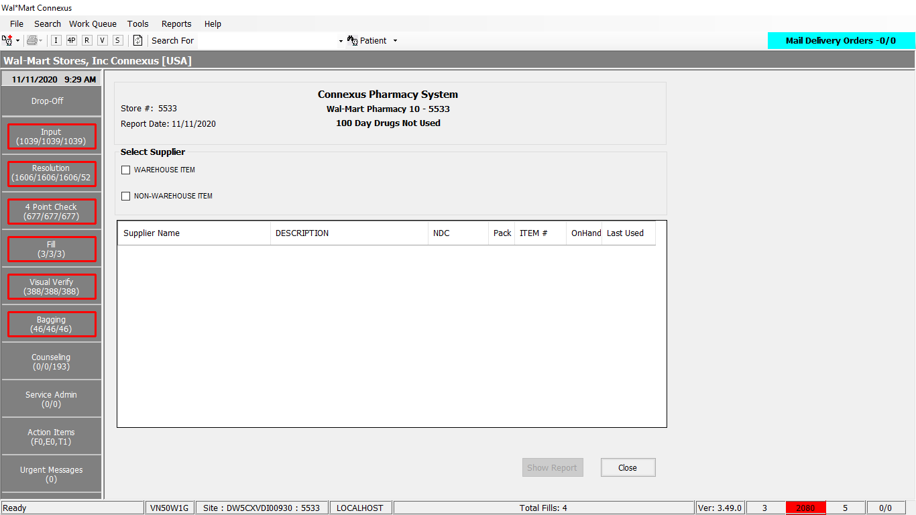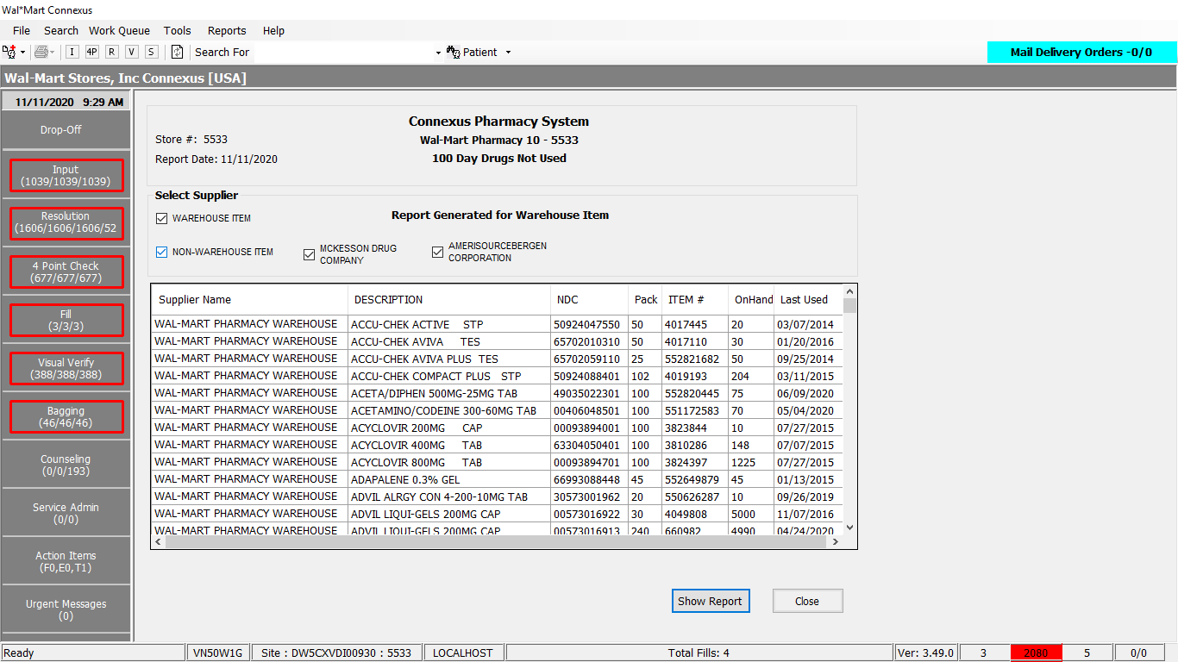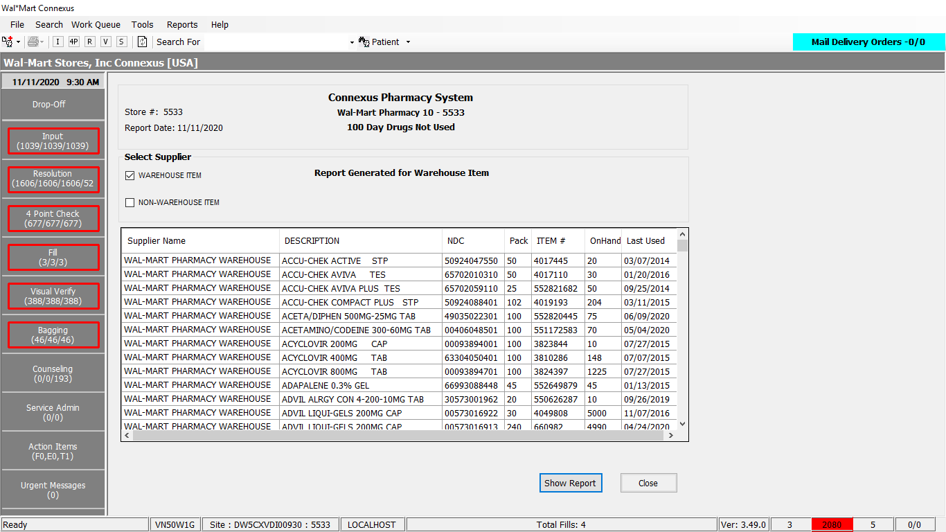

Response:

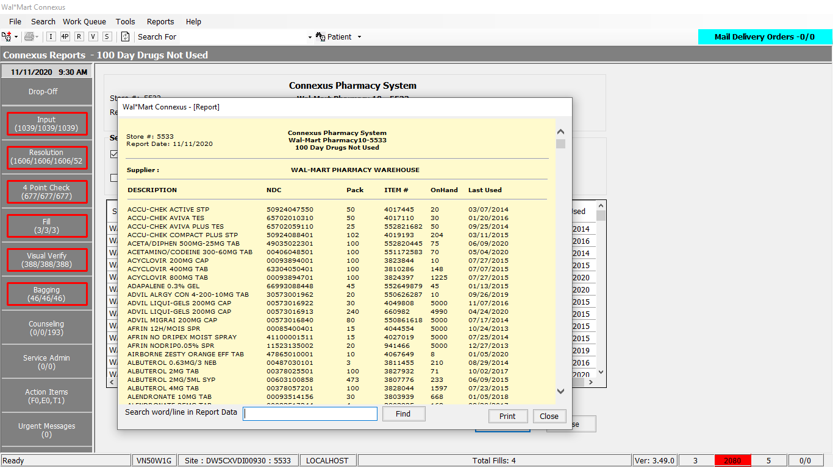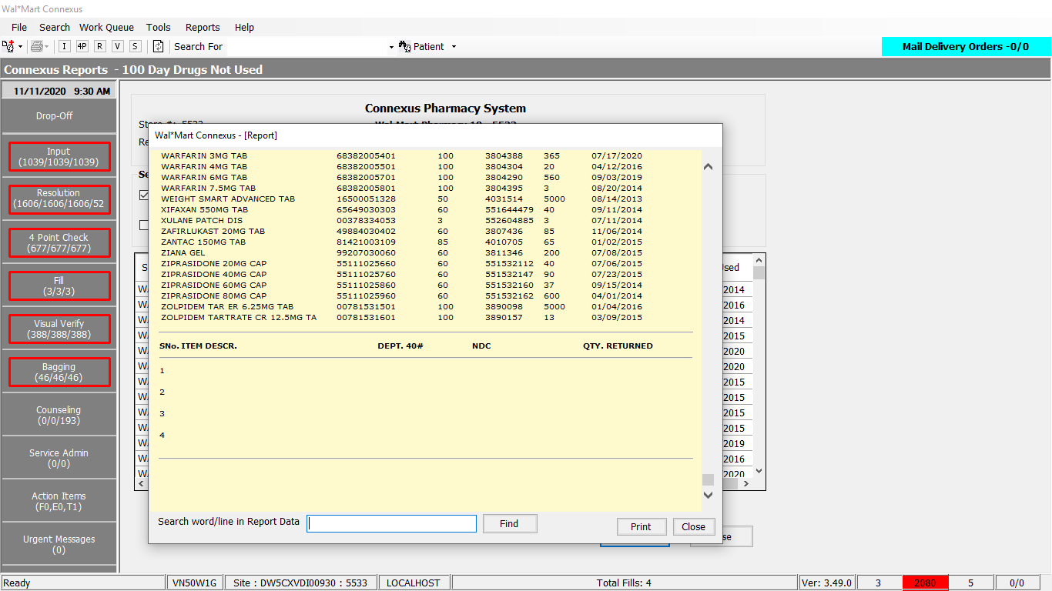

Query

Explicit query is not there ,it is embedded in DAL method

DAL Layer

Public Function GetDrugLast100DaysNotUsed(ByVal siteId As Integer,

ByVal wareHouseItemIndicator As Integer,

ByVal nonWareHouseItemIndicator As Integer) _

As List(Of GetDrugLast100DaysNotUsedInfoBE) Implements IReportDAL.GetDrugLast100DaysNotUsed

Using (New Tracer(ConnexusCommonConstants.ConnexusTracer))

'Declare the method variables

Dim sqlString As New StringBuilder

Dim partialSql As New StringBuilder

Dim getDrgLast100DaysNotUsedInfoBEList As New List(Of GetDrugLast100DaysNotUsedInfoBE)

If Not (wareHouseItemIndicator <> 0 And nonWareHouseItemIndicator <> 0) Then

If wareHouseItemIndicator <> 0 Then

partialSql.Append(" IN (" & wareHouseItemIndicator & "," &

nonWareHouseItemIndicator & ")")

Else

partialSql.Append(" NOT IN (" & ServicesCommonConstants.WareHouseItem & ")")

End If

End If

sqlString.Append("SELECT pp.short_name, pi.ndc_nbr,pi.inner_pack_qty,")

sqlString.Append(" pir.supplier_ref_nbr, pi.on_hand_qty, ")

sqlString.Append(" CASE WHEN pi.last_dispense_date IS NOT NULL THEN ")

'Modified by Infosys for QA40 - Service Reconciliation

If CacheWrapperDal.GetActiveCountryCode = ServicesCommonConstants.USACC Then

sqlString.Append(" to_char(pi.last_dispense_date,'%m/%d/%iY') ")

sqlString.Append(" ELSE to_char(pi.last_change_ts,'%m/%d/%iY') ")

ElseIf CacheWrapperDal.GetActiveCountryCode = ServicesCommonConstants.CanadaCC Then

sqlString.Append(" to_char(pi.last_dispense_date,'%d/%m/%iY') ")

sqlString.Append(" ELSE to_char(pi.last_change_ts,'%d/%m/%iY') ")

End If

'End of Changes

sqlString.Append(" END last_dispense_date, pir.phm_co_id ")

sqlString.Append(" FROM pharmacy_item pi,")

sqlString.Append(" pharmacy_product pp, ")

sqlString.Append(" phm_item_repl pir, ")

sqlString.Append(" rx21c:phm_company pc ")

sqlString.Append(" WHERE pi.product_mds_fam_id = pp.product_mds_fam_id ")

sqlString.Append(" AND on_hand_qty > 0 ")

sqlString.Append(" AND pi.mds_fam_id = pir.mds_fam_id ")

sqlString.Append(" AND pir.pri_supplier_ind = 'Y' ")

sqlString.Append(" AND pi.status_code = " & ServicesCommonConstants.PhmItemAct)

sqlString.Append(" AND pp.status_code = " & ServicesCommonConstants.PhmProdAct)

sqlString.Append(" AND pir.mds_fam_id = pi.mds_fam_id ")

sqlString.Append(" AND pc.phm_co_id = pir.phm_co_id ")

sqlString.Append(" AND DATE(CASE WHEN pi.last_dispense_date IS NOT NULL THEN ")

sqlString.Append(" to_char(pi.last_dispense_date,'%m/%d/%iY') ")

sqlString.Append(" ELSE to_char(pi.last_change_ts,'%m/%d/%iY') END) ")

sqlString.Append(" < (TODAY - 100 UNITS DAY) ")

If Not (wareHouseItemIndicator <> 0 And nonWareHouseItemIndicator <> 0) Then _

sqlString.Append(" AND pc.phm_co_id ")

sqlString.Append(partialSql)

sqlString.Append(" ORDER BY pir.phm_co_id,pp.short_name ")

Dim dataReader As IDataReader = ExecuteReader(DatabaseEnum.Pharmacy_Offering,

siteId, sqlString.ToString)

Dim getDrglast100DaysNotUsedBE As GetDrugLast100DaysNotUsedInfoBE

While dataReader.Read

getDrglast100DaysNotUsedBE = New GetDrugLast100DaysNotUsedInfoBE

If Not dataReader.IsDBNull(dataReader.GetOrdinal("inner_pack_qty")) Then

getDrglast100DaysNotUsedBE.InnerPackQty = CInt(dataReader("inner_pack_qty"))

End If

If Not dataReader.IsDBNull(dataReader.GetOrdinal("last_dispense_date")) Then

getDrglast100DaysNotUsedBE.LastDispenseDate = CStr(dataReader("last_dispense_date")).Trim

End If

If Not dataReader.IsDBNull(dataReader.GetOrdinal("ndc_nbr")) Then

getDrglast100DaysNotUsedBE.NdcNbr = CStr(dataReader("ndc_nbr")).Trim

End If

If Not dataReader.IsDBNull(dataReader.GetOrdinal("on_hand_qty")) Then

getDrglast100DaysNotUsedBE.OnHandQty = CInt(dataReader("on_hand_qty"))

End If

If Not dataReader.IsDBNull(dataReader.GetOrdinal("phm_co_id")) Then

getDrglast100DaysNotUsedBE.PhmCoId = CInt(dataReader("phm_co_id"))

End If

If Not dataReader.IsDBNull(dataReader.GetOrdinal("short_name")) Then

getDrglast100DaysNotUsedBE.ShortName = CStr(dataReader("short_name")).Trim

End If

If Not dataReader.IsDBNull(dataReader.GetOrdinal("supplier_ref_nbr")) Then

getDrglast100DaysNotUsedBE.SupplierRefNbr = CStr(dataReader("supplier_ref_nbr")).Trim

End If

'Add the BE to the BEList

getDrgLast100DaysNotUsedInfoBEList.Add(getDrglast100DaysNotUsedBE)

End While

If getDrgLast100DaysNotUsedInfoBEList.Count > 0 Then

Return getDrgLast100DaysNotUsedInfoBEList

Else

Return Nothing

End If

End Using

End Function

# 15. Reports/Inventory Reports/Cycle Count Report:

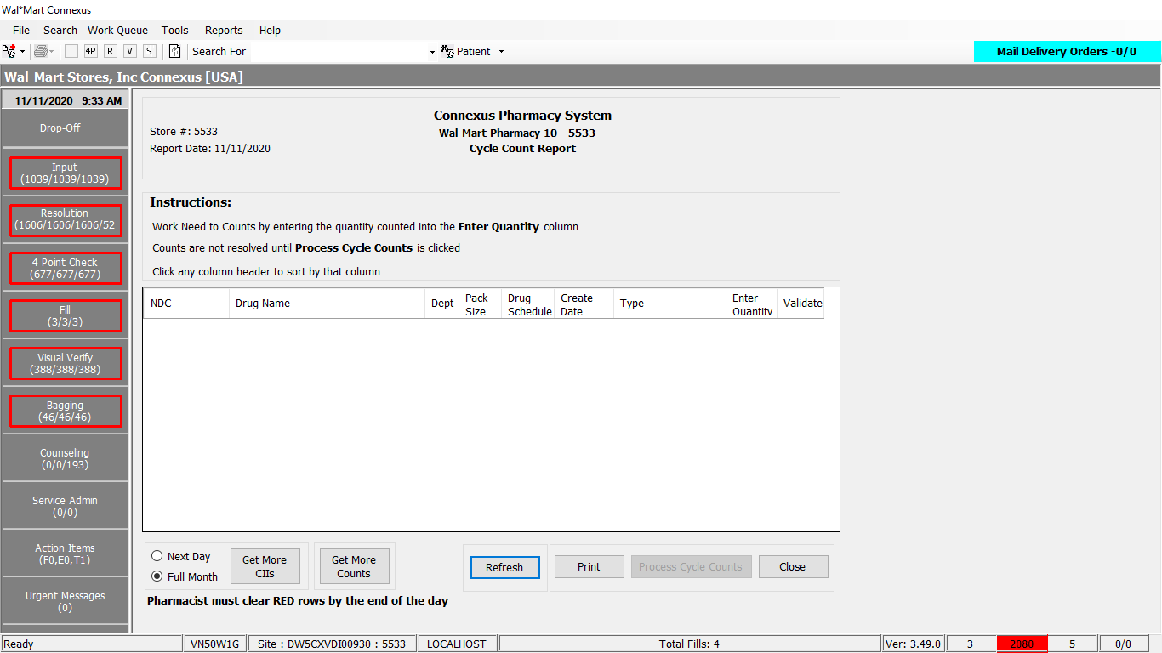

Note: Could not fetch data and by looking (intuitive) there is not response sheet.

Queries:

  Public Const GetCycleCountItemsQuery As String = "  SELECT ndc_nbr, short_name, dept_nbr, create_ts, PackSize, drug_control_abbr, " &

                                                " on_hand_qty, mds_fam_id, drug_control_code, count_reason_code, count_role_code," &

                                                " count_cycle_id, problem_seq_nbr, last_change_ts, count_reason_desc,priority_nbr FROM " &

                                                " ( SELECT  *, ROW_NUMBER() OVER (PARTITION BY mds_fam_id ORDER BY priority_nbr,count_reason_code desc) As ROWNUMBER FROM " &

                                                " ( SELECT pi.ndc_nbr, pp.short_name,pi.dept_nbr, max(pip.create_ts) as create_ts, " &

                                                " (pi.outer_pack_qty* pi.inner_pack_qty) PackSize, dct.drug_control_abbr, " &

                                                " pi.on_hand_qty , pi.mds_fam_id, pp.drug_control_code, pip.count_reason_code, " &

                                                " case " &

                                                " when count_role_code is null then " &

                                                " case " &

                                                " when pp.drug_control_code = 2300 then 3030 " &

                                                " else 3000 end " &

                                                " else count_role_code " &

                                                " end as count_role_code, " &

                                                " count_cycle_id, pip.problem_seq_nbr, pi.last_change_ts, icrt.count_reason_desc, " &

                                                "  case when priority_nbr is null then 5000 else priority_nbr end as priority_nbr " &

                                                " FROM pharmacy_product pp, " &

                                                " pharmacy_item pi, drug_control_text dct, phm_item_problem pip " &

                                                " LEFT OUTER JOIN pharmacy_offering:item_count_reason_txt icrt On pip.count_reason_code=icrt.count_reason_code " &

                                                " WHERE pi.mds_fam_id = pip.mds_fam_id " &

                                                " AND pi.product_mds_fam_id = pp.product_mds_fam_id " &

                                                " AND dct.drug_control_code = pp.drug_control_code " &

                                                " AND problem_type_code = 9001 " &

                                                " AND problem_stat_code = 6320 " &

                                                " AND (count_role_code <= ? or (count_role_code is null and ((? = 3000 and pp.drug_control_code > 2300) or (? = 3030 and pp.drug_control_code >= 2300)))) " &

                                                " GROUP BY ndc_nbr, short_name,dept_nbr, packsize, drug_control_abbr, on_hand_qty, mds_fam_id, " &

                                                " drug_control_code, count_reason_code, count_role_code, count_cycle_id, priority_nbr, problem_seq_nbr, last_change_ts, count_reason_desc " &

                                                " ORDER BY priority_nbr, create_ts, case count_reason_code when 2011 then 10 else 9 end, drug_control_code, short_name " &

                                                " )ORDER BY priority_nbr) WHERE ROWNUMBER = 1"

Public Const GenerateC2CycleCount = "call spcyclecountgenerator(?,?);"

  Public Const UpdateNeedToCountStatus As String = "UPDATE phm_item_problem SET problem_stat_code = ?, resolved_ts = current, resolved_userid = ? " &

                                                         " WHERE mds_fam_id = ? " &

                                                         "   AND problem_stat_code IN (6320, 6322) " &

                                                          "   AND problem_type_code = 9001 "

Public Const GetCycleCountItemsQuery As String = "  SELECT ndc_nbr, short_name, dept_nbr, create_ts, PackSize, drug_control_abbr, " &

                                                " on_hand_qty, mds_fam_id, drug_control_code, count_reason_code, count_role_code," &

                                                " count_cycle_id, problem_seq_nbr, last_change_ts, count_reason_desc,priority_nbr FROM " &

                                                " ( SELECT  *, ROW_NUMBER() OVER (PARTITION BY mds_fam_id ORDER BY priority_nbr,count_reason_code desc) As ROWNUMBER FROM " &

                                                " ( SELECT pi.ndc_nbr, pp.short_name,pi.dept_nbr, max(pip.create_ts) as create_ts, " &

                                                " (pi.outer_pack_qty* pi.inner_pack_qty) PackSize, dct.drug_control_abbr, " &

                                                " pi.on_hand_qty , pi.mds_fam_id, pp.drug_control_code, pip.count_reason_code, " &

                                                " case " &

                                                " when count_role_code is null then " &

                                                " case " &

                                                " when pp.drug_control_code = 2300 then 3030 " &

                                                " else 3000 end " &

                                                " else count_role_code " &

                                                " end as count_role_code, " &

                                                " count_cycle_id, pip.problem_seq_nbr, pi.last_change_ts, icrt.count_reason_desc, " &

                                                "  case when priority_nbr is null then 5000 else priority_nbr end as priority_nbr " &

                                                " FROM pharmacy_product pp, " &

                                                " pharmacy_item pi, drug_control_text dct, phm_item_problem pip " &

                                                " LEFT OUTER JOIN pharmacy_offering:item_count_reason_txt icrt On pip.count_reason_code=icrt.count_reason_code " &

                                                " WHERE pi.mds_fam_id = pip.mds_fam_id " &

                                                " AND pi.product_mds_fam_id = pp.product_mds_fam_id " &

                                                " AND dct.drug_control_code = pp.drug_control_code " &

                                                " AND problem_type_code = 9001 " &

                                                " AND problem_stat_code = 6320 " &

                                                " AND (count_role_code <= ? or (count_role_code is null and ((? = 3000 and pp.drug_control_code > 2300) or (? = 3030 and pp.drug_control_code >= 2300)))) " &

                                                " GROUP BY ndc_nbr, short_name,dept_nbr, packsize, drug_control_abbr, on_hand_qty, mds_fam_id, " &

                                                " drug_control_code, count_reason_code, count_role_code, count_cycle_id, priority_nbr, problem_seq_nbr, last_change_ts, count_reason_desc " &

                                                " ORDER BY priority_nbr, create_ts, case count_reason_code when 2011 then 10 else 9 end, drug_control_code, short_name " &

                                                " )ORDER BY priority_nbr) WHERE ROWNUMBER = 1"

DAL

Public Function GetCycleCountInfo(ByVal siteId As Integer, ByVal role As Integer) As List(Of CycleCountItemBE) Implements IItemDAL.GetCycleCountInfo

Using (New Tracer(ConnexusCommonConstants.ConnexusTracer))

Dim IsZippoEnabled As String = BaseDAL.GetBUPhmParm(siteId, BuPhmParmCode.ZippoFlag)

Dim cycleCountInfo As New List(Of CycleCountItemBE)

Dim paramList As New List(Of DbParameter)

Dim querySQL As New StringBuilder

Dim countRoleCode As Integer = 3000

If role = CycleCountRole.Pharmacist Then

countRoleCode = 3030

Else

countRoleCode = 3000

End If

paramList.AddParameter(DbType.Int16, countRoleCode)

paramList.AddParameter(DbType.Int16, countRoleCode)

paramList.AddParameter(DbType.Int16, countRoleCode)

querySQL.Append(DataAccess.ItemQueries.GetCycleCountItemsQuery)

Using dr As IDataReader = ExecuteReader(DatabaseEnum.Pharmacy_Offering, siteId, querySQL.ToString, paramList)

'Retrieve data from datareader to data entity

While dr.Read

Dim countInfo As New CycleCountItemBE

With countInfo

.NDC = dr.GetValueOrDefault(Of String)("ndc_nbr").SafeTrim

.Description = dr.GetValueOrDefault(Of String)("short_name").SafeTrim

.Dept_Nbr = dr.GetValueOrDefault(Of Int16)("dept_nbr")

.CreateDate = Convert.ToDateTime(dr.GetValueOrDefault(Of DateTime?)("create_ts")).Date

.Pack_Size = SafeConvert.ToInteger32(dr.GetValueOrDefault(Of Decimal)("PackSize"))

.Drug_Schedule = dr.GetValueOrDefault(Of String)("drug_control_abbr").SafeTrim

.OnHandQuantity = dr.GetValueOrDefault(Of Decimal)("on_hand_qty")

.MdsfamId = dr.GetValueOrDefault(Of Integer)("mds_fam_id")

.DrugControl_Code = dr.GetValueOrDefault(Of Int16)("drug_control_code")

.CountReason_Code = dr.GetValueOrDefault(Of Int16)("count_reason_code")

If SafeConvert.ToBoolean(IsZippoEnabled) Then

.IsZippoEnabled = True

Else

.IsZippoEnabled = False

End If

.Count_Cycle_Id = dr.GetValueOrDefault(Of Integer)("count_cycle_id")

.Count_Role_Code = dr.GetValueOrDefault(Of Integer)("count_role_code")

.Priority_Nbr = dr.GetValueOrDefault(Of Integer)("priority_nbr")

.Update_CountRoleCode = False

.ProblemSeqNbr = dr.GetValueOrDefault(Of Int16)("problem_seq_nbr")

.CountReasonDesc = dr.GetValueOrDefault(Of String)("count_reason_desc").SafeTrim

.last_change_ts = Convert.ToDateTime(dr.GetValueOrDefault(Of DateTime?)("last_change_ts")).Date

End With

cycleCountInfo.Add(countInfo)

End While

Return cycleCountInfo

End Using

End Using

End Function

Public Function GenerateCycleCount(ByVal siteId As Integer, ByVal isFullMonthSelected As Boolean, ByVal RequestType As Integer) As Integer Implements IItemDAL.GenerateCycleCount

Using (New Tracer(ConnexusCommonConstants.ConnexusTracer))

Dim paramList As New List(Of DbParameter)

Dim c2CycleCountGenResult As Integer

Try

'1001 - Generates C2 cycle count

'1000 - Genrates Non C2 Cycle Count

paramList.AddParameter(DbType.Int32, RequestType, "GenerateRequestType")

paramList.AddParameter(DbType.Boolean, isFullMonthSelected, "full_month")

'Calling stored Procedure spcyclecountgenerator

Using dr As IDataReader = ExecuteReader(DatabaseEnum.Pharmacy_Offering, siteId, ItemQueries.GenerateC2CycleCount, paramList)

If dr.Read Then

c2CycleCountGenResult = dr.GetValueOrDefault(Of Integer)(0)

End If

End Using

Catch ex As Exception

'There is an exception in generating the C2 Cycle count.

c2CycleCountGenResult = -1

End Try

'return_code=-1 if there is an error

'return_code = 0 if items are generated as expected

'return_code = 1 if all the items have been counted this month

Return c2CycleCountGenResult

End Using

End Function

Public Sub UpdateNeedToCountStatus(ByVal siteId As Integer, ByVal itemMdsFamId As Integer,

ByVal statusCode As Integer, ByVal userId As String) Implements IItemDAL.UpdateNeedToCountStatus

Using (New Tracer(ConnexusCommonConstants.ConnexusTracer))

Dim paramList As New List(Of DbParameter)

paramList.AddParameter(DbType.Int32, statusCode)

paramList.AddParameter(DbType.String, userId)

paramList.AddParameter(DbType.Int32, itemMdsFamId)

If itemMdsFamId > 0 Then

ExecuteNonQuery(DatabaseEnum.Pharmacy_Offering, siteId, ItemQueries.UpdateNeedToCountStatus, paramList)

End If

End Using

End Sub

Public Function GetCycleCountInfo(ByVal siteId As Integer, ByVal role As Integer) As List(Of CycleCountItemBE) Implements IItemDAL.GetCycleCountInfo

Using (New Tracer(ConnexusCommonConstants.ConnexusTracer))

Dim IsZippoEnabled As String = BaseDAL.GetBUPhmParm(siteId, BuPhmParmCode.ZippoFlag)

Dim cycleCountInfo As New List(Of CycleCountItemBE)

Dim paramList As New List(Of DbParameter)

Dim querySQL As New StringBuilder

Dim countRoleCode As Integer = 3000

If role = CycleCountRole.Pharmacist Then

countRoleCode = 3030

Else

countRoleCode = 3000

End If

paramList.AddParameter(DbType.Int16, countRoleCode)

paramList.AddParameter(DbType.Int16, countRoleCode)

paramList.AddParameter(DbType.Int16, countRoleCode)

querySQL.Append(DataAccess.ItemQueries.GetCycleCountItemsQuery)

Using dr As IDataReader = ExecuteReader(DatabaseEnum.Pharmacy_Offering, siteId, querySQL.ToString, paramList)

'Retrieve data from datareader to data entity

While dr.Read

Dim countInfo As New CycleCountItemBE

With countInfo

.NDC = dr.GetValueOrDefault(Of String)("ndc_nbr").SafeTrim

.Description = dr.GetValueOrDefault(Of String)("short_name").SafeTrim

.Dept_Nbr = dr.GetValueOrDefault(Of Int16)("dept_nbr")

.CreateDate = Convert.ToDateTime(dr.GetValueOrDefault(Of DateTime?)("create_ts")).Date

.Pack_Size = SafeConvert.ToInteger32(dr.GetValueOrDefault(Of Decimal)("PackSize"))

.Drug_Schedule = dr.GetValueOrDefault(Of String)("drug_control_abbr").SafeTrim

.OnHandQuantity = dr.GetValueOrDefault(Of Decimal)("on_hand_qty")

.MdsfamId = dr.GetValueOrDefault(Of Integer)("mds_fam_id")

.DrugControl_Code = dr.GetValueOrDefault(Of Int16)("drug_control_code")

.CountReason_Code = dr.GetValueOrDefault(Of Int16)("count_reason_code")

If SafeConvert.ToBoolean(IsZippoEnabled) Then

.IsZippoEnabled = True

Else

.IsZippoEnabled = False

End If

.Count_Cycle_Id = dr.GetValueOrDefault(Of Integer)("count_cycle_id")

.Count_Role_Code = dr.GetValueOrDefault(Of Integer)("count_role_code")

.Priority_Nbr = dr.GetValueOrDefault(Of Integer)("priority_nbr")

.Update_CountRoleCode = False

.ProblemSeqNbr = dr.GetValueOrDefault(Of Int16)("problem_seq_nbr")

.CountReasonDesc = dr.GetValueOrDefault(Of String)("count_reason_desc").SafeTrim

.last_change_ts = Convert.ToDateTime(dr.GetValueOrDefault(Of DateTime?)("last_change_ts")).Date

End With

cycleCountInfo.Add(countInfo)

End While

Return cycleCountInfo

End Using

End Using

End Function

# 16.Reports/Inventory Reports/CII Reports/CII Digital Logbook:

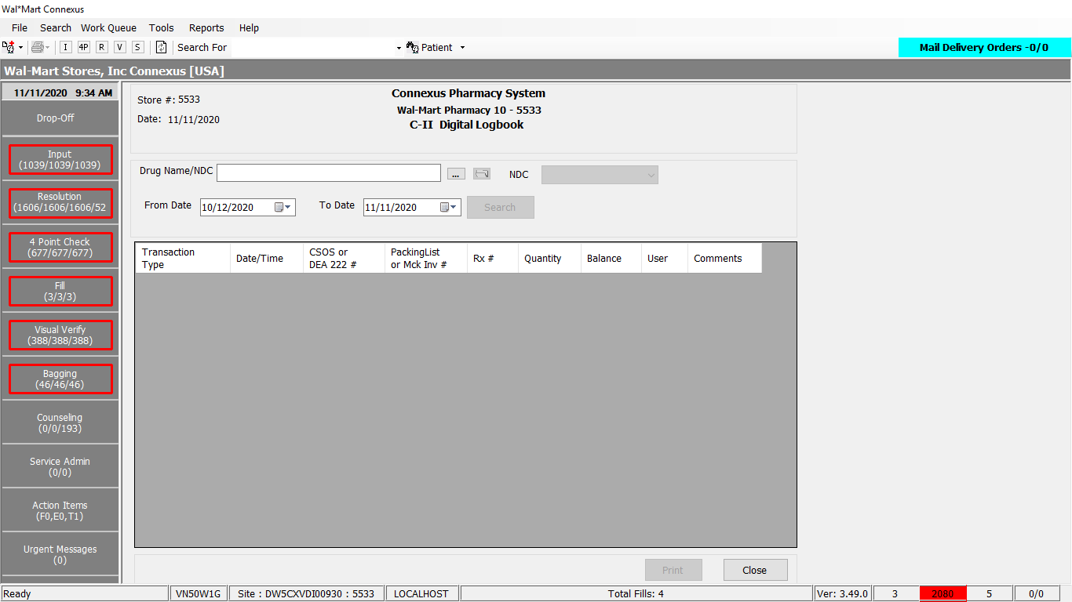

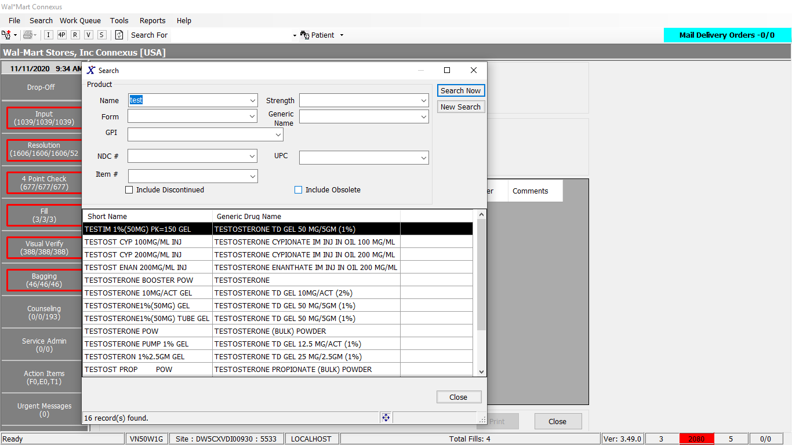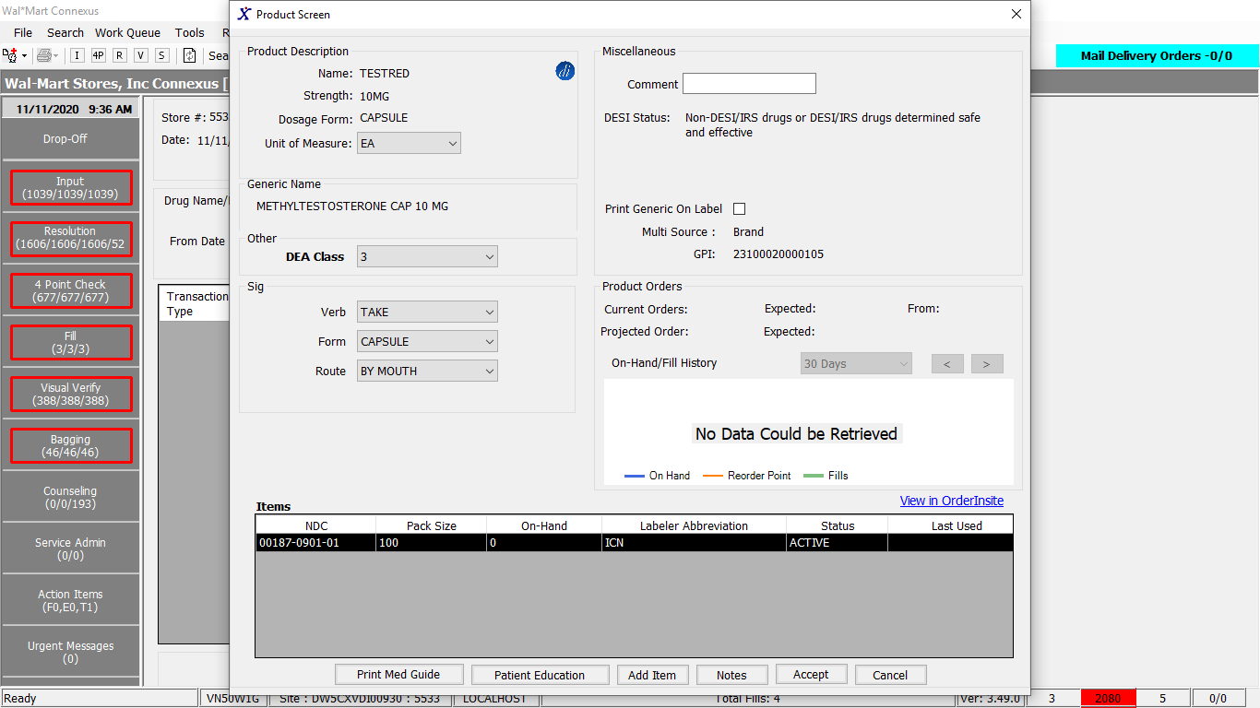

Queries

Public Const C2LogBookInfoForBeacon As String = " SELECT * FROM " &

" (SELECT CASE WHEN piial.adjmt_ref_id Is Not NULL THEN MAX( piial.log_id ) OVER( " &

" PARTITION BY piial.adjmt_ref_id,piial.adjmt_type_code)" &

" ELSE piial.log_id " &

" END AS log_id, adjmt_type_code, " &

" CASE WHEN piial.adjmt_type_code = 6603 THEN 'Rx Fill' " &

" WHEN piial.adjmt_type_code = 6606 THEN 'Return To Stock' " &

" WHEN piial.adjmt_type_code IN(6600,6601) THEN 'CII Order Received' " &

" WHEN piial.adjmt_type_code = 6622 THEN 'CII Order Pre-Received' " &

" WHEN piial.adjmt_type_code = 6640 THEN 'CII Monthly Audit' " &

" WHEN pip.count_reason_code = 2011 THEN 'Back Count' " &

" WHEN pip.count_reason_code = 2002 THEN 'Cycle Count from Connexus' " &

" WHEN pip.count_reason_code = 2013 THEN 'CII BackCount - RTS' " &

" ELSE pct.code_desc END AS TransactionType, " &

" CASE WHEN piial.adjmt_type_code IN(6600, 6601) THEN DEAOrderJoin.dea_order_id " &

" WHEN piial.adjmt_type_code IN(6605,6604,6624) " &

" AND piial.adjmt_rsn_code IN(2,5) THEN piial.adjmt_ref_nbr " &

" ELSE NULL END AS csos_dea222," &

" CASE WHEN piial.adjmt_type_code IN(6600,6601) THEN " &

" CASE WHEN DEAOrderJoin.dc_nbr > 0 THEN TO_CHAR(DEAOrderJoin.carton_nbr) " &

" ELSE DEAOrderJoin.supplier_invoice_nbr END ELSE NULL END AS Mckesson, " &

" CASE WHEN piial.adjmt_type_code IN(6600,6601) THEN CASE " &

" WHEN DEAOrderJoin.order_received_ts IS NULL THEN piial.adjmt_ts " &

" ELSE DEAOrderJoin.order_received_ts END WHEN piial.adjmt_type_code NOT IN (6603) THEN piial.adjmt_ts " &

" ELSE MAX( piial.adjmt_ts ) OVER( " &

" PARTITION BY piial.adjmt_ref_id, piial.adjmt_type_code ) END AS Date_time, " &

" CASE WHEN piial.adjmt_type_code IN(6603,6606) THEN rx.rx_nbr " &

" ELSE NULL END AS RxNbr, " &

" CASE WHEN piial.adjmt_ref_id IS NOT NULL THEN SUM( piial.adjmt_qty ) OVER( " &

" PARTITION BY piial.adjmt_ref_id,piial.adjmt_type_code)ELSE piial.adjmt_qty " &

" END AS Quantity,CASE WHEN piial.adjmt_ref_id IS NOT NULL THEN MIN( piial.onhand_qty ) OVER( " &

" PARTITION BY piial.adjmt_ref_id,piial.adjmt_type_code) ELSE piial.onhand_qty " &

" END AS Balance, " &

" CASE WHEN piial.adjmt_type_code IN(6600,6601) THEN CASE " &

" WHEN DEAOrderJoin.order_received_ts IS NULL THEN 'Received' " &

" ELSE DEAOrderJoin.order_received_userid END ELSE piial.adjmt_userid END AS userid, " &

" CASE WHEN piial.adjmt_rsn_code IS NOT NULL THEN piarst.adjmt_rsn_desc " &

" ELSE NULL END AS comments " &

" FROM pharmacy_offering:phm_item_inv_adjmt_log AS piial " &

" INNER JOIN pharmacy_offering:pharmacy_item AS pi ON pi.mds_Fam_id = piial.mds_Fam_id " &

" LEFT OUTER JOIN rx21c:pharmacy_code_txt AS pct ON " &

" pct.code_id = piial.adjmt_type_code " &

" LEFT OUTER JOIN pharmacy_offering:phm_item_problem AS pip ON " &

" pip.problem_seq_nbr = piial.problem_seq_nbr " &

" AND pip.mds_fam_id = piial.mds_fam_id LEFT OUTER JOIN rx21c:rx_fill AS rf ON " &

" piial.adjmt_ref_id = rf.rx_fill_id LEFT OUTER JOIN rx21c:rx AS rx ON " &

" rf.rx_id = rx.rx_id LEFT OUTER JOIN pharmacy_offering:phm_item_Adjmt_rsn_txt AS piarst ON " &

" piarst.adjmt_rsn_code = piial.adjmt_rsn_code " &

" LEFT OUTER JOIN(select DISTINCT do.dc_nbr,doi.mds_fam_id,do.dea_order_id,do.order_received_userid, " &

" do.carton_nbr,supplier_invoice_nbr,order_received_ts,DATE(adjmt_ts) adjmt_ts " &

" FROM pharmacy_offering:dea_order AS do, " &

" pharmacy_offering:dea_order_item AS doi, " &

" pharmacy_offering:phm_item_inv_adjmt_log AS piial " &

" WHERE do.dea_order_id = doi.dea_order_id " &

" AND do.store_nbr = doi.store_nbr " &

" AND do.dc_nbr = doi.dc_nbr " &

" AND do.div_nbr = doi.div_nbr " &

" AND do.carton_nbr = doi.carton_nbr " &

" AND DATE(piial.adjmt_ts) = DATE(do.order_received_ts) " &

" AND doi.mds_fam_id = piial.mds_fam_id " &

" AND doi.mds_fam_id = ? " &

" AND DATE(piial.adjmt_ts) >= ? " &

" AND DATE(piial.adjmt_ts) <= ? " &

" ) AS DEAOrderJoin ON " &

" CASE WHEN piial.adjmt_type_code IN(6600,6601) " &

" AND DEAOrderJoin.mds_fam_id = piial.mds_fam_id " &

" AND DATE(piial.adjmt_ts) = DATE(DEAOrderJoin.order_received_ts) THEN 1 " &

" ELSE 0 END = 1 " &

" WHERE piial.mds_fam_id = ? " &

" AND DATE(piial.adjmt_ts) >= ? " &

" AND DATE(piial.adjmt_ts) <= ? " &

" AND NOT piial.adjmt_type_code IN(6628) " &

" AND NOT piial.adjmt_userid = 'RXPAUDIT' ) " &

" GROUP BY log_id, adjmt_type_code,transactiontype,csos_dea222,mckesson, " &

" date_time,rxnbr,quantity,balance,userid,comments " &

" ORDER BY log_id DESC"

Public Const C2LogBookInfo As String = " SELECT distinct piial.log_id,piial.adjmt_type_code, " &

" CASE WHEN piial.adjmt_type_code = 6603 THEN 'Rx Fill' " &

" WHEN piial.adjmt_type_code = 6606 THEN 'Return To Stock' " &

" WHEN piial.adjmt_type_code IN( 6600, 6601 ) THEN 'CII Order Received' " &

" WHEN piial.adjmt_type_code = 6622 Then 'CII Order Pre-Received' " &

" WHEN piial.adjmt_type_code = 6640 THEN 'CII Monthly Audit' " &

" WHEN pip.count_reason_code = 2011 THEN 'Back Count' " &

" WHEN pip.count_reason_code = 2002 THEN 'Cycle Count from Connexus' " &

" WHEN pip.count_reason_code = 2013 THEN 'CII BackCount - RTS' " &

" ELSE pct.code_desc END TransactionType, " &

"'' AS csos_dea222, " &

" '' AS Mckesson, " &

" piial.adjmt_ts as Date_time, " &

" CASE WHEN piial.adjmt_type_code IN (6603,6606) THEN rx.rx_nbr ELSE NULL END RxNbr, " &

" piial.adjmt_qty As Quantity, " &

" piial.onhand_qty AS Balance, " &

" CASE WHEN piial.adjmt_type_code IN (6600,6601) THEN 'RECEIVED' ELSE piial.adjmt_userid END userid, " &

" CASE WHEN piial.adjmt_rsn_code IS NOT NULL THEN piarst.adjmt_rsn_desc ELSE NULL END comments " &

" FROM pharmacy_offering:phm_item_inv_adjmt_log piial " &

" INNER JOIN pharmacy_offering:pharmacy_item pi " &

" ON pi.mds_Fam_id = piial.mds_Fam_id " &

" LEFT OUTER JOIN rx21c:pharmacy_code_txt pct " &

" ON pct.code_id = piial.adjmt_type_code " &

" LEFT OUTER JOIN pharmacy_offering:phm_item_problem pip " &

" ON pip.problem_seq_nbr = piial.problem_seq_nbr " &

" AND pip.mds_fam_id = piial.mds_fam_id " &

" LEFT OUTER JOIN rx21c:rx_fill rf ON piial.adjmt_ref_id = rf.rx_fill_id " &

" LEFT OUTER JOIN rx21c:rx rx ON rf.rx_id = rx.rx_id " &

" LEFT OUTER JOIN pharmacy_offering:phm_item_Adjmt_rsn_txt piarst " &

" ON piarst.adjmt_rsn_code = piial.adjmt_rsn_code " &

" WHERE piial.mds_fam_id = ? " &

" AND DATE(piial.adjmt_ts) >= ? " &

" AND DATE(piial.adjmt_ts) <= ? " &

" AND NOT piial.adjmt_type_code In (6628) " &

" AND NOT piial.adjmt_userid = 'RXPAUDIT' " &

" ORDER BY piial.log_id desc "

DAL:

Public Function GetCIILogBookInfo(ByVal siteId As Integer, ByVal fromDate As Date, ByVal toDate As Date,

ByVal mdsFamId As Integer) As List(Of C2LogBookBE) Implements IItemDAL.GetCIILogBookInfo

Using (New Tracer(ConnexusCommonConstants.ConnexusTracer))

Dim cIILogBookInfoList As New List(Of C2LogBookBE)

Dim cIILogBookInfo As C2LogBookBE

Dim c2LogbookSQL As String = String.Empty

Dim paramList As New List(Of DbParameter)

paramList.AddParameter(DbType.Int32, mdsFamId)

paramList.AddParameter(DbType.Date, fromDate.ToShortDateString)

paramList.AddParameter(DbType.Date, toDate.ToShortDateString)

paramList.AddParameter(DbType.Int32, mdsFamId)

paramList.AddParameter(DbType.Date, fromDate.ToShortDateString)

paramList.AddParameter(DbType.Date, toDate.ToShortDateString)

Dim isBeaconStore As Boolean = GetBUPhmParm(siteId, ConnexusCommonConstants.BeaconEnabledFlag).EqualsIgnoreCase("TRUE")

If isBeaconStore Then

c2LogbookSQL = ItemQueries.C2LogBookInfoForBeacon

Else

c2LogbookSQL = ItemQueries.C2LogBookInfo

End If

Try

Using dr As IDataReader = ExecuteReader(DatabaseEnum.Pharmacy_Offering, siteId, c2LogbookSQL, paramList)

While dr.Read

cIILogBookInfo = New C2LogBookBE

With cIILogBookInfo

cIILogBookInfo.TransactionTypeCode = dr.GetValueOrDefault(Of Int16)("adjmt_type_code")

cIILogBookInfo.TransactionType = dr.GetValueOrDefault(Of String)("transactiontype").SafeTrim

cIILogBookInfo.DateTime = dr.GetValueOrDefault(Of DateTime)("date_time")

cIILogBookInfo.CSOSOrDEA = dr.GetValueOrDefault(Of String)("csos_dea222")

cIILogBookInfo.InvoiceNbr = dr.GetValueOrDefault(Of String)("Mckesson")

cIILogBookInfo.RxNbr = dr.GetValueOrDefault(Of Int32)("rxnbr")

cIILogBookInfo.Quantity = Convert.ToString(dr.GetValueOrDefault(Of Decimal)("quantity"))

If .TransactionTypeCode = AdjTypeCode.NOH OrElse .TransactionTypeCode = AdjTypeCode.POF OrElse

.TransactionTypeCode = AdjTypeCode.PDXOutDateReturn OrElse .TransactionTypeCode = AdjTypeCode.PDXInDateReturn Then

cIILogBookInfo.Quantity = "- " & cIILogBookInfo.Quantity.ToString

ElseIf .TransactionTypeCode = AdjTypeCode.POH OrElse .TransactionTypeCode = AdjTypeCode.CancelFill OrElse .TransactionTypeCode = AdjTypeCode.ManualRcvd OrElse

.TransactionTypeCode = AdjTypeCode.Returns OrElse .TransactionTypeCode = AdjTypeCode.PreRecvg OrElse .TransactionTypeCode = AdjTypeCode.PreRecAudit OrElse

.TransactionTypeCode = AdjTypeCode.CIIMonthlyAudit OrElse .TransactionTypeCode = AdjTypeCode.Recvg Then

cIILogBookInfo.Quantity = "+ " & cIILogBookInfo.Quantity

End If

cIILogBookInfo.Quantity = cIILogBookInfo.Quantity.Substring(0, cIILogBookInfo.Quantity.Length - 2)

cIILogBookInfo.Balance = dr.GetValueOrDefault(Of Decimal)("balance")

cIILogBookInfo.UserId = dr.GetValueOrDefault(Of String)("userid")

cIILogBookInfo.Comment = dr.GetValueOrDefault(Of String)("comments")

End With

cIILogBookInfoList.Add(cIILogBookInfo)

End While

End Using

Catch ex As Exception

cIILogBookInfoList = Nothing

End Try

Return cIILogBookInfoList

End Using

End Function

# 17.Reports/Inventory Reports/CII Reports/CII Monthly Audit:

Request:

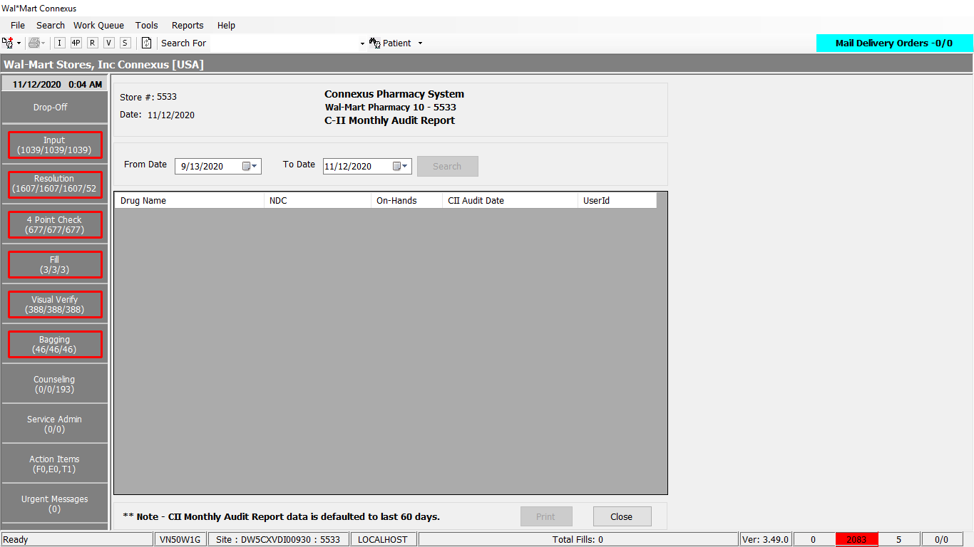

Response:

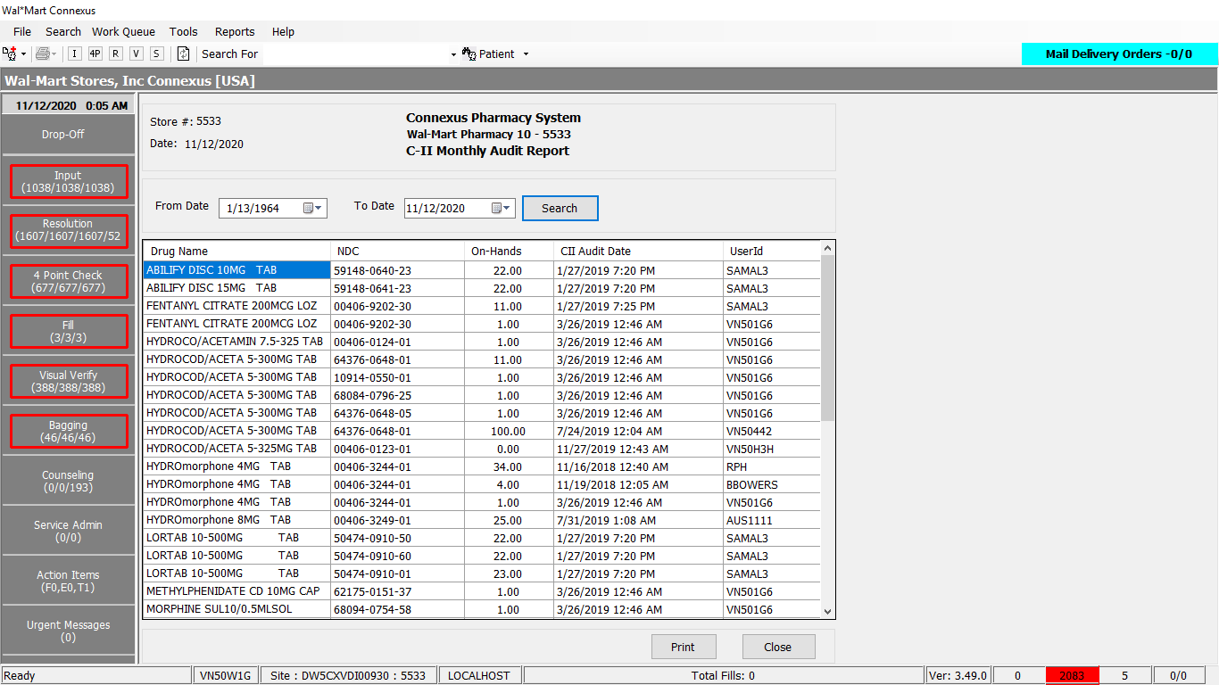

Queries

Public Const CIIMonthlyAuditData As String = " SELECT pp.short_name AS DrugName, " &

" pi.ndc_nbr AS NDC, " &

" piial.onhand_qty AS OnHands, " &

" piial.adjmt_ts AS CIIAuditDate, piial.adjmt_userid AS UserId " &

" FROM phm_item_inv_adjmt_log piial, pharmacy_item pi, pharmacy_product pp" &

" WHERE piial.mds_fam_id = pi.mds_fam_id " &

" AND pi.product_mds_fam_id = pp.product_mds_fam_id " &

" AND pp.drug_control_code = 2300" &

" AND DATE(piial.adjmt_ts) >= ? " &

" AND DATE(piial.adjmt_ts) <= ? " &

" AND piial.adjmt_type_code = 6640 " &

" ORDER BY DrugName,CIIAuditDate"

DAL

Public Function GetCIIMonthlyAuditData(ByVal siteId As Integer, ByVal fromDate As Date, ByVal toDate As Date) _

As List(Of ReturnToStockInfoBE) Implements IItemDAL.GetCIIMonthlyAuditData

Using (New Tracer(ConnexusCommonConstants.ConnexusTracer))

Dim CIIAuditInfoList As New List(Of ReturnToStockInfoBE)

Dim paramList As New List(Of DbParameter)

paramList.AddParameter(DbType.DateTime, fromDate)

paramList.AddParameter(DbType.DateTime, toDate)

Dim local As New LocalizationManager

Using dr As IDataReader = ExecuteReader(DatabaseEnum.Pharmacy_Offering, siteId, ItemQueries.CIIMonthlyAuditData, paramList)

'Retrieve data from datareader to data entity

While dr.Read

Dim CIIAuditInfo As New ReturnToStockInfoBE

With CIIAuditInfo

.NDC = String.Format(local, "{0:N}", dr.GetValueOrDefault(Of String)("NDC").SafeTrim)

.Description = dr.GetValueOrDefault(Of String)("DrugName").SafeTrim

'Assigning the on_hand_qty to vial quantity

.VialQuantity = (dr.GetValueOrDefault(Of Decimal)("OnHands"))

.LastChangets = dr.GetValueOrDefault(Of DateTime)("CIIAuditDate")

.UserId = dr.GetValueOrDefault(Of String)("UserId")

End With

CIIAuditInfoList.Add(CIIAuditInfo)

End While

Return CIIAuditInfoList

End Using

End Using

End Function

# 18.Reports/Inventory Reports/CII Reports/CII Adjustment:

Request:

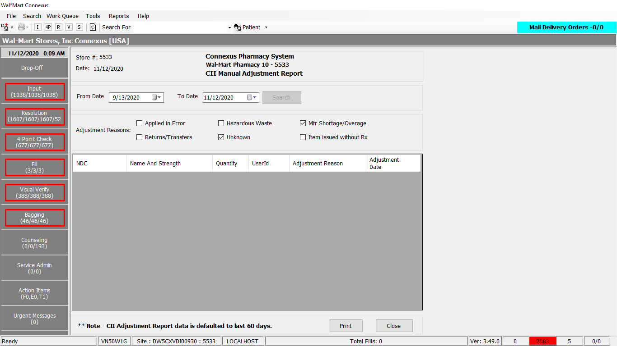

Response:

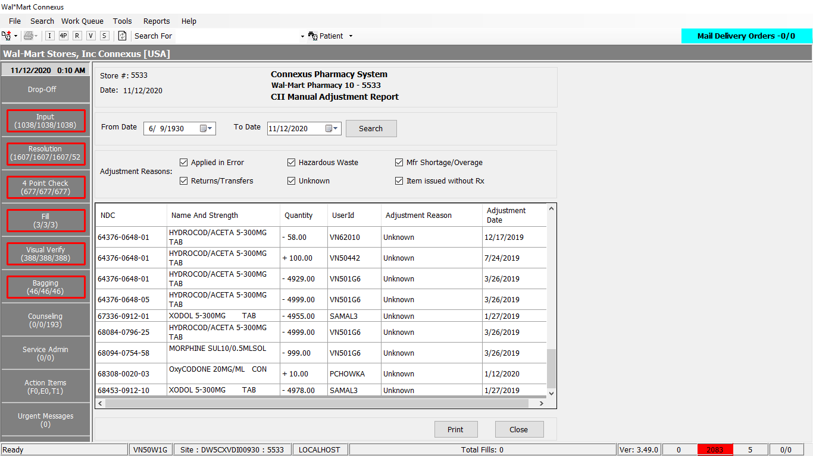

Queries

Public Const CIIMonthlyAuditData As String = " SELECT pp.short_name AS DrugName, " &

" pi.ndc_nbr AS NDC, " &

" piial.onhand_qty AS OnHands, " &

" piial.adjmt_ts AS CIIAuditDate, piial.adjmt_userid AS UserId " &

" FROM phm_item_inv_adjmt_log piial, pharmacy_item pi, pharmacy_product pp" &

" WHERE piial.mds_fam_id = pi.mds_fam_id " &

" AND pi.product_mds_fam_id = pp.product_mds_fam_id " &

" AND pp.drug_control_code = 2300" &

" AND DATE(piial.adjmt_ts) >= ? " &

" AND DATE(piial.adjmt_ts) <= ? " &

" AND piial.adjmt_type_code = 6640 " &

" ORDER BY DrugName,CIIAuditDate"

Public Const GetCommonBUInfo As String = "SELECT bua.Bu_nbr, bua.accounting_div_nbr , bua.street_line_1, " _

& " bua.street_line_2, bua.city, bua.state, " _

& " bua.zip, bua.zip_plus_four, " _

& " sh.sat_opening_time, sh.sat_closing_time, sh.Sun_opening_time," _

& " sh.Sun_closing_time, sh.Mon_opening_time, sh.Mon_closing_time, " _

& " sh.Tue_opening_time, sh.Tue_closing_time , sh.Wed_opening_time, " _

& " sh.Wed_closing_time, sh.Thu_opening_time, sh.Thu_closing_time , " _

& " sh.Fri_opening_time, sh.Fri_closing_time, bua.country_code,ia.issue_agency_code " _

& " FROM bus_unit_addr bua, " _

& " Store_Hours sh, " _

& " pharmacy_bu pb, " _

& " issuing_agency ia" _

& " WHERE bua.bu_nbr = pb.phm_bu_id" _

& " AND bua.accounting_div_nbr = ?" _

& " AND bua.bu_unit_type_code = ?" _

& " AND sh.accounting_div_nbr = ?" _

& " AND sh.effective_date = (SELECT max(effective_date) " _

& " FROM Store_Hours WHERE accounting_div_nbr = ?" _

& " AND effective_date <= current)" _

& " AND UPPER(TRIM(ia.issue_agency_abbr)) = UPPER(TRIM(bua.state))" _

& " AND UPPER(TRIM(ia.country_code)) = UPPER(TRIM(bua.country_code))"

Public Const validateParmValues As String = "SELECT phm_parm_code FROM bu_Phm_parm WHERE phm_parm_code IN (?,?,?,?,?,?,?,?)"

DAL

Public Function GetCIIMonthlyAuditData(ByVal siteId As Integer, ByVal fromDate As Date, ByVal toDate As Date) _

As List(Of ReturnToStockInfoBE) Implements IItemDAL.GetCIIMonthlyAuditData

Using (New Tracer(ConnexusCommonConstants.ConnexusTracer))

Dim CIIAuditInfoList As New List(Of ReturnToStockInfoBE)

Dim paramList As New List(Of DbParameter)

paramList.AddParameter(DbType.DateTime, fromDate)

paramList.AddParameter(DbType.DateTime, toDate)

Dim local As New LocalizationManager

Using dr As IDataReader = ExecuteReader(DatabaseEnum.Pharmacy_Offering, siteId, ItemQueries.CIIMonthlyAuditData, paramList)

'Retrieve data from datareader to data entity

While dr.Read

Dim CIIAuditInfo As New ReturnToStockInfoBE

With CIIAuditInfo

.NDC = String.Format(local, "{0:N}", dr.GetValueOrDefault(Of String)("NDC").SafeTrim)

.Description = dr.GetValueOrDefault(Of String)("DrugName").SafeTrim

'Assigning the on_hand_qty to vial quantity

.VialQuantity = (dr.GetValueOrDefault(Of Decimal)("OnHands"))

.LastChangets = dr.GetValueOrDefault(Of DateTime)("CIIAuditDate")

.UserId = dr.GetValueOrDefault(Of String)("UserId")

End With

CIIAuditInfoList.Add(CIIAuditInfo)

End While

Return CIIAuditInfoList

End Using

End Using

End Function

Public Shared Function GetCommonBUInfo(ByVal siteId As Integer) As CommonBuInfoBE

Using (New Tracer(ConnexusCommonConstants.ConnexusTracer))

Dim paramList As New List(Of DbParameter)

'Adds AcctDivNbr parameter

Dim paramDivNbr As DbParameter = New Odbc.OdbcParameter

paramDivNbr.DbType = DbType.Int16

paramDivNbr.Value = ServicesCommonConstants.ActgDivNumber

paramList.Add(paramDivNbr)

'Adds BuUnitType parameter

Dim paramUnitType As DbParameter = New Odbc.OdbcParameter

paramUnitType.DbType = DbType.Int16

paramUnitType.Value = ServicesCommonConstants.BuUnitType

paramList.Add(paramUnitType)

paramList.Add(paramDivNbr)

paramList.Add(paramDivNbr)

Using commonBuDR As IDataReader = ExecuteReader(Common.DatabaseEnum.rx21c, siteId,

CacheManagerQueries.GetCommonBUInfo, paramList)

'Declaring the required variables

Dim commonBu As New CommonBuInfoBE

Dim addressBE As BuAddressBE

Dim storeHours As StoreHoursBE

While commonBuDR.Read()

commonBu = New CommonBuInfoBE()

addressBE = New BuAddressBE()

storeHours = New StoreHoursBE()

commonBu.BUNbr = CInt(commonBuDR("Bu_nbr"))

commonBu.AccountingDivNbr = CInt(commonBuDR("accounting_div_nbr"))

If Not commonBuDR.IsDBNull(commonBuDR.GetOrdinal("street_line_1")) Then

addressBE.StreetLine1 = CStr(commonBuDR("street_line_1")).Trim

End If

If Not commonBuDR.IsDBNull(commonBuDR.GetOrdinal("street_line_2")) Then

addressBE.StreetLine2 = CStr(commonBuDR("street_line_2")).Trim

End If

If Not commonBuDR.IsDBNull(commonBuDR.GetOrdinal("city")) Then

addressBE.City = CStr(commonBuDR("city")).Trim

End If

If Not commonBuDR.IsDBNull(commonBuDR.GetOrdinal("state")) Then

addressBE.State = CStr(commonBuDR("state")).Trim

End If

If Not commonBuDR.IsDBNull(commonBuDR.GetOrdinal("zip")) Then

addressBE.Zip = CStr(commonBuDR("zip")).Trim

End If

If Not commonBuDR.IsDBNull(commonBuDR.GetOrdinal("zip_plus_four")) Then

addressBE.ZipPlusFour = CStr(commonBuDR("zip_plus_four")).Trim

End If

'Gets the address information to BuAdderssBE

commonBu.BuAddress = DirectCast(addressBE, BuAddressBE)

If Not commonBuDR.IsDBNull(commonBuDR.GetOrdinal("sat_opening_time")) Then

storeHours.SatOpeningTime = CDate(commonBuDR("sat_opening_time"))

End If

If Not commonBuDR.IsDBNull(commonBuDR.GetOrdinal("sat_closing_time")) Then

storeHours.SatClosingTime = CDate(commonBuDR("sat_closing_time"))

End If

If Not commonBuDR.IsDBNull(commonBuDR.GetOrdinal("Sun_opening_time")) Then

storeHours.SunOpeningTime = CDate(commonBuDR("Sun_opening_time"))

End If

If Not commonBuDR.IsDBNull(commonBuDR.GetOrdinal("Sun_closing_time")) Then

storeHours.SunClosingTime = CDate(commonBuDR("Sun_closing_time"))

End If

If Not commonBuDR.IsDBNull(commonBuDR.GetOrdinal("Mon_opening_time")) Then

storeHours.MonOpeningTime = CDate(commonBuDR("Mon_opening_time"))

End If

If Not commonBuDR.IsDBNull(commonBuDR.GetOrdinal("Mon_closing_time")) Then

storeHours.MonClosingTime = CDate(commonBuDR("Mon_closing_time"))

End If

If Not commonBuDR.IsDBNull(commonBuDR.GetOrdinal("Tue_opening_time")) Then

storeHours.TueOpeningTime = CDate(commonBuDR("Tue_opening_time"))

End If

If Not commonBuDR.IsDBNull(commonBuDR.GetOrdinal("Tue_closing_time")) Then

storeHours.TueClosingTime = CDate(commonBuDR("Tue_closing_time"))

End If

If Not commonBuDR.IsDBNull(commonBuDR.GetOrdinal("Wed_opening_time")) Then

storeHours.WedOpeningTime = CDate(commonBuDR("Wed_opening_time"))

End If

If Not commonBuDR.IsDBNull(commonBuDR.GetOrdinal("Wed_closing_time")) Then

storeHours.WedClosingTime = CDate(commonBuDR("Wed_closing_time"))

End If

If Not commonBuDR.IsDBNull(commonBuDR.GetOrdinal("Thu_opening_time")) Then

storeHours.ThuOpeningTime = CDate(commonBuDR("Thu_opening_time"))

End If

If Not commonBuDR.IsDBNull(commonBuDR.GetOrdinal("Thu_closing_time")) Then

storeHours.ThuClosingTime = CDate(commonBuDR("Thu_closing_time"))

End If

If Not commonBuDR.IsDBNull(commonBuDR.GetOrdinal("Fri_opening_time")) Then

storeHours.FriOpeningTime = CDate(commonBuDR("Fri_opening_time"))

End If

If Not commonBuDR.IsDBNull(commonBuDR.GetOrdinal("Fri_closing_time")) Then

storeHours.FriClosingTime = CDate(commonBuDR("Fri_closing_time"))

End If

'Added as the Country Code was missing

If Not commonBuDR.IsDBNull(commonBuDR.GetOrdinal("country_code")) Then

addressBE.CountryCode = commonBuDR.GetString(commonBuDR.GetOrdinal("country_code"))

End If

'Fetches the Issue Agency Code

If Not commonBuDR.IsDBNull(commonBuDR.GetOrdinal("issue_agency_code")) Then

commonBu.IssueAgencyCode = commonBuDR.GetInt32(commonBuDR.GetOrdinal("issue_agency_code"))

End If

'Gets the store hours information to StoreHoursBE

commonBu.StoreHours = DirectCast(storeHours, StoreHoursBE)

'CommonBuInfo.Add(CommonBu)

End While

Return commonBu

End Using

End Using

End Function

Public Shared Function GetVolatileBUInfo(ByVal siteId As Integer) As VolatileBuInfoBE

Using (New Tracer(ConnexusCommonConstants.ConnexusTracer))

Dim paramList As New List(Of DbParameter)

Dim paramValidationList As New List(Of DbParameter)

Dim querySelectBuilder As New StringBuilder

Dim queryFromBuilder As New StringBuilder

Dim queryWhereBuilder As New StringBuilder

Dim queryJoinBuilder As New StringBuilder

''Adds NDCChange parameter

paramList.AddParameter(DbType.String, ServicesCommonConstants.NdcChange)

''Adds Visual check Status parameter

paramList.AddParameter(DbType.String, ServicesCommonConstants.VisCheckStatus)

''Adds ReqPrinter parameter

paramList.AddParameter(DbType.String, ServicesCommonConstants.RefRqstPrinter)

' ''Adds Leaflet Printer parameter

paramList.AddParameter(DbType.String, ServicesCommonConstants.PatLfltPrinter)

''Adds FaxPrinter parameter

paramList.AddParameter(DbType.String, ServicesCommonConstants.FaxPrinter)

''Adds StationaryPrinter parameter

paramList.AddParameter(DbType.String, ServicesCommonConstants.StationaryPrinter)

''Adds StoreName parameter

paramList.AddParameter(DbType.String, ServicesCommonConstants.StoreName)

''Adds LabelMsg parameter

paramList.AddParameter(DbType.String, ServicesCommonConstants.LabelMsg)

''Adds ReqPrinter parameter

paramList.AddParameter(DbType.String, ServicesCommonConstants.TrayPrinting)

''Adds Medicare parameter

paramList.AddParameter(DbType.String, ServicesCommonConstants.MedicareBEnabled)

''Adds Medicare parameter

paramList.AddParameter(DbType.String, ServicesCommonConstants.SysGenPrinter)

paramValidationList.AddParameter(DbType.String, ServicesCommonConstants.DuplexRefillRequest)

paramValidationList.AddParameter(DbType.String, ServicesCommonConstants.DuplexLeafLet)

paramValidationList.AddParameter(DbType.String, ServicesCommonConstants.DuplexScanTag)

paramValidationList.AddParameter(DbType.String, ServicesCommonConstants.DuplexIVRFax)

paramValidationList.AddParameter(DbType.String, ServicesCommonConstants.DuplexRxImage)

paramValidationList.AddParameter(DbType.String, ServicesCommonConstants.ScanTagTrayNumber)

paramValidationList.AddParameter(DbType.String, ServicesCommonConstants.PrintLeafLetTrayNumber)

paramValidationList.AddParameter(DbType.String, ServicesCommonConstants.ScanTagPrinter)

'--BaggingQueue - Phase III - START

Dim IsDuplexRefillRequestAvailable As Boolean = False

Dim IsDuplexLeafLetAvailable As Boolean = False

Dim IsDuplexScanTagAvailable As Boolean = False

Dim IsDuplexIVRFaxAvailable As Boolean = False

Dim IsDuplexRxImageAvailable As Boolean = False

Dim IsDuplexScanTagTrayNumberAvailable As Boolean = False

Dim IsPrintLeafLetTrayNumberAvailable As Boolean = False

Dim IsScanTagPrinterAvailable As Boolean = False

Using validateParmValues As IDataReader = ExecuteReader(Common.DatabaseEnum.rx21c, siteId,

CacheManagerQueries.validateParmValues,

paramValidationList)

Do While validateParmValues.Read()

Dim phmParmCode As Short = validateParmValues.GetValueOrDefault(Of Int16)("phm_parm_code")

If (Convert.ToString(phmParmCode).SafeTrim().Equals(ServicesCommonConstants.DuplexRefillRequest.ToString())) Then

paramList.AddParameter(DbType.String, ServicesCommonConstants.DuplexRefillRequest)

querySelectBuilder.Append(", p22.phm_parm_value DuplexRefillRequest, ")

queryFromBuilder.Append(",Bu_Phm_parm p22,")

queryWhereBuilder.Append(" AND p1.phm_bu_id = p22.phm_bu_id ")

queryJoinBuilder.Append(" AND p22.phm_parm_code = ? ")

IsDuplexRefillRequestAvailable = True

End If

If (Convert.ToString(phmParmCode).SafeTrim().Equals(ServicesCommonConstants.DuplexLeafLet.ToString())) Then

paramList.AddParameter(DbType.String, ServicesCommonConstants.DuplexLeafLet)

querySelectBuilder.Append(" p23.phm_parm_value DuplexPatLeafLet, ")

queryFromBuilder.Append(" Bu_Phm_parm p23,")

queryWhereBuilder.Append(" AND p1.phm_bu_id = p23.phm_bu_id ")

queryJoinBuilder.Append(" AND p23.phm_parm_code = ? ")

IsDuplexLeafLetAvailable = True

End If

If (Convert.ToString(phmParmCode).SafeTrim().Equals(ServicesCommonConstants.DuplexScanTag.ToString())) Then

paramList.AddParameter(DbType.String, ServicesCommonConstants.DuplexScanTag)

querySelectBuilder.Append(" p24.phm_parm_value DuplexScanTag, ")

queryFromBuilder.Append(" Bu_Phm_parm p24,")

queryWhereBuilder.Append(" AND p1.phm_bu_id = p24.phm_bu_id ")

queryJoinBuilder.Append(" AND p24.phm_parm_code = ? ")

IsDuplexScanTagAvailable = True

End If

If (Convert.ToString(phmParmCode).SafeTrim().Equals(ServicesCommonConstants.DuplexIVRFax.ToString())) Then

paramList.AddParameter(DbType.String, ServicesCommonConstants.DuplexIVRFax)

querySelectBuilder.Append(" p25.phm_parm_value DuplexIVRFax, ")

queryFromBuilder.Append(" Bu_Phm_parm p25,")

queryWhereBuilder.Append(" AND p1.phm_bu_id = p25.phm_bu_id ")

queryJoinBuilder.Append(" AND p25.phm_parm_code = ? ")

IsDuplexIVRFaxAvailable = True

End If

If (Convert.ToString(phmParmCode).SafeTrim().Equals(ServicesCommonConstants.DuplexRxImage.ToString())) Then

paramList.AddParameter(DbType.String, ServicesCommonConstants.DuplexRxImage)

querySelectBuilder.Append(" p26.phm_parm_value DuplexRxImage, ")

queryFromBuilder.Append(" Bu_Phm_parm p26,")

queryWhereBuilder.Append(" AND p1.phm_bu_id = p26.phm_bu_id")

queryJoinBuilder.Append(" AND p26.phm_parm_code = ? ")

IsDuplexRxImageAvailable = True

End If

If (Convert.ToString(phmParmCode).SafeTrim().Equals(ServicesCommonConstants.ScanTagTrayNumber.ToString())) Then

paramList.AddParameter(DbType.String, ServicesCommonConstants.ScanTagTrayNumber)

querySelectBuilder.Append(" p27.phm_parm_value ScanTagTray, ")

queryFromBuilder.Append(" Bu_Phm_parm p27,")

queryWhereBuilder.Append(" AND p1.phm_bu_id = p27.phm_bu_id ")

queryJoinBuilder.Append(" AND p27.phm_parm_code = ? ")

IsDuplexScanTagTrayNumberAvailable = True

End If

If (Convert.ToString(phmParmCode).SafeTrim().Equals(ServicesCommonConstants.PrintLeafLetTrayNumber.ToString())) Then

paramList.AddParameter(DbType.String, ServicesCommonConstants.PrintLeafLetTrayNumber)

querySelectBuilder.Append(" p28.phm_parm_value PatientLeafletTray, ")

queryFromBuilder.Append(" Bu_Phm_parm p28,")

queryWhereBuilder.Append(" AND p1.phm_bu_id = p28.phm_bu_id ")

queryJoinBuilder.Append(" AND p28.phm_parm_code = ? ")

IsPrintLeafLetTrayNumberAvailable = True

End If

If (Convert.ToString(phmParmCode).SafeTrim().Equals(ServicesCommonConstants.ScanTagPrinter.ToString())) Then

paramList.AddParameter(DbType.String, ServicesCommonConstants.ScanTagPrinter)

querySelectBuilder.Append(" p29.phm_parm_value ScanTagPrinter, ")

queryFromBuilder.Append(" Bu_Phm_parm p29 ,")

queryWhereBuilder.Append(" AND p1.phm_bu_id = p29.phm_bu_id ")

queryJoinBuilder.Append(" AND p29.phm_parm_code = ? ")

IsScanTagPrinterAvailable = True

End If

Loop

End Using

Dim querySelect As String

Dim queryFrom As String

If (querySelectBuilder.ToString.LastIndexOf(",") > 0) Then

querySelect = querySelectBuilder.ToString.Remove(querySelectBuilder.ToString.LastIndexOf(","))

Else

querySelect = querySelectBuilder.ToString()

End If

If (querySelectBuilder.ToString.LastIndexOf(",") > 0) Then

queryFrom = queryFromBuilder.ToString.Remove(queryFromBuilder.ToString.LastIndexOf(","))

Else

queryFrom = queryFromBuilder.ToString()

End If

Dim getVolatileBuInfoQuery As String = String.Concat(CacheManagerQueries.querySelect, querySelect, CacheManagerQueries.queryFrom, queryFrom,

CacheManagerQueries.queryWhere, queryWhereBuilder, CacheManagerQueries.queryJoin, queryJoinBuilder)

'--BaggingQueue - Phase III - END

Using volatileBuDR As IDataReader = ExecuteReader(Common.DatabaseEnum.rx21c, siteId,

getVolatileBuInfoQuery,

paramList)

'Declaring the required variables

Dim volatileBu As New VolatileBuInfoBE

While volatileBuDR.Read()

volatileBu = New VolatileBuInfoBE()

volatileBu.PhoneNumber = volatileBuDR.GetValueOrDefault(Of String)("Phone_Number").SafeTrim()

volatileBu.FaxNumber = volatileBuDR.GetValueOrDefault(Of String)("Fax_Number").SafeTrim()

volatileBu.PhmDeaNumber = volatileBuDR.GetValueOrDefault(Of String)("phm_dea_nbr").SafeTrim()

volatileBu.RxProcessCategoryCode = Convert.ToInt32(volatileBuDR.GetValueOrDefault(Of Int16)("Rx_prc_catg_code"))

volatileBu.OtcProcessCategoryCode = Convert.ToInt32(volatileBuDR.GetValueOrDefault(Of Int16)("Otc_prc_catg_code"))

volatileBu.DrugNameSeqIndicator = volatileBuDR.GetValueOrDefault(Of String)("drug_name_seq_ind").SafeTrim()

volatileBu.Barcode = volatileBuDR.GetValueOrDefault(Of String)("Barcode").SafeTrim()

volatileBu.IvrLive = volatileBuDR.GetValueOrDefault(Of String)("IVRLive").SafeTrim()

volatileBu.IvrRefresh = volatileBuDR.GetValueOrDefault(Of String)("IVRRefresh").SafeTrim()

volatileBu.FourPointAfterInput = volatileBuDR.GetValueOrDefault(Of String)("blnFourPointAfterInput").SafeTrim()

volatileBu.DriveThrough = volatileBuDR.GetValueOrDefault(Of String)("blnDrivethru").SafeTrim()

volatileBu.FaxAvailable = volatileBuDR.GetValueOrDefault(Of String)("blnFaxAvailable").SafeTrim()

volatileBu.LaserPrinterDown = volatileBuDR.GetValueOrDefault(Of String)("blnLaserPrinterDown").SafeTrim()

volatileBu.AllScannersDown = volatileBuDR.GetValueOrDefault(Of String)("blnAllScannersDown").SafeTrim()

volatileBu.FaxPrefix = volatileBuDR.GetValueOrDefault(Of String)("blnFaxPrefix").SafeTrim()

volatileBu.PhmBuId = volatileBuDR.GetValueOrDefault(Of Int32)("phm_bu_id")

volatileBu.NdcChangeWarn = volatileBuDR.GetValueOrDefault(Of String)("blnNDCChangeWarn").SafeTrim()

volatileBu.VisCheckStatus = volatileBuDR.GetValueOrDefault(Of String)("VisCheckStatus").SafeTrim()

volatileBu.TriplicateStatus = volatileBuDR.GetValueOrDefault(Of String)("blnTriplicateStatus").SafeTrim()

volatileBu.RefRequestPrinter = volatileBuDR.GetValueOrDefault(Of String)("RefRqstPrinter").SafeTrim()

volatileBu.PatLeafletPrinter = volatileBuDR.GetValueOrDefault(Of String)("PatLeafletPrinter").SafeTrim()

volatileBu.FaxPrinter = volatileBuDR.GetValueOrDefault(Of String)("FaxPrinter").SafeTrim()

volatileBu.StationaryPrinter = volatileBuDR.GetValueOrDefault(Of String)("StationaryPrinter").SafeTrim()

'Bagging Queue - Phase 3 - START

If (IsDuplexRefillRequestAvailable = True) Then

volatileBu.DuplexRefillRequest = volatileBuDR.GetValueOrDefault(Of String)("DuplexRefillRequest").SafeTrim()

Else

volatileBu.DuplexRefillRequest = "FALSE"

End If

If (IsDuplexLeafLetAvailable) Then

volatileBu.DuplexPatLeafLet = volatileBuDR.GetValueOrDefault(Of String)("DuplexPatLeafLet").SafeTrim()

Else

volatileBu.DuplexPatLeafLet = "FALSE"

End If

If (IsDuplexScanTagAvailable) Then

volatileBu.DuplexScanTag = volatileBuDR.GetValueOrDefault(Of String)("DuplexScanTag").SafeTrim()

Else

volatileBu.DuplexScanTag = "FALSE"

End If

If (IsDuplexIVRFaxAvailable) Then

volatileBu.DuplexFaxIVRPrint = volatileBuDR.GetValueOrDefault(Of String)("DuplexIVRFax").SafeTrim()

Else

volatileBu.DuplexFaxIVRPrint = "FALSE"

End If

If (IsDuplexRxImageAvailable) Then

volatileBu.DuplexRxImage = volatileBuDR.GetValueOrDefault(Of String)("DuplexRxImage").SafeTrim()

Else

volatileBu.DuplexRxImage = "FALSE"

End If

If (IsDuplexScanTagTrayNumberAvailable) Then

volatileBu.ScanTagTray = volatileBuDR.GetValueOrDefault(Of String)("ScanTagTray").SafeTrim()

Else

volatileBu.ScanTagTray = "1"

End If

If (IsPrintLeafLetTrayNumberAvailable) Then

volatileBu.PatientLeafletTray = volatileBuDR.GetValueOrDefault(Of String)("PatientLeafletTray").SafeTrim()

Else

volatileBu.PatientLeafletTray = "2"

End If

If (IsScanTagPrinterAvailable) Then

volatileBu.ScanTagPrinter = volatileBuDR.GetValueOrDefault(Of String)("ScanTagPrinter").SafeTrim()

Else

volatileBu.ScanTagPrinter = ServicesCommonConstants.DefaultPrinter

End If

'Bagging Queue - Phase 3 - END

volatileBu.StoreName = volatileBuDR.GetValueOrDefault(Of String)("StoreName").SafeTrim()

volatileBu.DoctorNumber = volatileBuDR.GetValueOrDefault(Of String)("Doctor_number").SafeTrim()

volatileBu.LabelMsg = volatileBuDR.GetValueOrDefault(Of String)("LabelMsg").SafeTrim()

volatileBu.TrayPrinting = volatileBuDR.GetValueOrDefault(Of String)("blnTrayPrinting").SafeTrim()

volatileBu.MedicareB = volatileBuDR.GetValueOrDefault(Of String)("blnMedicareB").SafeTrim()

volatileBu.SysGenPrinter = volatileBuDR.GetValueOrDefault(Of String)("SysGenPrinter").SafeTrim()

End While

Return volatileBu

End Using

End Using

End Function

# 19.Reports/Inventory Reports /NIOSH Report:

Request:

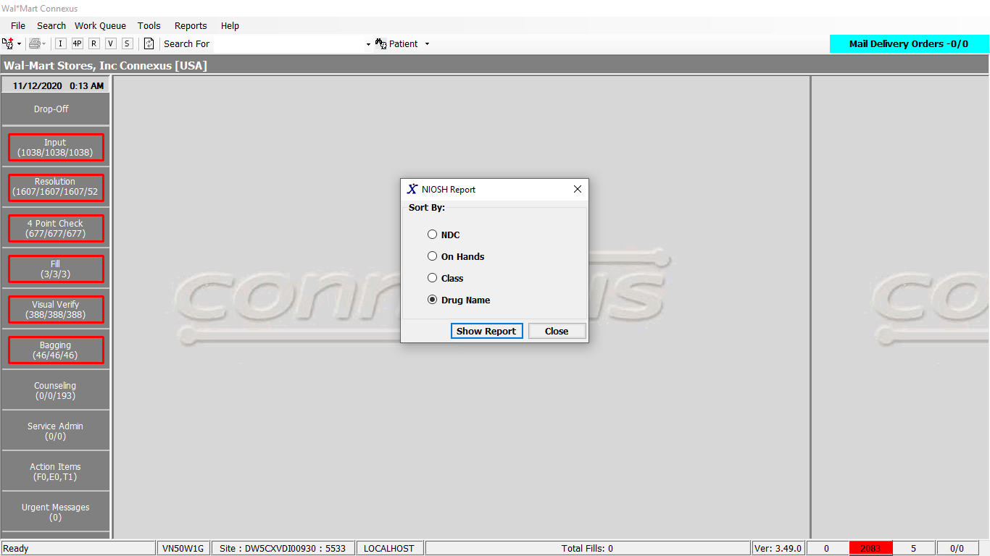

Note: In above request screen we only select one of the option. Below i have provided screenshot for data sorted with respect to Class.

Request:

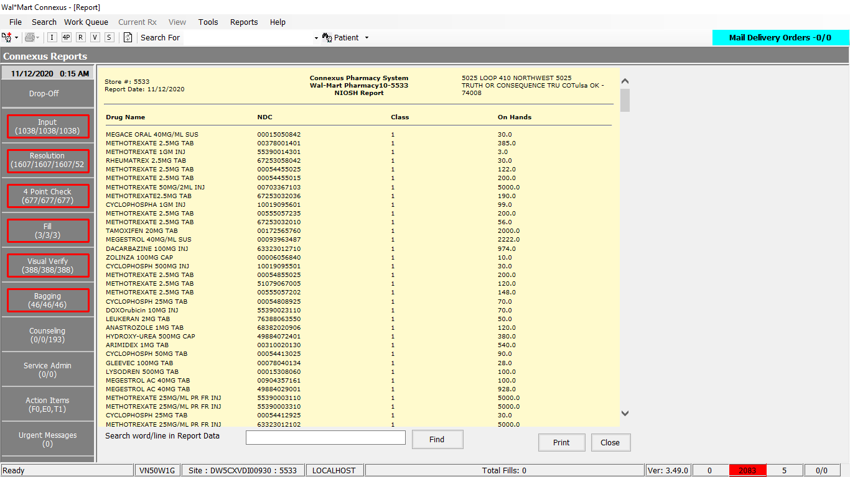

Queries

Friend Const NioshQuery As String = "SELECT pp.short_name,pi.ndc_nbr,ROUND(pi.on_hand_qty,1) on_hand_qty,SUBSTR(pir.issued_id_nbr,3,1) issued_id_nbr " &

"FROM pharmacy_offering:pharmacy_product pp,pharmacy_offering:pharmacy_item pi, pharmacy_offering:phm_item_ref pir " &

"WHERE pp.product_mds_fam_id=pi.product_mds_fam_id " &

"AND pir.mds_fam_id=pi.mds_fam_id " &

"AND pir.issued_id_nbr in (?,?,?,?,?,?) " &

"AND pi.on_hand_qty > 0 "

DAL

Public Function GetNIOSHReport(ByVal siteId As Integer,

ByVal sortOrder As Integer) As List(Of NIOSHReportBE) Implements IReportDAL.GetNIOSHReport

Using (New Tracer(ConnexusCommonConstants.ConnexusTracer))

Dim paramList As New List(Of DbParameter)

Dim sqlString As New StringBuilder

Dim nioshDataList As New List(Of NIOSHReportBE)

sqlString.Append(ReportQueries.NioshQuery)

paramList.Add(ParameterHelper.BuildParameter("issued_id_nbr", DbType.String, ConnexusCommonConstants.HazardousDrugClass1))

paramList.Add(ParameterHelper.BuildParameter("issued_id_nbr", DbType.String, ConnexusCommonConstants.HazardousDrugClass2))

paramList.Add(ParameterHelper.BuildParameter("issued_id_nbr", DbType.String, ConnexusCommonConstants.HazardousDrugClass3))

paramList.Add(ParameterHelper.BuildParameter("issued_id_nbr", DbType.String, ConnexusCommonConstants.HazardousDrugFridgeClass1))

paramList.Add(ParameterHelper.BuildParameter("issued_id_nbr", DbType.String, ConnexusCommonConstants.HazardousDrugFridgeClass2))

paramList.Add(ParameterHelper.BuildParameter("issued_id_nbr", DbType.String, ConnexusCommonConstants.HazardousDrugFridgeClass3))

If sortOrder = NIOSHReportSortOption.DrugName Then ' sort by drug name

sqlString.Append(" ORDER BY pp.short_name asc; ")

ElseIf sortOrder = NIOSHReportSortOption.NDC Then ' sort by ndc

sqlString.Append(" ORDER BY pi.ndc_nbr asc; ")

ElseIf sortOrder = NIOSHReportSortOption.ClassName Then 'Sort by Class name

sqlString.Append(" ORDER BY pir.issued_id_nbr asc; ")

ElseIf sortOrder = NIOSHReportSortOption.OnHands Then 'Sort by On hands

sqlString.Append(" ORDER BY pi.on_hand_qty asc; ")

End If

Dim dataReader As IDataReader = ExecuteReader(DatabaseEnum.rx21c, siteId,

sqlString.ToString, paramList)

Dim nioshDataBE As NIOSHReportBE

While dataReader.Read

nioshDataBE = New NIOSHReportBE

nioshDataBE.DrugName = SafeConvert.ToString(dataReader.GetValue(dataReader.GetOrdinal("short_name")))

nioshDataBE.NDC = SafeConvert.ToString(dataReader.GetValue(dataReader.GetOrdinal("ndc_nbr")))

nioshDataBE.ClassName = SafeConvert.ToString(dataReader.GetValue(dataReader.GetOrdinal("issued_id_nbr")))

nioshDataBE.OnHand = SafeConvert.ToDecimal(dataReader.GetValue(dataReader.GetOrdinal("on_hand_qty")))

nioshDataList.Add(nioshDataBE)

End While

If nioshDataList IsNot Nothing AndAlso nioshDataList.Count > 0 Then

Return nioshDataList

Else

Return Nothing

End If

End Using

End function

# 20.Reports/Inventory Reports/ MTR Report:

Request:

(View for “Need to MTR” checked)

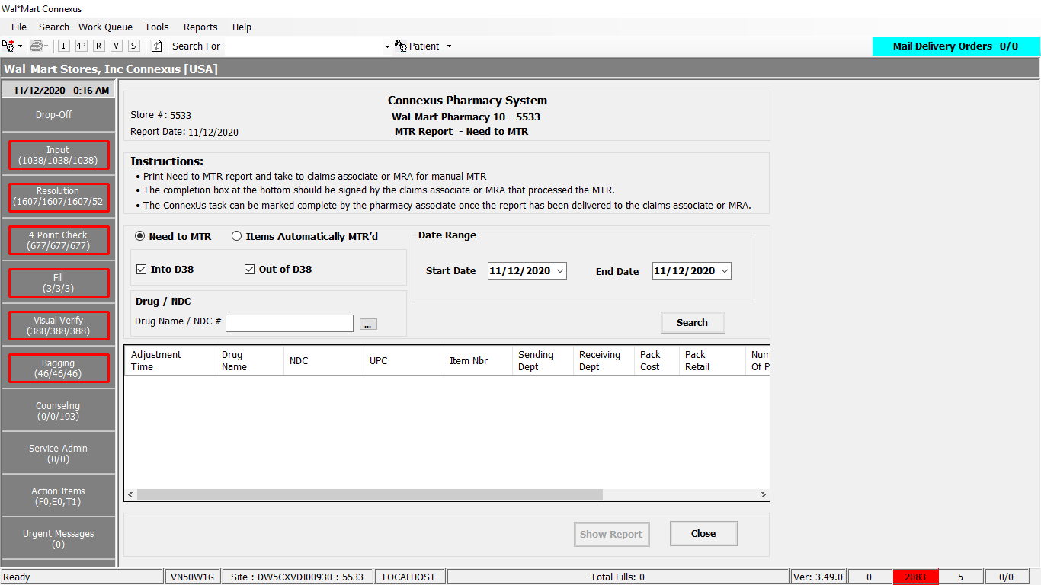

(View for “Items for Automatically MTR’d” checked)

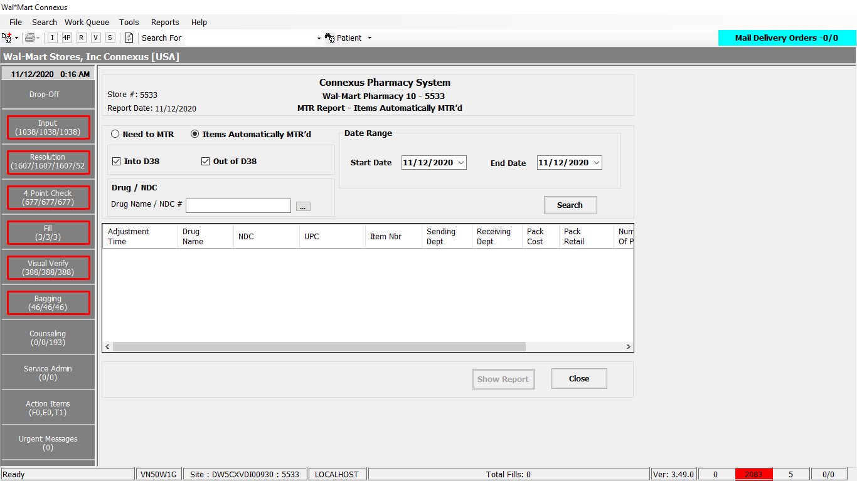

View after search click in “Need to MTR”:

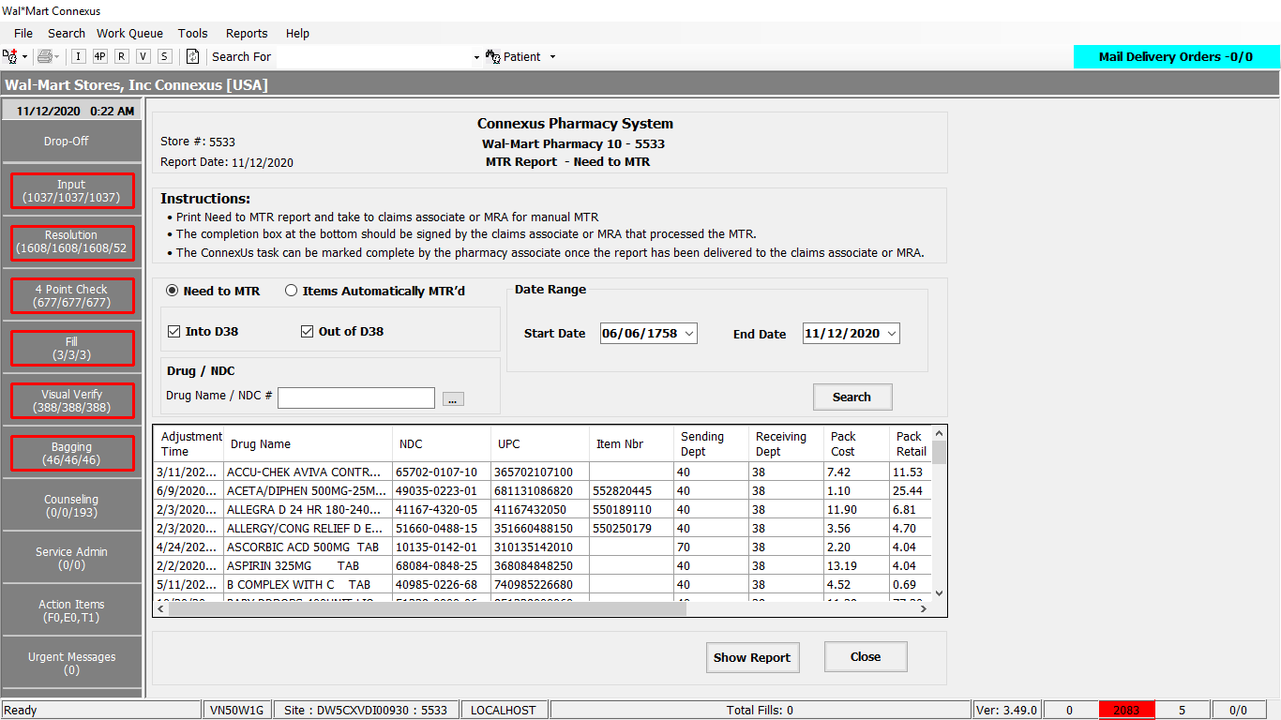

Response:

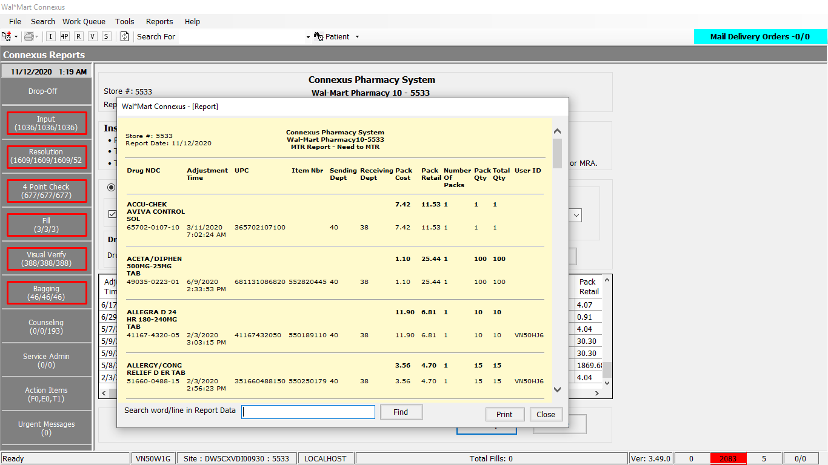

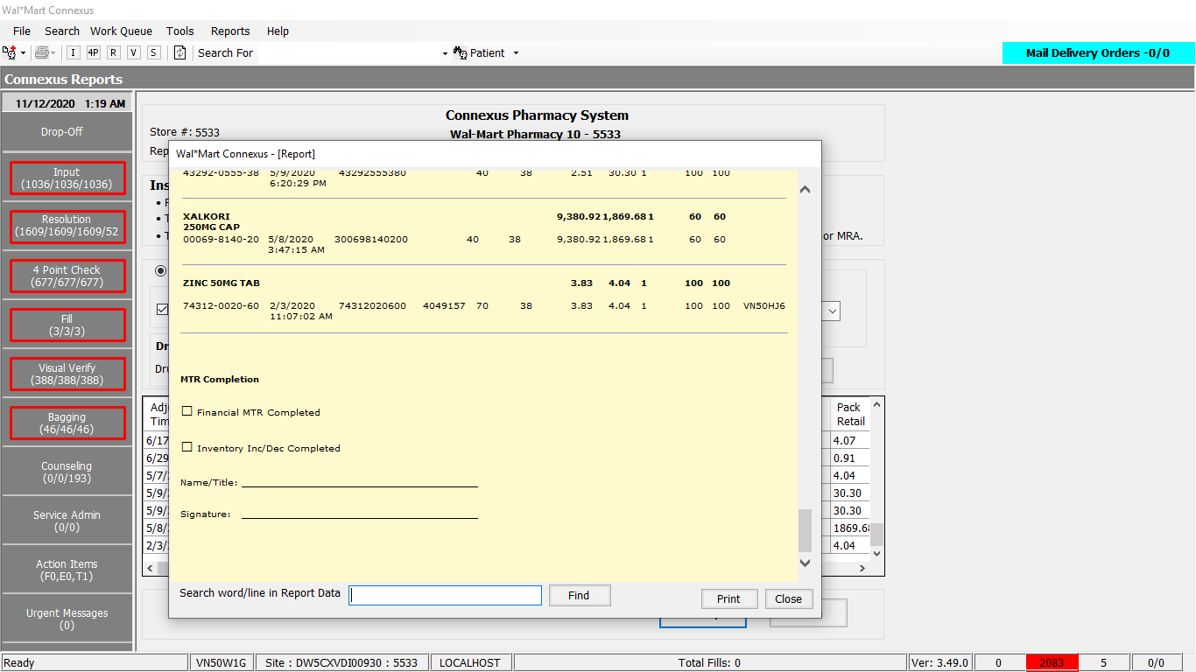

Query

s Public Const GetMerchTransferRequestReportInfoQuery As String = " SELECT pi.mds_fam_id,pp.product_mds_fam_id,pi.ndc_nbr, pi.upc_nbr,pi.dept_nbr, pi.item_nbr, pp.short_name,retail_txn_amt packretail,

CAST((pi.inner_pack_qty * pi.outer_pack_qty) AS int) packqty,piia.adjmt_ts,

(pi.INNER_PACK_QTY*pi.OUTER_PACK_QTY*pic.phm_item_cost_amt) As packcost, piia.adjmt_type_code

,piia.adjmt_status_code,(piia.adjmt_qty / (pi.inner_pack_qty * pi.outer_pack_qty)) AS numberOfPacks , wot.last_change_userid userid, ((piia.adjmt_qty / (pi.inner_pack_qty * pi.outer_pack_qty))*(pi.inner_pack_qty * pi.outer_pack_qty)) AS totalQty

FROM pharmacy_offering:phm_item_inv_adjmt_log piia,

pharmacy_offering:pharmacy_item pi,

pharmacy_offering:pharmacy_product pp

, OUTER (pharmacy_offering:phm_item_cost pic)

, OUTER rx21c:work_order_task wot

WHERE piia.adjmt_type_code in (?, ?)

AND piia.adjmt_status_code in (?, ?, ?)

AND piia.adjmt_ts BETWEEN ? AND ?

AND pi.dept_nbr != ?

AND (piia.adjmt_qty / (pi.inner_pack_qty * pi.outer_pack_qty)) >= 1.0

AND piia.adjmt_ref_nbr = wot.work_order_id

AND piia.mds_fam_id = pi.mds_fam_id

AND pp.product_mds_fam_id= pi.product_mds_fam_id

AND piia.mds_fam_id = pic.mds_fam_id

AND pic.cost_type_code = 3001

AND pic.effective_date =(SELECT MAX( effective_date ) FROM pharmacy_offering:phm_item_cost pic2

WHERE pi.mds_fam_id = pic2.mds_fam_id AND pic2.cost_type_code = 3001 )"

Public Const IsValidDrug As String = "SELECT COUNT(short_name) FROM pharmacy_product WHERE short_name = ?"

DAL

Public Function GetMerchTransferRequestReportInfo(ByVal siteId As Integer, ByVal productMdsFamID As Integer, ByVal startDate As String, ByVal endDate As String) As List(Of MerchTransferRequestInfoBE) Implements IItemDAL.GetMerchTransferRequestReportInfo

Using (New Tracer(ConnexusCommonConstants.ConnexusTracer))

Dim mtrInfoList As New List(Of MerchTransferRequestInfoBE)

Dim paramList As New List(Of DbParameter)

Dim querySQL As New StringBuilder

Dim local As New LocalizationManager

querySQL.Append(ItemQueries.GetMerchTransferRequestReportInfoQuery)

paramList.AddParameter(DbType.Int16, ConnexusCommonConstants.PrescriptionsFilledAdjmtTypeCode)

paramList.AddParameter(DbType.Int16, ConnexusCommonConstants.PrescriptionsCancelledAdjmtTypeCode)

paramList.AddParameter(DbType.Int16, ConnexusCommonConstants.PendingItemsToDepartment38AdjustmentStatusCodes1)

paramList.AddParameter(DbType.Int16, ConnexusCommonConstants.PendingItemsToDepartment38AdjustmentStatusCodes2)

paramList.AddParameter(DbType.Int16, ConnexusCommonConstants.TransferredItemsToDepartment38AdjustmentStatusCode)

paramList.AddParameter(DbType.String, startDate)

paramList.AddParameter(DbType.String, endDate)

paramList.AddParameter(DbType.Int16, ConnexusCommonConstants.Department38)

If productMdsFamID > 0 Then

paramList.AddParameter(DbType.Int32, productMdsFamID)

querySQL.Append(" AND pp.product_mds_fam_id= ? ")

End If

querySQL.Append(ItemQueries.GetMerchTransferRequestReportInfoOrderBy)

Using dr As IDataReader = ExecuteReader(DatabaseEnum.Pharmacy_Offering, siteId, querySQL.ToString, paramList)

'Retrieve data from datareader to data entity

While dr.Read

Dim mtrinfo As New MerchTransferRequestInfoBE

With mtrinfo

.NdcNumber = String.Format(local, "{0:N}", dr.GetValueOrDefault(Of String)("ndc_nbr").SafeTrim)

.ProductMdsFamId = dr.GetValueOrDefault(Of Integer)("product_mds_fam_id")

.DrugName = dr.GetValueOrDefault(Of String)("short_name").SafeTrim

.UpcNumber = If(SafeConvert.ToString(dr.GetValueOrDefault(Of Decimal)("upc_nbr")) = "0", " ",

SafeConvert.ToString(dr.GetValueOrDefault(Of Decimal)("upc_nbr")))

.DepartmentNumber = dr.GetValueOrDefault(Of Int16)("dept_nbr")

.ItemNumber = If(SafeConvert.ToString(dr.GetValueOrDefault(Of Integer)("item_nbr")) = "0", " ",

SafeConvert.ToString(dr.GetValueOrDefault(Of Integer)("item_nbr")))

.PackRetail = dr.GetValueOrDefault(Of Decimal)("packretail")

.PackQuantity = dr.GetValueOrDefault(Of Integer)("packqty")

.AdjustmentTimeStamp = SafeConvert.ToDateTime(dr.GetValueOrDefault(Of DateTime?)("adjmt_ts"))

.PackCost = dr.GetValueOrDefault(Of Decimal)("packcost")

.NumberOfPacks = dr.GetValueOrDefault(Of Decimal)("numberOfPacks")

.AdjustmentTypeCode = dr.GetValueOrDefault(Of Int16)("adjmt_type_code")

.AdjustmentStatusCode = dr.GetValueOrDefault(Of Int16)("adjmt_status_code")

.TotalQuantity = dr.GetValueOrDefault(Of Decimal)("totalQty")

If .AdjustmentTypeCode = ConnexusCommonConstants.PrescriptionsFilledAdjmtTypeCode Then

.ReceivingDepartmentNumber = ConnexusCommonConstants.Department38

.SendingDepartmentNumber = .DepartmentNumber

Else

.ReceivingDepartmentNumber = .DepartmentNumber

.SendingDepartmentNumber = ConnexusCommonConstants.Department38

End If

.UserId = dr.GetValueOrDefault(Of String)("userid").SafeTrim

End With

mtrInfoList.Add(mtrinfo)

End While

Return mtrInfoList

End Using

End Using

End Function

-----------------------------------------------------------

Public Function IsValidDrug(ByVal siteId As Integer, ByVal drugName As String) As Boolean Implements IItemDAL.IsValidDrug

Using (New Tracer(ConnexusCommonConstants.ConnexusTracer))

Dim isValid As Boolean = False

Dim paramList As New List(Of DbParameter)

paramList.AddParameter(DbType.String, drugName.Trim, "DrugName")

Dim count As Integer = Convert.ToInt32(ExecuteScalar(DatabaseEnum.Pharmacy_Offering, siteId, ItemQueries.IsValidDrug, paramList))

isValid = count > 0

Return isValid

End Using

End Function